**Who Is Excluded from Gender Equality in Elite Sport research project progress report**

An evaluation of Finnish sports culture by the Ministry of Education and Culture (Lehtonen et al., 2022) shows that gender equality in sport is progressing very slowly. Our research project asks why this is the case and how gender equality should be promoted, especially in top-level sport. In the study, we propose that, in addition to gender, other intersecting identity factors should be examined in order to broaden the possibilities of creating sporting careers in Finland and to concretely improve athletes' well-being and career perseverance by creating a more equal sporting environment.

In this research project, we will analyse changes in the meanings and values associated with athlete identity between genders and generations. We examine which identities and experiences are excluded from elite sport and how. In addition to gender and age, many other factors, such as economic circumstances, minority status and parenthood, play a role in creating inequalities and may limit the opportunities for pursuing a sporting career in Finland. The study will provide information on inequalities in sport careers and practical recommendations on how to promote social justice and equality in sport.

In the first phase of the study, a survey was carried out in which people who had participated in different roles in Finnish sport were asked a broad range of questions about their views and experiences of inequality in top-level sport. The survey was conducted in autumn 2023 and reached 1,286 people, with around 600 respondents answering all questions. The sample of respondents does not represent a statistical population distribution.

**Who responded to the survey?**

Respondents were differentiated according to whether they are currently active in sport or have been active in sport in the past. 80% responded that they were currently active in sport. **These data suggest that the majority of respondents are involved in the day-to-day running of sport and related practices.**

Almost half of the respondents were currently involved in women's sport and a third in men's sport. The majority reported their role (Figure 1) as athlete (72%). Around a third (34%) were coaches, 14% of respondents were in management/administrative roles and 4% in specialist roles (including medicine, psychology, nutrition and fitness testing). 48% of respondents reported working in more than one role. The largest group of respondents was involved in athletics (17%). The next largest sport group was basketball (14%), followed by volleyball (7%) and hockey, dance and orienteering (5% each).

We looked at the age of respondents by generation. Today's sports organisations are in a new situation where five different generations can be involved at the same time. Generational differences in values, practices and beliefs have an impact within sport and wider society, and they potentially exacerbate inequalities (Twenge, 2023). Figure 2 shows the age distribution of respondents by generation: Generation Z (15-29 year olds), Millennials (30-44 year olds), Generation X (45-59 year olds), Baby Boomers (60-78 year olds) and Silents (79+ year olds). The majority of respondents belonged to Generation Z.

Figure 1: Roles reported by respondents in the data. 'Other roles' included referees, club officials and parents of athletes.

Figure 2: Distribution of respondents by generation.

The gender breakdown of respondents was as follows: 61% of all respondents said they were female, 36% male and 3% gender minority. The gender breakdown of respondents reflects some of the perceived inequalities. In surveys on gender equality, women are often in the majority of respondents, as having own experience of inequality can be one of the motivations for participating in research on this topic. This trend was also repeated in this survey, where the majority of respondents were women.

However, the same was not true for all other identity groups, such as gender minorities, who, according to previous studies, often experience discrimination and inequality in sport (e.g. Kokkonen, 2012). The group of respondents for these minority groups was small despite the inclusion of many response options in the questionnaire, especially for reporting gender identity.

Other minority groups among respondents included people from sexual minorities, to which 18% of respondents said they belonged. This proportion is estimated to be the same as the proportion of sexual minorities in the total population (Statistics Finland, 2013; Lehtonen, 2007). The majority of respondents reported their identity as heterosexual. In further examination of the survey data, we will also look at the ethnic identity and disability reported by respondents and the relationship between these groups and perceived inequalities in sport.

**In summary, the majority of respondents self-identified as heterosexual women. Some respondents from different minority groups were also reached.** The distribution of respondents suggests that gender equality issues continue to affect a large number of women in Finnish elite sport. On the other hand, the low proportion of respondents from some minorities raises questions as to whether elite sport excludes people from minorities, who were therefore few in number. There is also the question of whether, for example, sharing one's minority identity in a sporting context is an excessive risk of being identified, which may raise the threshold for participation in the survey. Further analysis of these inequality trends and identification of the causes of inequality is crucial to creating a better sporting culture.

**Awareness of Equity Diversity and Inclusion (EDI) practices**

The survey also looked at the awareness of people involved in elite sport of gender equality practices in sport organisations. Sports federations that receive state funding are required by the funding criteria to have an equality and equity plan for their activities. There is no similar requirement at club level, but clubs are free to promote equality in the way they prefer.

Only less than a fifth of respondents reported knowing whether the sports club they represent has a gender equality plan (Figure 3). The majority of respondents were not aware whether or not their sports club had such a plan. When looking at knowledge of the practices of national sports federations, around one fifth of respondents were aware of a gender equality plan. In contrast, 16% indicated that their sports federation did not have an equality plan in place.

Half of the respondents said they were aware of the International Federation's gender equality plan for their sport. A large proportion, around 60% of respondents, were not aware whether if such a plan was in place in their international federation.

Figure 3: Awareness of a Gender Equality Plan at national and international level

It seems that equality and equity plans in sporting environments and their concrete objectives and measures to promote equality do not reach the majority of people involved in sport. Awareness and more effective means of promoting equality in sport should be developed.

We also asked respondents about their views and experiences of combining parenthood with a sporting career, as parenting in a sporting career affects genders differently. The responses indicated that only a small number of sport organisations had taken into account the inequalities associated with athletes’ parenting-related issues.

24% of the respondents were parents or carers of a minor child. Only 6% of respondents reported that their team or club had developed policies or practices for the period of pregnancy, parental leave and return to sport. Around a third reported that there are no such policies or practices at all. The remaining respondents, around 70%, did not know whether their sporting environment had a policy on parenting.

However, more than half of respondents agreed that clubs/groups/sports organisations should commit to providing paid parental leave and childcare for their professional athletes who are also parents. 10% of respondents disagreed. When asked about the creation and implementation of family-friendly policies in sporting environments, around a third answered "not in favour, but not against".

When asked about the compatibility of elite sport and parenthood, 10% of respondents felt that elite sport is not suitable for athlete mothers (Figure 4). Around a fifth of respondents felt that elite sport is not suitable for pregnant athletes.

**Combining parenting and sport therefore seemed to be either unknown or a strongly divisive issue for a significant number of respondents.**

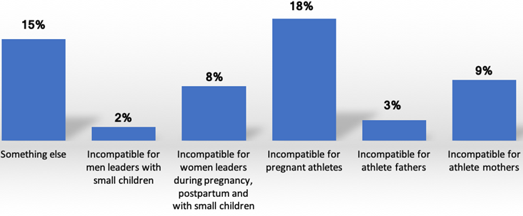

Figure 4. Compatibility between parenthood and elite sport

**Discrimination in sporting environments**

Respondents were also asked about their experiences of equity, diversity and inclusion (EDI) in the sporting environments in which they have been involved. When asked about the importance of promoting EDI for personal safety, one third of respondents indicated that they strongly agreed or agreed that implementing EDI in sport is important for their personal safety. Approximately 10% of respondents indicated that their views on IDE were not aligned with the daily practices of the sport organisation or team.

A fifth of respondents indicated that they had observed discriminatory practices in sporting environments based on minority identity. Equally as many respondents reported experiencing discriminatory practices based on their own identity (e.g. being prevented from participating in sport, being denied a promotion in their profession, not feeling safe enough to share their opinions, being bullied, threatened or harassed). In contrast, 5% of respondents reported experiencing discriminatory practices based on their parental identity. In the open responses, respondents reported experiencing various forms of mistreatment, including abuse (e.g., bullying, sexual harassment, and humiliation), discrimination (e.g., based on gender, language, disability, religion, or minority status), and insecurity (e.g., being belittled and silenced). Further analysis of these experiences of discrimination is crucial to creating safer and fairer elite sport environments.

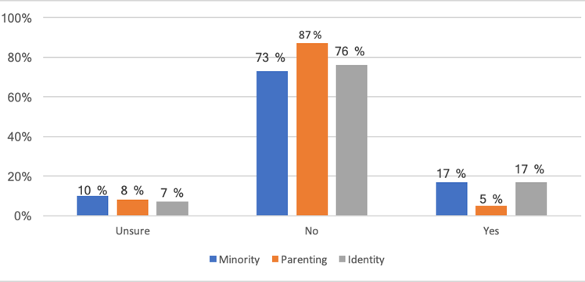

Figure 5: Experience of discrimination based on personal identity, minority identity and parental identity.

**Conclusions and future of the research project**

The preliminary results of the survey suggest that respondents have encountered very different forms of inequality and discrimination in sporting environments. At the same time, general awareness of the promotion of gender equality and related measures in sport organisations was relatively low. In order to promote equality, further critical reflection on gender inequalities and their links with other forms of inequalities, such as discrimination and inequality on the basis of age, ethnicity, sexuality or parenthood, is necessary. Intense debate should be continued within the world of elite sport regarding the many forms of inequality and ways to reduce it in the careers of athletes.

**References:**

Kokkonen, M. (2012). Seksuaali- ja sukupuolivähemmistöjen syrjintä

liikunnan ja urheilun parissa. Valtion liikuntaneuvoston julkaisuja 2012:5.

https://www.liikuntaneuvosto.fi/wp-content/uploads/2019/09/Seksuaali-ja-sukupuoliv%C3%A4hemmist%C3%B6t-raportti.pdf

Lehtonen, J. (2007). Seksuaaliseen suuntautumiseen ja sukupuolen moninaisuuteen liittyvä syrjintä. Teoksessa: Lepola, O. & Villa, S. (toim.) Syrjintä Suomessa 2006. Helsinki: Ihmisoikeusliitto.

Lehtonen, K., Oja, S. & Hakamäki, M. (2022). Liikunnan ja urheilun tasa-arvo Suomessa 2021. Opetus- ja kulttuuriministeriön julkaisuja 2022:5. <https://julkaisut.valtioneuvosto.fi/bitstream/handle/10024/163828/OKM_2022_5.pdf?sequence=4&isAllowed=y>

Tilastokeskus (2013) Sateenkaariperheet tuovat väriä tilastoihin. Linkki noudettu 4.4.2024. <https://www.stat.fi/artikkelit/2013/art_2013-09-23_001.html?s=0#:~:text=Arvioiden%20mukaan%205%E2%80%9315%20prosenttia,koosta%20ole%20siten%20tarkkaa%20tietoa>.

Twenge, J. M. (2023). Generations: The real differences between gen z, millenials, gen x, boomers, and silents – And what they mean for America’s future. New York: Atria Books