This document has been created as part of the Erasmus+ project "Developing Digital Physics Laboratory Work for Distance Learning" (DigiPhysLab). More information: [www.jyu.fi/digiphyslab](http://www.jyu.fi/digiphyslab)

Acoustic experiments

Instructor version

20.2.2023

# [Creative Commons License](https://creativecommons.org/licenses/by-sa/4.0/) This work is licensed under [the Creative Commons Attribution-ShareAlike 4.0 International License](https://creativecommons.org/licenses/by-sa/4.0/).

# Acoustic experiments - Instructor version

## Task overview

* Topic: Acoustics, interference, frequency spectrum, Doppler effect
* Target group: Physics teacher training students and minor physics students e.g., medicine students.
* Timeframe: 2.5 hours for conducting the task and writing the report.
* Recommended to work in pairs.

The aim of this task is to introduce the students to several acoustics phenomena and give them some ideas on how they can be demonstrated experimentally. The task is divided into three parts. In the first part, students will study the interference of sound waves, in the second part they will study the frequency spectrum of different sounds, and in the third part they will study the Doppler effect.

## Required equipment

* Two smartphones with *PhyPhox* installed (available for both *Android* and *Apple* devices)
* Computer with data analysis software (e.g., *Excel*)
* Elastic spring with low spring constant
* A stand for the spring
* Maybe further sound sources, e.g., tuning forks, music instruments, etc. (or alternatively Youtube-videos)

The length of the elastic spring should be sufficient for the phone attached to the spring to oscillate with several different amplitudes. It is not recommended to use springs with a high spring constant as students could damage their phones. Make sure that the students have secured their phones before they start conducting the experiment. In our laboratory, some of the students used a charger hole on the cell phone case to secure it to the spring, others tied their phone to the spring with a string.

The task can be easily adapted for a distance learning scenario. Students can use some kind of elastic band instead of a spring.

## Pre-lab exercise

Before coming to the lab, students should install *PhyPhox* on their phones and should use it to record different sounds. It will be useful for the students to investigate what different kinds of data they can obtain from the app.

## Part One – Sound Interference

Students can search for positions of local minimums by using their hearing or by using *the PhyPhox* app. We recommend searching by hearing first and after that students can compare their observations with measured data from the app.

During the task, you can give students guidance with the following questions:

1. What were you guided by when you were choosing the conditions (source position, loudness, frequency) in which you will conduct the experiment?
2. Under what conditions, of the ones you tried, it was the easiest to hear interference minimums? Try to explain why.

If the students are in physics teacher training, you can ask them how they would conduct this experiment in the classroom with their students.

### From our lab

Students placed the sound sources at the height of their ears and generated two equal tones. It was easier to notice the minimums for higher frequencies (over 2 000 Hz). We found an explanation that the human ear is most sensitive to the frequency range of about 2 000 Hz to 5 000 Hz. They also discussed how very high frequency tones would not be suitable for classroom experiments because they are irritating to listen to especially over a longer period.

## Part two – Frequency spectrum of different sounds

In this part of the task, by using *PhyPhox*, students need to record the sound of a tuning fork, the sound of some musical instrument playing a certain note, then the sound of another musical instrument playing that same note and finally the sound of creasing paper. Since students probably won’t have musical instruments at their disposal, they can be instructed to find videos of the notes played on YouTube. Recorded sounds are then analyzed in *PhyPhox* app and *Excel* (or other data analysis software).

During the task, you can give students guidance in the form of the following questions:

1. What differences and similarities have you found between the $A-t$ (amplitude in time) graphs of the different sounds?
2. What part of the frequency spectrum will you use for your analysis?
3. For which sounds were you able to determine the fundamental frequency and higher harmonics?
4. How did you find the relationship between the fundamental frequency and the higher harmonics?
5. What similarities and differences have you noticed between the same notes played on different instruments?
6. How would you explain why the same note played on different instruments doesn’t sound the same?

### Data collection and analysis

*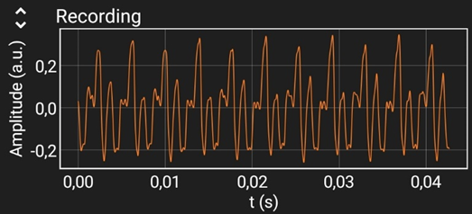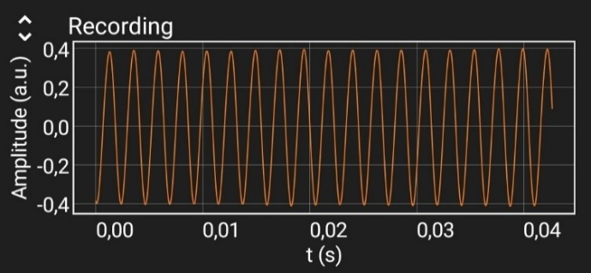**PhyPhox* in Audio Spectrum mode will collect all the data that students need to conduct this part of the task. Graphs of amplitude in time can be analyzed directly in the application.

Figure 2. A-t graph; guitar C4 note – periodic function

Figure 1. $A-t$ graph; tuning fork – sinusoidal function

Students should export frequency spectrum data to a computer and analyze it in Excel (or other data analysis software) as it is impossible to do quantitative analysis in the application. Students can draw frequency spectrum graphs for different sounds by following the task instructions.

*Figure 3. Frequency spectrum for the C4 note played on a piano.*

*Figure 4. Frequency spectrum for the C4 note played on a guitar.*

### From our lab

Students agreed on the recording order so that the sounds from one group don’t interfere with the sounds from another one. Students themselves should remember to try to reduce the background noise, but if there is a need, you should warn them about it.

Some of the students had difficulties with determining which part of the spectrum they should remove from the analysis. Displaying all possible frequencies on the graph gives poor visualization of the experiment so students are advised to eliminate frequencies that are not relevant for their analysis. However, some of the students have also removed a part of the spectrum in which higher harmonics appear. Discuss with your students how they have determined which part of the spectrum they can remove from their analysis. During the task evaluation, many students pointed out that they didn’t know why the same notes played on different instruments sound different and that this analysis was particularly interesting to them.

Some students had difficulties with estimating the uncertainty of the fundamental frequency. Although the instructions explain the procedure in detail, several students estimated uncertainty as half the height of the maximum instead of half the width of the maximum.

Students had fun during the task in which they recorded themselves and a colleague saying 2 different vowels. During this task, it can be mentioned that speech therapists sometimes use a visualization of the sound waves of human speech to help people visualizing their progress in pronunciation.

## Part three – Doppler effect

In this part of the task, students emit a high frequency tone from a phone that oscillates harmonically and collect information about the detected frequency with another stationary phone. Ultrasonic frequency is used in the experiment because the Doppler frequency shift is proportional to the value of the emitted frequency. When the emitted frequency is high, the difference between the emitted and detected frequency is noticeable even if the source of the sound is moving slowly. In addition, students will not hear emitted sounds which would be irritating to listen to, especially if several groups of students are conducting the task at the same time. It is still possible for some interferences to occur between different groups taking the measurements at the same time.On the other hand, it is not recommended to use frequencies greater than 20 kHz because the phones are not able to adequately broadcast them.

During the task, you can give students guidance in the form of the following questions:

1. How did you position your phones in this experiment? Why?
2. What do you expect the $f-t$ graph to look like for the detected frequencies? Explain your expectations.
3. How did you select the frequency range you displayed in the graph? In what frequency range do you expect to find the detected frequencies?
4. In what position is the source phone when the detected frequency is maximum, and in what when it is minimal? In what position is the phone when there is no difference between the emitted and detected frequencies?
5. How can you use the Doppler effect to determine the velocity of your phone in the equilibrium position?
6. If all local minimums/maximums of the detected frequency are not equal, what could be the reason behind this?
7. What are the limitations of this experiment?

### Data collection and analysis

Students should place their phones so that the speakers and microphones of both phones are facing each other. The oscillations of the phone should be as one-dimensional as it is possible to achieve. The *PhyPhox* application in Audio Spectrum mode will collect all the data that students need to conduct this part of the task. Before the students start the measurements, it is important that they choose the method of data processing in *PhyPhox* according to the task instructions. The measurement instructions are explained in detail and it is important that students read them carefully before starting the experiment.

Figure 5. An example of a graph of detected frequency in time for two different amplitudes of phone oscillation.

### From our lab

Students successfully predicted the $f-t$ graph, but they again had problems with displaying the collected data on the graph. *PhyPhox* (in the working mode described in the instructions) collects at any time only the frequency of the highest intensity, which in this experiment should be the frequency emitted by the source phone. However, most of the students also collected some of the much lower background noise frequencies in their measurements. In that case, if the students display all collected data, they will get a graph (example; Figure 6) which is a poor visualization of what is happening in the experiment. From such a graph students concluded either that they had misconducted the experiment or that the experimental setup was not working. The collection of lower frequencies mostly occurred at the beginning or end of the measurement, but it is possible at any part of measurement.

*Figure 6. An example of the $f-t$ graph from which the detected low frequencies were not removed.*

It was necessary to discuss with the students in which frequency range it is realistic to expect detected frequencies, why much lower frequencies are collected, and why they need to be removed when analyzing data. While this difficulty can be avoided by reducing the background noise, we think it's useful to discuss with students when and why some data can be removed from data analysis.

The students themselves discussed how oscillations in more than one dimension can affect the velocity of the phone in the equilibrium position. They concluded that because of that and the limitations of the phone as a measuring instrument all detected local minimums and maximums were not equal.

A significant part of the students did not carefully read the measurement instructions before conducting the experiment, so they successfully collected data only in the second or third attempt. Advice the students to read the instructions carefully.

## Reporting

Students wrote their answers directly into the task document and sent the word/PDF document to the instructor. Students need to be reminded to attach all the results and graphs, and to write down their observations, explanations, and conclusions where they are asked to do so.