Instructions for using the Tracker app – Coupled compass oscillations
Tracker is a free video analysis tool used in physics classes. Download the application at https://physlets.org/tracker/ and install it on your computer.
Through these instructions, you will record and analyze one video in Tracker. The analysis in the instructions is analogous to the one in the task.
How to record the video
Tie a small object to a string and fix it so that it can oscillate. Pull the object from its equilibrium position and record the oscillation with your phone. Record a video on a background that does not change e.g., a white wall, so it is easier to determine the positions of object. Place an object of known length next to the experimental setup. Make sure that this object is in the same plane as the object you are observing to make the measurements more accurate. With this object you will calibrate the length within the application. While recording make sure that your phone is not moving so that the video is stable. Transfer the video you recorded to your computer.
Instructions for using Tracker
Start Tracker. The user interface is shown on the image below.
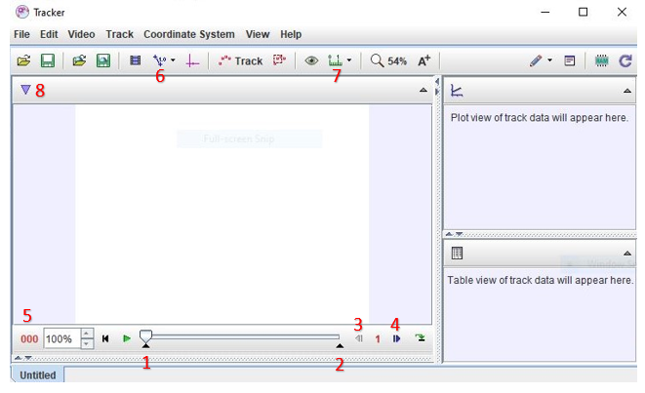
Opening the video
To open the video, click on File à Open File à Chooser, find the video you want to upload, and click Open. Note: Tracker sometimes takes a little time to upload the video.
Sometimes the video rotates while uploading. If you want to change the rotation of the video, click on Video à Filters à Rotate and select the rotation you want to perform.

Cutting the video
You should determine the part of the video that you want to analyze. In this task, you will analyze the oscillation of an object fixed to the string.
You can determine the initial and final frames by moving the sliders marked with the numbers 1 and 2 in the figure below. The left pointer determines the beginning of the video and the right one determines the end.
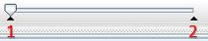
For this analysis, you should cut the video so that it begins exactly when the object first reaches the amplitude position and ends after the object performs several full oscillations. Start the video and pause it when it seems that the object has reached an amplitude position for the first time. While the video is paused, you can move the frames one by one forward or backward by using buttons 3 and 4 until you find the exact moment in which the body is in an amplitude position. You can see the number of the frame on button 5. When you have determined with which frame the video should start, mark it with slider 1. Use slider 2 to specify the end of the video.
If you want to know the time that has passed since the beginning of the video instead of the frame number, click on 5 à Display à Time.
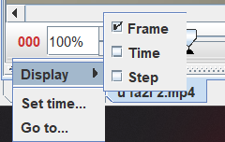
The time counts from the frame you have chosen for the starting one. You can change the cropped part of the video and the data displayed at 5 at any time.
Scale calibration
By pressing Calibration tools (6) à New à Calibration stick, we determine the length calibration within the video. Place the ends of the rod at an object of known length and change the length of the rod (which is initially 1 m) to the known length of the object in meters.

Length measurement
You can measure lengths by pressing Measuring tools (7)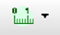à New à Tape measure. When you stretch the ends of the arrow to the ends of the object that you want to measure, the measured length will appear. With the middle wheel, you can zoom in and out of the image (this can be useful for more accurate measurement).
You can hide or delete all the tools you have used to analyze the video. E.g., if you want to hide or delete Tape measure, click on Select existing track (8)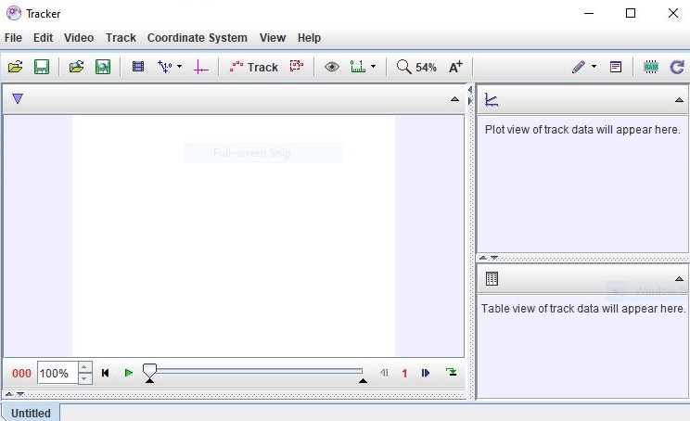à Tape A à Tape A à Visible / Delete.

Task for practice
- Measure the object dimensions from the video.
- Determine the oscillation period of your pendulum.

