This document has been created as a part of the Erasmus+ -project “Developing Digital Physics Laboratory Work for Distance Learning” (DigiPhysLab). More info: [www.jyu.fi/digiphyslab](http://www.jyu.fi/digiphyslab)

Oscillation of an elevator car

Instructor version

17.2.2023

[Creative Commons License](https://creativecommons.org/licenses/by-sa/4.0/)  
This work is licensed under a [Creative Commons Attribution-ShareAlike 4.0 International License](https://creativecommons.org/licenses/by-sa/4.0/).

# Oscillation of an elevator car – Instructor version

## Task Overview

* Topic: Investigation of elevator oscillations with discrete Fourier transform (DFT)
* Target group: Physics and physics teacher training students in the introductory phase, depending on the desired deepening of the DFT also higher semester.
* Time frame: depending on the desired deepening of the DFT approx. 8-20 hours including data analysis or about 2 hours for the short version (see below)
* Recommended social form: in pairs or groups (2-3 students per group)

## Preparation

The aim of the experiment is to acquire the analysis method of the DFT using rope oscillations of an elevator car as an example. If the students have no previous knowledge of Fourier transforms and their application in Python, a prior familiarization of the students in the topic is necessary. This can be done using either the introductory tasks in the task description or the *jupyter-N*otebook provided, which gradually introduces the data analysis with DFT in Python and is also suitable for students without (deep) Python knowledge. We therefore strongly recommend using this Python notebook for data analysis. A short instruction on how to install and use *Python* can be found in the materials provided. On request, the topic of the Fourier transform as a central tool of contemporary data analysis and coding can be further deepened in this context.

## Set up and implementation

For the experiment, the accelerometers (with or without gravitational acceleration g) of the smartphone can be used. Also measuring the gravitational acceleration has the advantage that a precise alignment of the smartphone is possible based on the real-time measurement data, so that a sensor axis is aligned as precisely as possible in the direction of oscillation. The *phyphox* tool *Inclination* can also be used to measure the angle. Due to the precise alignment, the measured accelerations are maximized, which leads to a higher precision of the measurement. Sometimes it is worthwhile to compare the individual sensor axes, as the sensors measure with different precision in the different coordinate axes. The naming and alignment of the coordinate axes depend on the device.

Test measurements for the cable oscillations of the elevator car have shown that it makes sense to attach the telephone to the wall of the elevator, since the flooring of the elevator causes measurable intrinsic oscillations. The students can specifically investigate this in their own sub-experiment. When choosing the elevator, it must be explicitly ensured that the elevator car actually hangs on a rope and does not follow a different functional principle.

During the measurements, the safety instructions in the task document must be noted. Under no circumstances should you jump during an elevator ride, otherwise the cabin could wedge. The measurements should only be carried out when the elevator is permanently located on one floor. It is advisable to carry out the measurements while the cabin doors are closed in order to avoid malfunctions caused by the automatic door mechanism.

Several oscillation processes should be recorded per floor, since the oscillation process is damped relatively strongly and only a few measurement data are available for analysis per oscillation process (less than 200 measuring points, depending on the sampling rate of the smartphone). The data of several oscillation processes can then either be evaluated individually and the frequencies averaged for each floor, or the oscillation processes can be summarized in a data file and transferred together to the Fourier transform algorithm. In the latter case, the peak belonging to the oscillation is more visible in the frequency spectrum, but care must be taken that there is no large shift between the last data point of the first measurement and the first data point of the second measurement (and between the last data point of the second and the first data point of the third measurement), as this distorts the Fourier transform.

Different methods can be used to measure the rope length per floor. In all cases, the difference in height between the individual floors (these may be different in the same building!) and the offset caused by the fact that the pulley of the rope on the top floor is not directly above the elevator car must be determined. The determination of the individual floor heights is possible, for example, by

* measuring the height of steps in the stairwell and counting the number of steps;
* measuring an elevator ride between floors with the accelerometer and determining the distance traveled by integrating the acceleration data twice;
* determining the difference in altitude based on the difference in air pressure, if the smartphone has a barometer;
* GPS measurements.

The first method is likely to provide the most precise results in many cases. Most barometric pressure sensors have a slower readout rate compared to accelerometers in phones and high fluctuations of the measured values even in the rest position, so that the measurements are less precise than with the accelerometers. In the latter case, the measurement should only be started when the door is closed in order not to record the closing of the doors.

## Transferring the data to the PC

There are three main methods available for data transmission:

1. One option is to use the remote-control function offered by *phyphox*. Here, the data recorded by the smartphone is transferred to a computer in real-time (only works with appropriate network availability). It is also possible to start and stop recording remotely.
2. The data is transferred directly to the computer via e-mail, Bluetooth, airdrop, etc.
3. *Only useful for Android devices*: The data is initially stored on the smartphone. Since *phyphox* cannot access the internal memory directly, this requires a file management app such as *TotalCommander*, which can receive the file and save it internally. The file can then be transferred, e.g., via data cable.

## Data analysis

Before fitting, the data must be prepared accordingly. The following aspects are pointed out:

* The relevant data must be selected from the data set of oscillations. The correct coordinate axis and only the periods in which the intended oscillation took place must be selected. Otherwise, other artifacts (e.g., moving the smartphone when starting/stopping data ingestion) will affect the results.
* When using the accelerometer with $g$, the gravitational acceleration should be excluded from the data. Here you can check the orientation of the smartphone again and, if necessary, also include components of other coordinate axes in the description of the oscillation.
* To determine the rope length, the length of the rope above the cabin on the top floor up to the pulley must be estimated.

When applying the Fourier transform (in the Python script), consider the following:

* The duration of an oscillation is relatively short which means that only a few periods of the oscillation can be analyzed for each jump.
* Using multiple jumps as one signal can lead to a widening of the possible frequency spectrum for an elevator ride.
* The use of a Gaussian fit can make it possible to determine an average value for the frequency of the elevator oscillation. For the fit, the frequency range may have to be narrowed to a certain width.
* In order to successfully perform a Gaussian fit, a value for the mean value must be specified in the *initial guesses*, which lies in the interval under investigation.
* The half-width or the standard deviation sigma can be used to describe the measurement uncertainty of the frequency mean values.

## Expected results

In the following, the implementation and the results for an elevator in a four-story building are described as examples. The rope length was determined by determining the distances travelled using of an acceleration sensor. For this purpose, the acceleration values of the corresponding elevator runs were be integrated twice. For the distance from the 1st to the 4th floor you get a distance of 11.1 m. The distance between the pulley and the cabin on the top floor, which was estimated to be 0.5 m, must be added to this value.

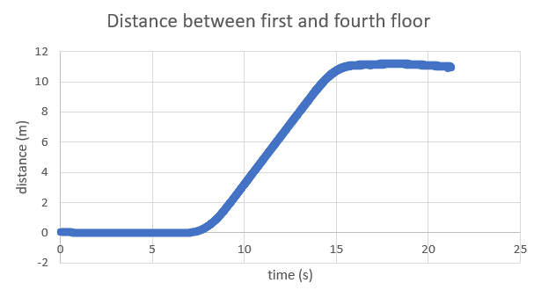

Figure 1 Integration of the acceleration values of an elevator ride from the 1st to the 4th floor

Due to the sampling rate of the smartphone $f_{s}$ ( $f_{s}≈198$ Hz in the example), only frequencies from 0 to $\frac{f_{s}}{2}$, i.e., from 0 to approx. 99 Hz, can be analyzed in the Python script using the Fast Fourier Transform (FFT). However, this is more than sufficient, since the frequencies of the rope oscillation are in the range between 1 and 10 Hz. Due to the brevity of the oscillation, it makes sense here to treat several jumps in one Fourier transform. When jumping, care should be taken to ensure that the jumps do not influence each other. In addition, a somewhat wider distribution of frequencies can be expected due to possible phase jumps between the oscillations. Despite positioning the smartphone on the wall of the elevator car, further oscillations may be observed. In this case, it is advisable to compare different mounting points in the cabin.

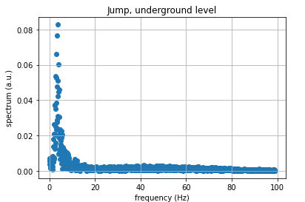

Figure 3 Fourier transform for oscillations in the basement.

Figure 2 Example of a recorded oscillation

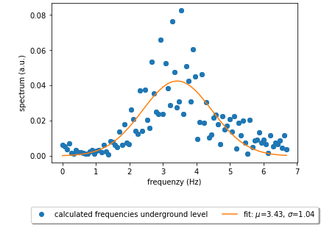

Figure 4 Gaussian fit for a Fourier transform

With measurement uncertainty $σ$ and Gaussian measurement uncertainty propagation, the following diagram emerges for the dependence of $T^{2}$ on the rope length $l$.

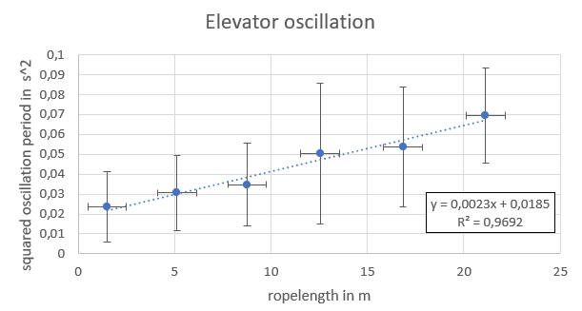

Figure 5 Relationship between $l$ and $T^{2}$

## Possible forms of assessment

The results of the preparatory tasks can be presented, for example, on a scientific poster. The poster should then contain, among other things, exemplary illustrations for the oscillation data, the analysis with FFT and Gaussian fits and of course the central result, the graphical representation of the proportional relationship between the rope length and the square of the periodic oscillation duration (analogous to the figures in this document). Alternatively, short presentations, laboratory reports or *computational essays* are also possible. The last two forms of testing also allow a detailed description and discussion of details on the conduct of experiments and data analysis.

## Suggestions for modifying the experiment

In the context of elevator oscillations, the following modifications/extensions are possible:

* The oscillatory behavior of different elevators (e.g., normal elevator versus freight elevator) can be compared. The challenge here is to estimate the mass of the elevator car and the data of the rope in a reasonable way.
* The relationship between the mass of the elevator and the period of oscillation can be studied for the same floor where, for example, several people are standing in the elevator while it is oscillating. Due to the large range of measurement uncertainties, however, a mass difference of several 100 kg difference (e.g., 3-5 persons) would be necessary. Here it is essential to pay attention to the permissible total mass of the elevator!
* The oscillatory behavior of the elevator in the other two spatial directions (i.e. in the horizontal plane) can be investigated while the elevator car continues to oscillate in the vertical direction due to jumping.

In addition, it is also possible to work on the task without the students using Python to perform the Fourier transform independently. This is particularly suitable if there is little time available, the deeper understanding of the Fourier transform is not a learning objective, or the topic of the Fourier transform or programming with Python is too difficult for the target group. *Phyphox* offers the experiment *acceleration spectrum*, which outputs the frequency spectrum, the frequency peak and other parameters in real time. Furthermore, since settings for the sampling rate are also possible and the raw data is output, too, an enactive and hypothesis-guided access to the oscillation processes of the elevator is also possible in this way, without dealing with Python and the principle of the Fourier transform in detail. This is particularly useful if there is little time (e.g., 2 hours) available for the experimental task.

In addition, other mechanical oscillation processes can be investigated in an analogous way. At this point, reference should therefore be made to the task "Digital Signal Processing".

## Literature

The experiment task is inspired by the following paper, which can also serve the students to prepare for the experiment:

Kuhn, J., Vogt, P., & Müller, A. (2014). Analyzing elevator oscillation with the smartphone acceleration sensors. *The Physics Teacher*, *52*(1), 55–56. <https://doi.org/10.1119/1.4849161>