This document has been created as a part of the Erasmus+ -project “Developing Digital Physics Laboratory Work for Distance Learning” (DigiPhysLab). More info: [www.jyu.fi/digiphyslab](http://www.jyu.fi/digiphyslab)

Oscillation of an elevator car

Student version

20.2.2023

[Creative Commons License](https://creativecommons.org/licenses/by-sa/4.0/)  
This work is licensed under a [Creative Commons Attribution-ShareAlike 4.0 International License](https://creativecommons.org/licenses/by-sa/4.0/).

# Oscillation of an elevator car

## Motivation

The spring pendulum is a typical mechanical experiment to discuss, for example, the material properties of springs, Hooke's law or simple oscillation processes. In lectures and lab-courses, small springs and pieces of mass are often used, so that, strictly speaking, Hooke's law is only studied for a small order of magnitude. In this experiment, you will therefore investigate a large-scale version of the spring pendulum. A passenger elevator serves as the experimental setup. It often consists of a car and a rope on which the car is lowered and pulled up again. When the elevator is at a standstill on one floor and you jump up and down inside the car, you can feel an oscillation that is caused by the oscillating elevator rope. This oscillation can be measured using the smartphone.

The aim of this task is to investigate the relationship between the period duration of an oscillating elevator car and the length of the elevator rope. With the discrete Fourier transform, you will get to know and apply a new analysis method that enables a precise determination of the period duration.

## Experimental materials

Smartphone with *phyphox*, building with several floors and elevator, computer for data analysis, adhesive tape, clear plastic bag if needed (protection of the smartphone when attaching with adhesive tape)

## Fostered experimental skills and topics

**Experimental skills**: design of the experiment, acquisition of measurement data, analysis of data using the discrete Fourier transform

**Topics regarding experimental physics**: accelerated motion, spring pendulum, oscillations  
**Mathematical methods**: Fourier transform, complex numbers

**+ for physics students:** first insight into modern signal processing

**+ for student teachers:** Analysis of an everyday situation

You will now receive all the materials for the oscillation of an elevator car experiment, in which you examine the oscillatory behavior of an elevator car on different floors with your smartphone. Below, you will find materials to prepare for the experiment, followed by the actual task document for the experiment and the auxiliary materials (I) to (II).

### Preparation

Use the following materials to prepare yourself content wise before planning and conducting your experiment. To do this, also work on the corresponding subtasks.

## Technical preparation

1. Please install the free app *phyphox* on your smartphone. Check whether data from *phyphox* can be stored locally on your smartphone. For Android devices, this is usually done with a free file management app such as *Total Commander*.
2. Please arrange an access to Python*.* You can use browser-based jupyter notebooks, for example at *google colab* or directly under [www.jupyter.org](http://www.jupyter.org).

## Content preparation I

1. **Read the information below about the oscillations of an elevator and the discrete Fourier transform and complete the corresponding tasks.** The focus should be on a conceptual understanding of experiment (goal and theory) and the analysis method of the discrete Fourier transform (DFT). You will need the DFT to analyze the oscillations. For more information, read the paper by Kuhn et al. (2014) on which this experimental task is based: <https://aapt.scitation.org/doi/10.1119/1.4849161>.

## Oscillations of the elevator

A cabin of the mass $M$ suspended from a rope can be simplified as a spring pendulum. By jumping inside the elevator, this system can be set into oscillation. With the spring constant $k$ of the rope the equation $T=2π\sqrt{\frac{M}{k}}$ applies to the oscillation duration of this oscillation. The spring constant $k=\frac{E∙A}{l}$ is antiproportional to the rope length $l$ and proportional to the elastic modulus $E$ and the cross-sectional area of the rope $A$. Inserted in the formula for oscillation duration we get $T=2π\sqrt{\frac{M∙l}{E∙A}}$, i.e. the square of the oscillation duration $T^{2}$ should be proportional to the length $l$ of the rope. This relation can be checked by determining the rope length and the square oscillation duration for different floors.

**Preparatory tasks n for the physical background/experiment:**

3a) Research and outline the structure and functioning of a cable-powered elevator. Then describe different ways (e.g., with and without smartphone use) to determine the rope length of the elevator car for each floor of a building.

3b) Research and describe which sensors of your smartphone you can use to measure the oscillations of the elevator car.

## The discrete Fourier transform

Jumping in the elevator causes the elevator to oscillate periodically, which can be measured using smartphone sensors. Ideally, the period duration of the oscillation could be read directly from the raw data, e.g., graphically. However, it is to be expected that further oscillations, e.g. harmonics or oscillations independent of the rope (e.g. natural oscillations of the elevator car) will overlap and make it difficult to determine precisely the period duration of the rope oscillation. To do this, however, the Fourier transform offers a mathematical tool that allows the frequencies occurring in a signal to be identified.

In a Discrete Fourier transform, $N$ discrete measured values $\{x_{0}, x_{1}, …, x_{N-1}\}$, each recorded over a time interval $\frac{T}{N}$, are considered. It is now assumed that the signal consisting of the measured values $\{x_{0}, x_{1}, …, x_{N-1}\}$ is based on a continuous functioni.e., that the signal can be periodically continued after $N$ values and approximated by a function. This approximation follows the principle that a periodic function can be approximated as a superposition of continuous sine functions of different frequencies. (This is comparable to the Taylor series concept, in which a function is approximated by a sum of power functions.)

This now motivates the definition of the discrete Fourier transform, the function that maps the measured values $\{x_{0}, x_{1}, …, x_{N-1}\}$ to the associated amplitudes ${\{X}_{0},X_{1},…,X_{N-1}$}. These are defined by

|  |  |
| --- | --- |
| $$X_{\text{k}} :=\sum_{n=0}^{N-1}{x_{n}}⋅e^{-\frac{i2π}{N}kn},$$ | (1) |

where the exponent $\frac{i2π}{N}kn$ can be written as $\frac{i2π}{N}kn=\frac{i2π}{T}kn\frac{T}{N}=iω_{k}n\frac{T}{N}$ with the frequency $ω_{k}=\frac{2π}{T}k$ that is being tested at the time $n\frac{T}{N}$. The values ${\{X}_{0},X_{1},…,X_{N-1}$} therefore indicate amplitudes that were determined via the possible frequencies $ω_{k}$ and the measured values $\{x_{0}, x_{1}, …, x_{N-1}\}$. In task 3c) you will show that this definition actually describes a sum of sinusoidal functions with the corresponding frequencies.

Similarly, a function can now be defined that maps the amplitudes $X_{k}$ back to the measured values $x_{\text{n}}$. This inverse DFT is, as you will show in exercise 3d), given by

|  |  |
| --- | --- |
| $$x_{\text{n}}=\frac{1}{N}\sum_{k=0}^{N-1}{X_{k}}⋅e^{\frac{i2π}{N}kn}.$$ | (2) |

This rule shows that each measured value can also be described as a sum of sinusoidal functions with the amplitudes $X_{k}$. It is now clear that the DFT can indicate how strongly a certain frequency is represented in the measurement data. Fourier transform thus gives $N$ complex amplitudes $X_{k}$ and the corresponding frequencies $ω_{k}$ are more strongly represented in the signal, the larger the absolute value of these amplitudes ${|X}_{k}|$ are.

Various algorithms can be used for the application of DFT. In the Python script provided, the so-called *Fast Fourier Transform* algorithm (FFT) is implemented. This returns the amplitudes of a frequency spectrum from $-f_{max}$ to $f_{max}$, where the maximum sampleable frequency is $f_{max}=\frac{1}{2}∙\frac{N}{T}$ according to Nyquist. As a rule (also in the Python script), therefore, only the determined frequencies from 0 to $f_{max}$ are specified. The normalized amplitudes must be calculated according to the formula $A_{\text{k}} :=\frac{2}{N}∙\left|X_{k}\right|$. The prefactor $\frac{1}{N}$ for normalization results from the fact that there are $N$ amplitudes ${\{X}_{0},X_{1},…,X_{N-1}\}$ in total ; the prefactor $2$ follows from the fact that amplitudes were also determined for frequencies from $-f_{max}$ up to 0 in FFT, but these are not taken into account. The normalization is not relevant for data analysis in this experiment but it is implemented in the script for the sake of completeness.

You can now use the provided Python script to apply a Fourier transform to your measurement data, as described here. You will find instructions on how to use it in the auxiliary material (I). The script itself is commented in detail, so you can gradually familiarize yourself with its use.

**Preparatory tasks for mathematical background:**

3c) Show that the definition of $X_{k}$ describes a sum of sine functions. Use the Euler formula to get a representation of $X_{k}$ with its real and imaginary parts.

3d) With the definition of the DFT, confirm the plausibility of the rule for the inverse DFT, i.e. that $x_{n}=\frac{1}{N}\sum_{k=0}^{N-1}{X_{k}}⋅e^{\frac{i2π}{N}kn}$ is well-defined. You can take advantage of the fact that $\sum_{n=0}^{N-1}{e^{inx}}=\frac{1-e^{iNx}}{1-e^{ix}}$ applies to all $N∈N$.

## Content preparation II

1. **Read the instructions on how to get started with *Jupyter* (****auxiliary material I). Work through the notebook up until the step "Import data" to understand the basics of data analysis with a DFT in Python.** With this basic understanding, the analysis of the data of your experiment should succeed well. Investigate which parameters are important for DFT analysis and which sources of error can occur.
2. **Read the instructions for the *app phyphox* (auxiliary material II). Try out the workflow** using the data from any sensor (e.g., acceleration with/without $g$). Try to read this first data into Python. Please note the hints in the notebook in the step "Import data".

### The experiment

After preparation, you can plan and carry out your experiment. Your task, as described above, is to investigate **the relationship between the period duration of an oscillating elevator car of your choice and the length of the elevator cable. For data analysis, you should use the method of the discrete Fourier transform.**

Specifically, this results in the following subtasks:

* Select an elevator and check, for example, by test jumps, that the elevator can be modeled as a spring pendulum.
* Determine the rope length of the elevator for the different floors. If necessary, compare the results of different methods of determination.
* Use your smartphone to record the oscillations caused by a jump for each floor. Plan your exact procedure in advance (e.g., choice of sensor, positioning of the smartphone, number of repeated measurements, type of jumps).
* Use Fourier transforms (and Gaussian fits) to determine the frequency or period duration of the elevator oscillation for each floor from the measurement data. To do this, use the Python script provided.
* Graphically represent the period duration depending on the rope length of the elevator and check the mathematical relationship between these two quantities.
* Additional task: Develop your own, further question in which you vary certain parameters (e.g., elevator size, mass, jumping behavior, ...) and examine the influence of these parameters on the oscillation behavior.

**Attention! Safety:**

* Only jump when the elevator is stopped on one floor! Never jump while the elevator is moving, otherwise the car could get stuck!
* Do not jump too high to prevent the elevator from getting damaged or jammed!
* Do not exceed the permissible total weight (especially if you are in the elevator with several people)!

## Guiding questions for the experimental process

To structure your experimentation process, you can use the following questions for guidance:

1. What assumptions do you make regarding the construction of your elevator and what consequences does this have for determining the rope length? If in doubt, make a sketch.
2. What is the relationship between your sensations during the jump and the measured physical quantities?
3. Which sensor can you use to measure the oscillations of the elevator car most precisely? Perform sample measurements if necessary.
4. What influence does the positioning of the smartphone in the elevator (height, wall or floor, orientation...) have on the experiment and results?
5. How does the way you jump affect your data?
6. What influence does the frequency of your jumps have on the analysis?
7. What measurement uncertainties occur during the experiment? How can these be quantified?

## Guiding questions during and after the data analysis

During the data analysis, you can also use the following questions for guidance:

1. Which part of the data set is (ir-)relevant for further data analysis?
2. To what extent do you need to modify your data before you can apply DFT? Consider the relevant parameters that you learned about in the introduction to the Fourier transform in the Python script.
3. Interpret the frequency spectrum produced by the DFT by explaining the respective physical meaning/cause of the determined frequencies.
4. How likely do you think the *alias* effect will occur? Consider the sample rate of your smartphone and the frequency spectrum resulting from the DFT.
5. For which part of the frequency spectrum does it make sense to fit the data with a Gaussian fit?
6. What significance do the *initial guesses* have for the quality of your fits? How do you apply the *initial guesses*?
7. What criteria can you use to decide whether a fit was "successful"?
8. How can you take into account the identified and quantified measurement uncertainties in the individual steps of the data analysis ("error calculation")?

## Assessment

Write a short *computational essay* consisting of text, numerical values and excerpts from code and code outputs, in which you

1. work on the preparatory tasks in this task document and answer the **bold** questions in the Python notebook and provide the desired numerical values
2. describe what you want to investigate and explain the experimental setup you used
3. outline the code you used to analyze the experiment's data
4. present and discuss your results and the uncertainties
5. reflect on the experiment by, for example, listing ways to optimize the experiment.

The *computational essay* should be a coherent overview of your elaborations. The Python notebook is an example of what such an *essay* looks like. You can make a copy of the notebook and create your *computational essay* in the same format.

## (I) Instructions for Python

With *Python*, you are using a popular programming language in science, which can be used to analyse experimental data. The following instructions are for the jupyter notebook. Whichever platform you use, please upload the notebook and follow its instructions and later use python for your data analysis.

1. **Jupyter and Python**
   1. After launching *jupyter*, you will see the home screen. On the right, you can choose between various programs. We will work with Python notebooks.
   2. You will find a list with all your files in the sidebar on the left. Here you can create a folder for your project and take further actions by right-clicking. The program code can access files (e.g., raw data) uploaded to this directory and also store analysis files there.
   3. Upload and launch the **DFT_elevator_notebook_english.ipynb** file.
   4. The file consists of different cells to which you can add more using (A). With (B), you can change the type of cells. For programming, you need to use the type “**code**”.
   5. You can now write your programming code into the code cell and compile it using the play button (C). Once compiled, the variables are set for the entire notebook until you overwrite them or terminate the notebook (shutdown).

An image that contains text.

Automatically generated description

**(D)**

**(A)**

**(B)**

**(C)**

1. **Using the self-explanatory notebook**
   1. Work through the notebook to learn the basics on how data can be processed with *Python*.
2. **Working with data in your code**
   1. Create a text file in the folder of your project. To label it, you can use the file extension “*.dat”*.
   2. Open the Excel file with your data. Copy the relevant data columns into the text file.
   3. Remove empty lines and strings of letters and replace the decimal commas with periods (ctrl + f or edit (D)>> find...)

## (II) Instructions for phyphox

*phyphox* is a free app with which all data from the sensors built into the smartphone can be read out. Below you will find a step-by-step guide on how to use this app to record measurement data.

**(A)**

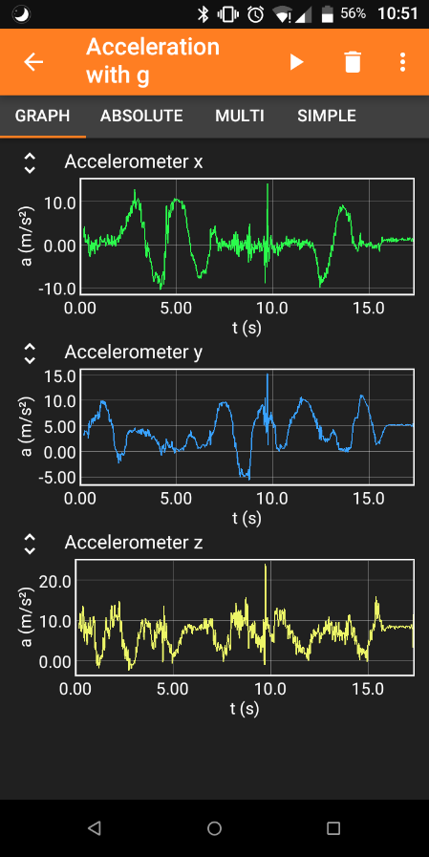Download: in all common app stores

1. **Step: Start your experiment**

**(B)**

**(C)**

* 1. Launch the app on your smartphone.
  2. On the start page, all sensors that you can read out are displayed. Select the desired sensor.

1. **Step: Record your data**
   1. Click the play button () to start data collection (A).
   2. In the tabs, the data is displayed graphically and numerically in real time (B).
   3. Click the Pause button () to pause/stop your data collection.
2. **Step: Save your data**
   1. Click the three dots () to open the menu (C). Select **Export data** (D).
   2. Select the desired data format (usually *Excel*) (E). Press **OK** (F).
   3. Save the file to the desired program (local memory or a file management app such as *Total Commander* that receives the file).
   4. Transfer the file via cable, *Bluetooth*, *Airdrop,* or Internet to the data analysis computer.

**(F)**

**(E)**

**(D)**

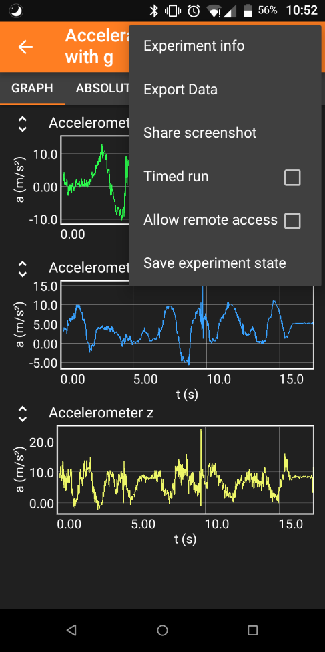Ein Bild, das Text enthält.
