This document has been created as a part of the Erasmus+ -project “Developing Digital Physics Laboratory Work for Distance Learning” (DigiPhysLab). More info: [www.jyu.fi/digiphyslab](http://www.jyu.fi/digiphyslab)

Freely rotating smartphone

Instructor version

24.2.2023

[Creative Commons License](https://creativecommons.org/licenses/by-sa/4.0/)  
This work is licensed under a [Creative Commons Attribution-ShareAlike 4.0 International License](https://creativecommons.org/licenses/by-sa/4.0/).

# Freely rotating smartphone – Instructor version

## Task Overview

* Topic: Investigation of the properties of free rotations
* Target group: Physics and physics teacher training students in the introductory phase
* Time frame: approx. 10-15 hours including data analysis, but excluding poster creation
* Recommended social form: In pairs or groups (2-3 students per group)

## Preparation

The aim of the experiment is to investigate the properties of free rotations of a smartphone in free fall, whereby the (in)stability of the individual rotation axes is also to be investigated. For the appropriate physical investigation of this topic, it is necessary to familiarize the students with the theory of free rotations, in particular the concepts of moment of inertia, rotational energy, etc. To do so, the introductory tasks in the task description can be used, which already use the dimensions of the smartphone to, for example, calculate its moment of inertia. The data is recorded with *phyphox*, for which instructions on how to install and get started are provided in the materials. Optionally, a *jupyter* notebook is available that includes the essential steps for data analysis. However, the data analysis can also be done using *Excel*, *Origin* or *SciDAVis*. For the latter program, instructions are also provided in the task documents.

## Set-up and implementation

The gyroscope sensor of the smartphone is used to conduct the experiment. This directly provides the angular velocities around the three main rotation axes of the smartphone. (The respective orientation/designation of the axes is device-specific and must therefore be determined in advance for each device.) Most gyroscope sensors have a maximum value up to which angular velocities can be measured. In the devices we tested, this was about 35 rad/s. The example results below show that such angular velocities can actually occur in this experiment and then the actual angular velocities can no longer be measured because only the (constant) maximum value is output. When carrying out the experiment, it is therefore always important to ensure that the smartphone is only rotated so much that the corresponding angular velocities can still be measured so that meaningful data analysis is possible.

The experiment itself is divided into two parts. In the first part, the moment of inertia of the smartphone will be determined experimentally with respect to its three main axes of rotation. All you need is a base and the gyroscope of the smartphone, which then measures a 90° tilting process of the smartphone around its three outer edges. The angular velocities at impact can then be used to determine the moment of inertia of the smartphone when rotating about the three outer edges and, with the help of Steiner's theorem, also with respect to the three main axes of rotation through the smartphone's center of gravity. However, depending on the length of the edge, different measurement uncertainties can occur here, which must then be taken into account.

In the second part, rotational movements of the smartphone in free fall are examined. Here, the smartphone is set in rotation by a twisting motion in the wrist with respect to one of the three main rotation axes and then dropped freely. To avoid damage to the smartphone, a soft surface is needed to mitigate the impact. It is recommended to use a sofa, a mattress or similar, since a pillow might be too small and certain horizontal movement of the phone can be caused by the throw and the impact.

When initiating rotational motion, the main axis of rotation can be aligned either parallel or perpendicular to the horizon; other movements are rather difficult coordinatively. This alignment should have little effect on the data/results. The initial orientation of the smartphone and the axis around which the rotation was initiated should be documented. This can also be done, for example, by recording the data from the accelerometer during the experiment.

In the further course of the experiment, additional objects are attached to the smartphone to change its moment of inertia (or susceptibility to air friction). Attention must be paid to a stable attachment so that there is as little play as possible between the object and the smartphone. When initiating the rotational movement, it may then make more sense, depending on the object, to hold the smartphone or the object in your hand and set it into rotation.

## Transferring the data to the PC

There are three main methods available for data transmission:

1. One option is to use the remote-control function offered by *phyphox*. Here, the data recorded by the smartphone is transferred to a computer in real-time (only works with appropriate network availability). It is also possible to start and stop recording remotely.
2. The data is transferred directly to the computer via e-mail, Bluetooth, airdrop, etc.
3. *Only useful for Android devices*: The data is initially stored on the smartphone. Since *phyphox* cannot access the internal memory directly, this requires a file management app such as *TotalCommander*, which can receive the file and save it internally. The file can then be transferred, e.g., via data cable or e-mail.

## Data analysis

A central goal in the course of the data analysis in this task is the representation of the angular velocity around all three main rotation axes as a function of time, in order to be able to draw conclusions concerning the stability and instability of the individual rotational movements. For this (and for the other analysis steps), the data must be prepared accordingly. The following aspects should be pointed out:

* The relevant data must be selected from the data set. Only the periods in which the intended rotational movement took place are to be selected. Otherwise, other artifacts (e.g. moving the smartphone when starting/stopping data recording) will affect the results. The rotational movement is easy to identify.
* Unlike in many other experiments, it makes sense to look at the angular velocities around all three main rotation axes of the smartphone. By comparing the angular velocities around these three main axes of rotation, it is easier to identify stable and unstable axes. It is crucial that for each measurement process, the main rotation axis around which the rotation was initiated was documented beforehand.
* In the course of the experiment, various rotational movements are generated and measured. These must be analyzed and discussed separately. An average of results from different measurement repetitions does not make sense since the initial displacement of the smartphone in rotation is manual and therefore not reproducible. This can be discussed accordingly with the students.
* In many parts, the data analysis is more qualitative than quantitative. When determining the moment of inertia of the smartphone from the tilting process, a quantitative data analysis is possible and useful in any case (including Gaussian measurement uncertainty propagation). In the investigation of the actual rotational movements, it is otherwise mainly a matter of graphically representing and interpreting the measurement data (Which axes are stable/unstable? ) and to compare (What is the difference between rotation processes that were initially triggered around different main rotation axes? What influence do the modifications of the rotational body have on the results?). Nevertheless, angular momentum and rotational energies for different points in time can also be calculated from the measurement data (in this case, Gaussian measurement uncertainty propagation makes sense again) and in this way, for example, the conservation of angular momentum and energy can be investigated.

## Expected results

First, the three moments of inertia of the smartphone are determined with respect to the rotation around its three main axes. This can be done both theoretically (by measuring the lengths and mass and then calculating) or experimentally using the tilting test according to Kaps & Stallmach (2020). Examples of student results are shown in the following table:

|  |  |  |  |
| --- | --- | --- | --- |
| **Smartphone** | $I_{x}$**in g $∙{\text{m}}^{2}$** | $I_{y}$**in g $∙{\text{m}}^{2}$** | $I_{z}$**in g $∙{\text{m}}^{2}$** |
| theoretical | 0,309 $±0,002$ | 0,0720,001 $±$ | 0,379 $±0,006$ |
| experimental | 0,452 $±0,033$ | 0,087015 $±0,$ | 0,521 $±0,053$ |

It can be seen that the results do not always agree even in the context of the measurement uncertainties. Here, the students should discuss in detail which measurement uncertainties exist and how they can be meaningfully quantified.

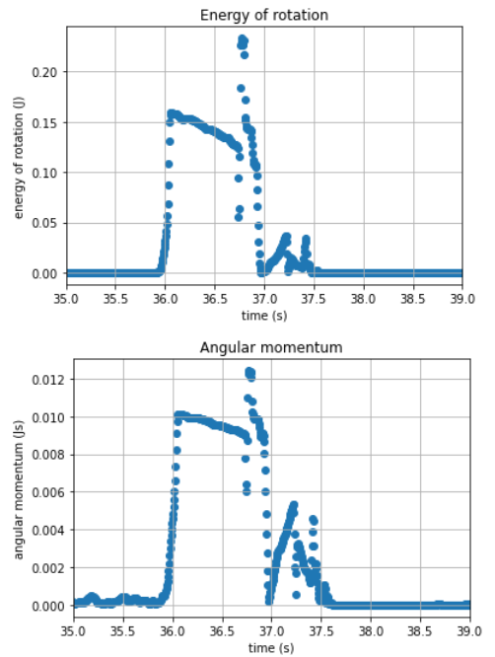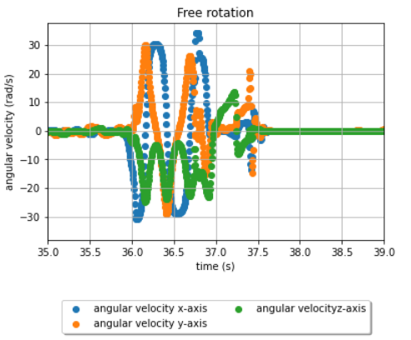As the students can independently develop within the framework of the preparatory tasks, rotations around two axes (here y- and z-axis) are stable and an unstable rotation can be observed around the other axis (here x-axis) (see Figures 1 to 3). The rotational energy and the total angular momentum remain roughly constant over time in all three rotational movements until the smartphone hits the ground; the slight decrease is due to frictional effects caused by air resistance. Wheatland et al. (2021) describe how the effect on the angular momentum caused by air friction can be quantified. But also a purely qualitative description of the behavior of the angular momentum is possible.

Figure 1: Angular velocities along the three main axes of rotation of the smartphone and the rotational energy and total angular momentum over the time for a rotational motion initiated around the x-axis of the smartphone. It can be seen that this free rotation is unstable because the angular velocity oscillates around the x-axis.

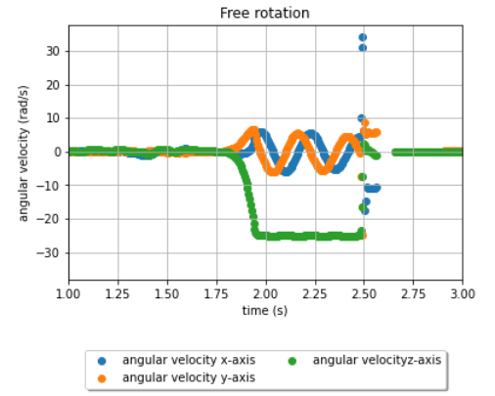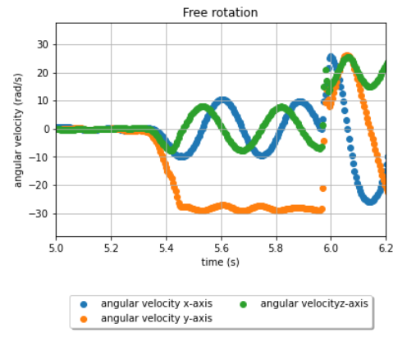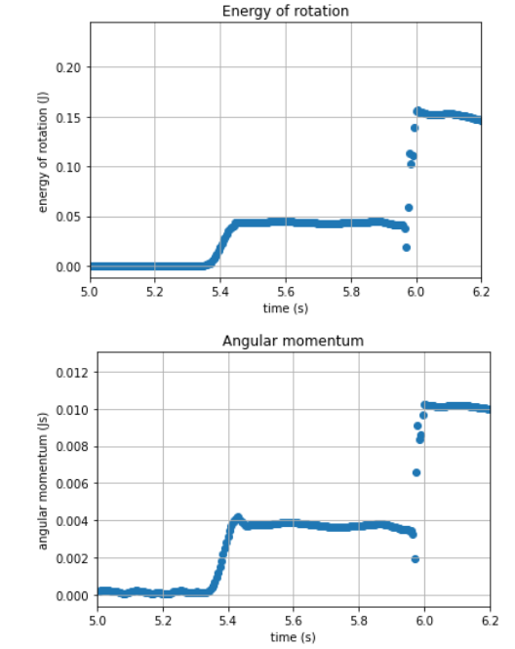Figure 2: Angular velocities along the three main axes of rotation of the smartphone and the rotational energy and total angular momentum over the time for a rotational motion initiated around the y-axis of the smartphone. It can be seen that this free rotation is stable because the angular velocity around the y-axis is approximately constant during movement.

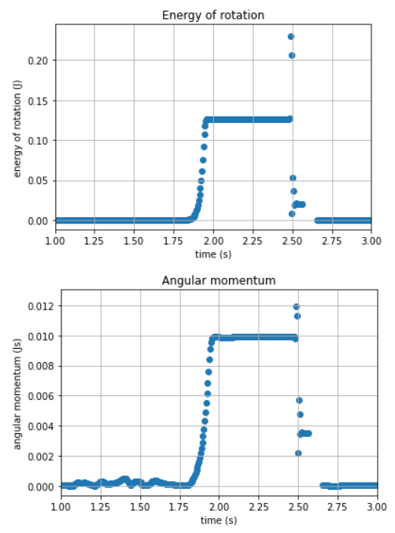

Figure 3 over the time for a rotational motion initiated around the z-axis of the smartphone. It can be seen that this free rotation is stable because the angular velocity around the z-axis is approximately constant during movement.

By gluing a narrow but elongated object (e.g., a rod), the rotational behavior can be changed so that a previously stable axis becomes unstable and correspondingly the previously unstable axis becomes stable when the relationships between the moments of inertia change. This is shown as an example in Figure 4.

Ein Bild, das Text enthält.
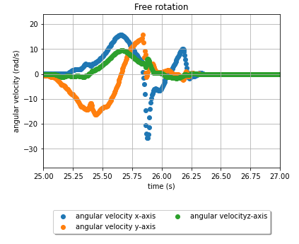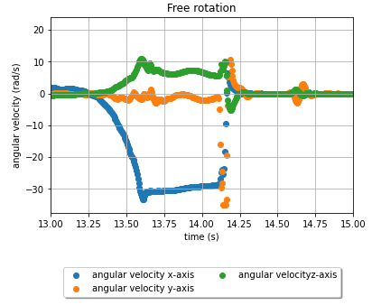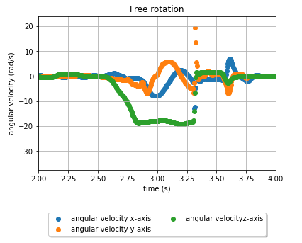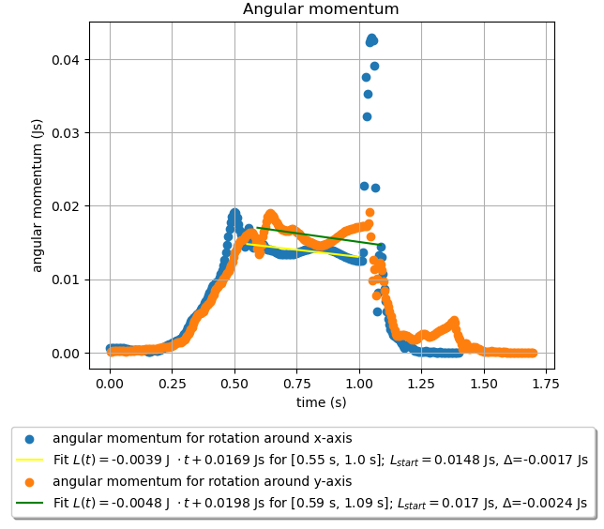

Figure 4: By attaching a rod to the smartphone along the x-axis of the smartphone (see photo), the rotational properties can be specifically changed. The rotation around the x-axis is shown in the upper left figure, which is now stable in contrast to Figure 1. The rotation around the y-axis is shown in the upper right figure, which is now unstable, unlike in Figure 2. At the bottom left, the rotation around the z-axis is shown; the comparison with Figure 3 shows that the rod has no influence on this rotational movement (the rotation around this axis is stable with and without a rod). At the bottom right, the total angular momentum for rotation around the x- and y-axes is shown. For the time interval [a, b] in which the actual rotational motion is exercised, the time-dependent angular momentum was modeled with a linear fit of the shape $L\left(t\right) = m⋅t+c$. This can be used to determine $L_{start}=L\left(a\right) Δ=L\left(a\right)-L\left(b\right)$. In both cases a slight decrease in the angular momentum of approx. 11% in rotation around the x-axis and 14% in rotation around the y-axis can be seen that is caused by air friction effects.

Ein Bild, das Text enthält.
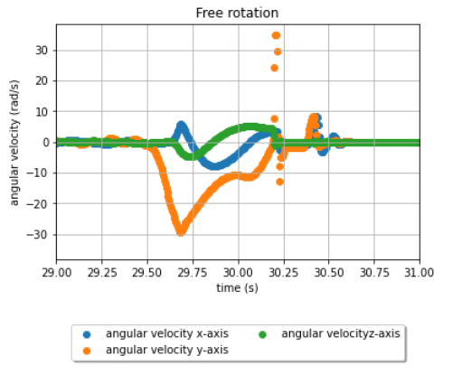Furthermore, it is possible to increase air resistance, e.g. by attaching a cardboard to the smartphone. Due to its low mass, it does not cause any significant change in the moments of inertia. However, (see Figure 5) a strong effect of air resistance on rotation can be seen, recognizable by the fact that during the rotation around the y-axis, which should actually be stable, the angular velocity (it’s magnitude) gradually decreases. The rotation is therefore slowed down and no longer stable.

Figure 5: Rotation of the smartphone around y-axis, which was attached to a piece of cardboard (see photo). The cardboard causes the angular velocity (its magnitude) to gradually decrease with respect to the actually stable y-axis.

## Possible forms of assessment

The processing results of the task preparation can, for example, be displayed on a scientific poster as suggested in the task document. In addition to information on the design, execution and analysis of the experiment, the poster should contain visualizations of angular velocities, angular momentum and rotational energies for different rotation axes and a reasoned decision as to which rotation axes of your smartphone are (in)stable. In addition, the modifications made to the rotational body and their influence on the properties of the rotation properties should be presented.

As an alternative to the poster, short presentations, laboratory reports or *computational essays* are also possible. The last two forms of assessment also allow a detailed description and discussion of details on the conduct of experiments and data analysis.

## Suggestions for modifying the experiment

In the context of the experiment, the following modifications/deepening are possible:

* In preparation for the actual experiment, this task determines the moment of inertia of a smartphone in a tilt test, as described by Kaps & Stallmach (2020). Referring to this article by Kaps & Stallmach (2020), there is also an Article Commentary by Hinrichsen (2022), in which suggestions are formulated on how the moment of inertia can be determined more precisely by a slightly modified experiment and another analysis method. It is crucial that not only the final rotational speed, but all other measurement data are also taken into account. With the help of this commentary, the students could understand, try out and compare the alternative determination methods themselves and at the same time understand the discursive, iterative process of scientific knowledge acquisition on a meta-level.
* As an alternative to attaching new objects to the smartphone when examining free rotation, it is also possible to compare the extent to which the results differ for different smartphone models.
* As the example results in the diagram above show, frictional effects also play a major role when attaching additional objects to the smartphone. The task can therefore also be deepened with regard to the influence of air friction on angular momentum and rotational energy (e.g., whether this is the same for each main axis of rotation, how the influence on the stability of the smartphone is, etc.).
* In addition to the modifications of the rotating body described in the task documents by sticking rigid objects to the smartphone, one can also attempt to investigate the rotational motion at a temporally changing center of gravity, according to Wheatland et al. (2021). This can be done, for example, by attaching a half-filled water bottle. However, the data interpretation is much more difficult here.

## Literature

The experiment task is inspired by the following two papers, which can also serve as preparation for the experiment:

Hinrichsen, P. F. (2022). Comment on "Tilting Motion and the Moment of Inertia of the Smartphone". *The Physics Teacher*, *60*, 223-225. <https://doi.org/10.1119/5.0061475>.

Kaps, A., & Stallmach, F. (2020). Tilting motion and the moment of inertia of the smartphone. *The Physis Teacher*, *58*, 216-217. <https://doi.org/10.1119/1.5145423>

Wheatland, M. S., Murphy, T., Naoumenko, D., Schijndel, D. van, & Katsifis, G. (2021). The mobile phone as a free-rotation laboratory. *American Journal of Physics*, *89*(4), 342–348. <https://doi.org/10.1119/10.0003380>