This document has been created as a part of the Erasmus+ -project “Developing Digital Physics Laboratory Work for Distance Learning” (DigiPhysLab). More info: [www.jyu.fi/digiphyslab](http://www.jyu.fi/digiphyslab)

Freely rotating smartphone

Student version

24.2.2023

[Creative Commons License](https://creativecommons.org/licenses/by-sa/4.0/)  
This work is licensed under a [Creative Commons Attribution-ShareAlike 4.0 International License](https://creativecommons.org/licenses/by-sa/4.0/).

# Freely rotating smartphone

## Motivation

In addition to translational movements, rotational movements also occur often. Many rotational movements have a predefined, fixed axis of rotation, e.g., at the drum of a washing machine in the spin cycle or turbines. But there are also many movements, especially in sports, in which such a clear axis of rotation is missing: When jumping from the ten-meter tower, you can experience for yourself that not all turns are possible without further ado and you sometimes have to bend strongly to create a certain jump. Various skateboard tricks also show that certain rotational movements are very stable when executed correctly (e.g. the monster flip, in which a perfect rotation around the middle axis of the skateboard can succeed, <https://www.youtube.com/watch?v=tT5dlPf4tVs> ), others are inherently unstable (e.g. the impossible flip, in which the rotation must be stabilized with the back of the foot to prevent rotation around the longitudinal axis of the skateboard, <https://www.youtube.com/watch?v=wCucgxqIRiA>).

Which laws follow free rotation movements can be easily investigated with a smartphone in free fall. The smartphone can be rotated in different directions by hand and then released. In free fall, it then performs a certain rotational movement. With the help of the sensors built into the smartphone, this movement process can be analyzed. The aim of this task is to examine the rotational properties and stability of the individual main components of your smartphone in free fall and to describe the physical properties. The aim is also to hypothesize and test how attaching additional objects to the smartphone (i.e. modifying the shape and mass distribution of your rotating body) affects rotation.

## Experimental materials

Smartphone with *phyphox*, scales, rigid objects to stick to the smartphone (get creative!), computer for data analysis, folding ruler, a soft surface (e.g., blanket to protect the smartphone - it is thrown!)

## Fostered experimental skills and content topics

**Experimental skills**: making & testing hypotheses, designing an experiment, collection of measurement data, analysis of data

**Topics Experimental physics:** free rotation, moment of inertia, air resistance **Mathematical methods:** multidimensional integrals, differential equations

**+ for physics students**: in-depth analysis of a problem

**+ for student teachers:** different forms of representation of movement

You will now receive the materials for the experiment *Freely rotating Smartphone*, in which you examine the rotation of your smartphone in free fall. Below, you will find materials to prepare for the experiment, followed by the actual task document for the experiment and the auxiliary materials (I) to (III).

### Preparation

Use the following supportive materials to prepare your content before planning and conducting your experiment. To do this, also edit the corresponding subtasks.

## Technical preparations

1. Please install the free app *phyphox* on your smartphone. Please check whether data from *phyphox* can be stored locally on your smartphone. For Android devices, this usually requires a free file management app such as *Total Commander*.
2. Please organize access to a program for data analysis. You can either use Python via browser-based jupyter notebooks (e.g., google colab or directly under jupyter.org) or SciDAVis or Origin.

## Content preparation I

1. **Read the following information text on the determination of moments of inertia of a smartphone and on free rotational movements without** a **fixed axis of rotation and work on the corresponding tasks.** The focus should be on a conceptual understanding of the relevant quantities (moment of inertia, rotational energy, etc.) and the comprehension of the formulas/derivations. For more information, read the paper by Wheatland et al. (2021): <https://aapt.scitation.org/doi/full/10.1119/10.0003380>

## Free rotation of a smartphone

**The smartphone**

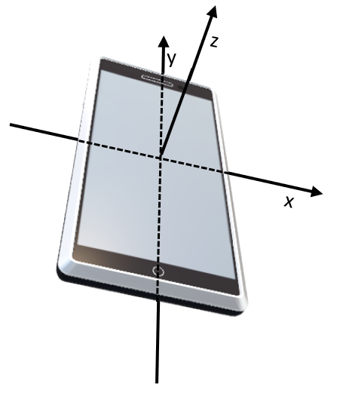A gyroscope sensor is installed in a smartphone to determine its spatial orientation. Gyroscopes often consist of three gimbal mounted spinning tops (see Figure 1) that can rotate depending on external influence. Due to the moment of inertia of the gyroscope, its orientation of the axis of rotation does not change when the smartphone is rotated. This allows the angular velocity to be specified for the three main axes of the smartphone during a rotation.





x

x

Figure 1: Structure of a gyroscope.

Figure 2: Smartphone with axes through the center of gravity. The orientation of the axes is different for each model. The derivation of the formulas in the text is based on the orientation shown here.

**The moment of inertia**

The rotational motion of a rigid body is largely determined by the moment of inertia, which results from the arrangement of its mass $m$ around the axis of rotation. A smartphone can be considered as a cuboid with the edge lengths $a,b$ and $c$. Assuming that the mass is homogeneously distributed in the cuboid, the moment of inertia can be determined by $I_{ϕ}=ρ\int_{V}{r^{2}dV}$, where $ρ=\frac{m}{a∙b∙c}$ is the density distribution and $r$ indicates the distance from a rotational axis $ϕ$. Thus, the angular momentum $L$ and the rotational energy $E_{\text{rot}}$ around the center of gravity can now be described by:

$L=I_{x}ω_{x}{\vec{e}}_{x}+I_{y}ω_{y}{\vec{e}}_{y}+I_{z}ω_{z}{\vec{e}}_{z}$ or $E_{\text{rot}}=\frac{1}{2}I_{x}ω_{x}^{2}+\frac{1}{2}I_{y}ω_{y}^{2}+\frac{1}{2}I_{z}ω_{z}^{2}$*.*

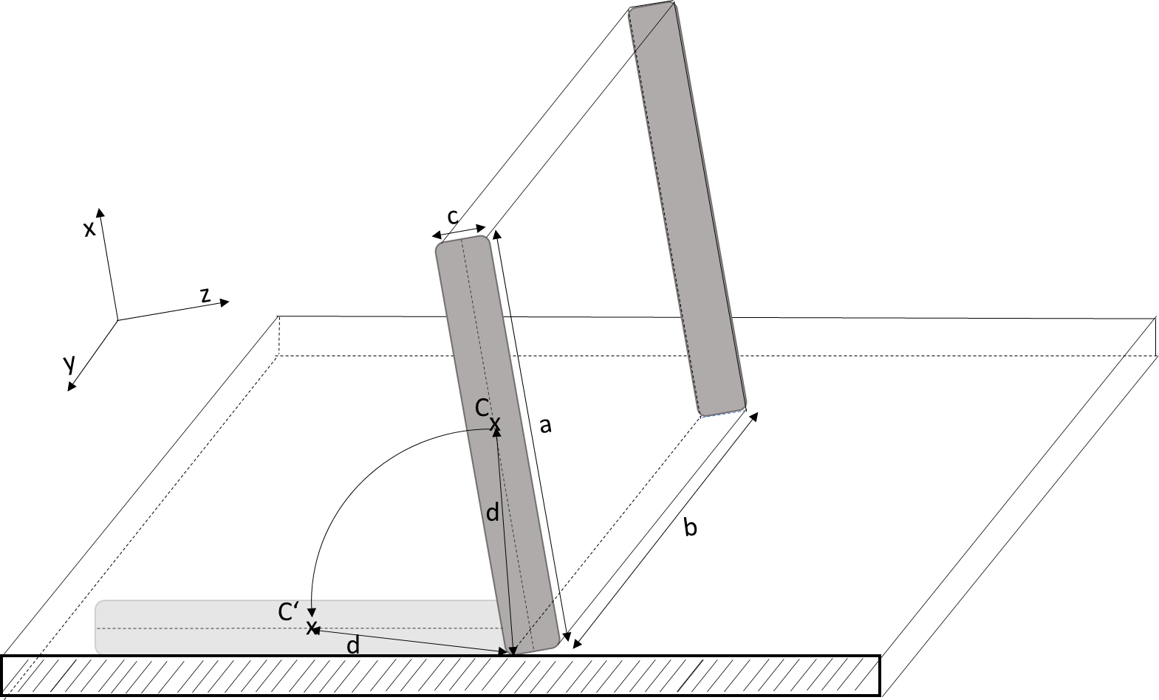

Figure 3: Sketch for the tilting process of the smartphone with edges a, b and c around its center of gravity C on a soft surface. The length d indicates how far the center of gravity C is from the axis of rotation at the beginning. The coordinate system corresponds to Figure 2; therefore, the origin is in the center of gravity C of the smartphone, unlike shown for clarity.

Alternatively, the moment of inertia can also be determined experimentally via a controlled tilting movement (cf. Kaps & Stallmach, 2020, <https://aapt.scitation.org/doi/full/10.1119/1.5145423>). The following example shows how the moment of inertia around the main $y$-axis of the smartphone running through the center of gravity can be determined. For this purpose, the smartphone is placed on a soft surface in equilibrium position perpendicular to the base on the longest edge $b$. The smartphone is then carefully rotated with respect to the desired axis of rotation (see edge at the bottom left of Figure 3) until the center of gravity $C$ of the smartphone is perpendicular to the axis of rotation. In this position, the center of gravity reaches the greatest distance to the base, which corresponds to the length of half a diagonal from one corner of the smartphone to the center of gravity $C$, i.e., $d=\frac{1}{2}\sqrt{a^{2}+c^{2}}$. If the smartphone now tilts to the wide side, almost all the potential energy is converted into rotational energy. Only the potential energy remains, which results from the fact that the center of gravity is still $\frac{c}{2}$ above the base after hitting it. Accordingly, the potential energy $E_{pot}= m∙g∙\left(d-\frac{c}{2}\right)$ is converted into rotational energy during the tilting process. It follows that $E_{rot}= \frac{I_{b}}{2}∙ω_{\text{max}}^{2}$ because at the time of impact, the angular velocity $ω$ and thus the rotational energy are at a maximum. Where $I_{b}$ is the moment of inertia of the smartphone with respect to the axis of rotation along the edge $b$. Due to the conservation of energy, the following applies:

$$\frac{I_{b}}{2}∙ω_{\text{max}}^{2}=m∙g∙\left(d-\frac{c}{2}\right)$$

Since the axis of rotation is parallel to the axis $y$ of the smartphone passing through the center of gravity $C$, Steiner's theorem can ultimately be applied to determine the moment of inertia $I_{y}$ so that $I_{y}=I_{b}-m∙d^{2}$ applies.

**Preparatory tasks for the moments of inertia of the smartphone:**

3a) Find out (e.g. through appropriate test measurements with *phyphox*) how the axes of your smartphone are named and aligned.

3b) Calculate the moments of inertia $I_{x},I_{y}$ and $I_{z}$ for your smartphone by explicitly calculating the integrals for rotations with respect to the respective axis. Research or measure the edge lengths and mass $m$ of your smartphone.

3c) Analogous to the example calculation $I_{y}$, set up a formula for the moments of inertia $I_{x}$ and $I_{z}$ depending on $ω_{max}$ and the dimensions of the phone. Perform the tilt experiment with respect to the three main axes of your smartphone ($x$-, $y$- and $z$-axis) and also empirically determine the three moments of inertia $I_{x},I_{y}$ and $I_{z}$ of your smartphone based on the maximum angular velocity. Compare your empirical results with the computational results from exercise 3b).

**Free rotation**

In the following, we now look at the central motion process that you are to investigate in this experiment: A smartphone is manually rotated with respect to one of its three main coordinate axes (origin of the coordinate system in the center of gravity of the smartphone) and then dropped freely. Under the assumption that no external torque acts on the center of gravity during the fall, e.g., by air resistance, Euler's equations apply:

$$I_{x}{\dot{ω}}_{x}=-(I_{y}-I_{z})ω_{y}ω_{z}$$

$$I_{y}{\dot{ω}}_{y}=-\left(I_{x}-I_{z}\right)ω_{x}ω_{z}$$

$$I_{z}{\dot{ω}}_{z}=-(I_{y}-I_{x})ω_{x}ω_{y}$$

which describe the relationship between angular velocities and moments of inertia as first-order differential equations. (For a derivation of these equations refer to the literature or to the paper by Wheatland et al.)

Of course, with regard to the problem formulated at the beginning, it is interesting to see which stable states are theoretically possible for the rotational movements. Such a stable state exists when the angular velocities along the three principal coordinate axes are constant in time, i.e., ${\dot{ω}}_{x}={\dot{ω}}_{y}={\dot{ω}}_{z}=0$. Since the moments of inertia $I_{x}$, $I_{y}$ and $I_{z}$ are generally different, this can only mean that

$$ω_{y}ω_{z}=ω_{x}ω_{z}=ω_{x}ω_{y}=0$$

must be fulfilled. Beyond the trivial solution ${ω_{x}=ω}_{y}=ω_{z}=0$ this is only possible if exactly one of the three cases occurs: $ω_{x}≠0$, $ω_{y}≠0$, or $ω_{z}≠0$, where in each case the other two angular velocities are equal to 0. This means that, according to these considerations, stable rotations are only possible if the body (the smartphone) rotates exactly around the $x$-, $y$-, or $z$-axis because a rotation with proportions with respect to more than one main rotation sequence would result in a temporal change in angular velocity, which would lead to an instability of the overall rotation.

In fact, it can even be shown that not even the three candidates found (rotation around $x$-, $y$- or $z$-axis) all allow stable rotation. You will show this yourself in the following.

**Preparatory tasks for free rotation:**

3d) Prove that for Euler's equations for the rotation of a rigid body with three different moments of inertia ( $I_{x}, I_{y}$ and $I_{z}$ pairwise different) without acting torque, there are only two stable rotational motions. Without loss of generality, assume that $I_{x}<I_{y}<I_{z}$.

* Consider separately the three cases where at time 0 a rotation is initiated around the $x$-, $y$- or $z$-axis and there are small time-dependent disturbances $\left(ε_{x},ε_{y},ε_{z}\right)$ with $|ε_{i}|≪ \frac{L}{I_{i}}$ for $i=x,y,z$. In Euler's equations, substitute $ω_{i}$ by $ω_{i}+ε_{i}$.
* Then, by appropriate combination of equations and substitutions, establish a new differential equation for $ε_{i}$ and look for solutions to this differential equation.
* Interpret these solutions in a physical context.

*Control solution:* You should be able to show that, under the assumptions made, a rotation around the $y$- and $z$-axis is stable, while a rotation around the $x$-axis is unstable. Unstable with respect to rotation around the $x$-axis means that even small perturbations $ε_{y}$ and $ε_{z}$ cause them to grow exponentially. Stable, e.g., with respect to the $z$-axis, means that small $ε_{x}$ and $ε_{y}$ do not grow exponentially, but rather lead to small oscillations.

3e) Based on the results from task 3d), make a prediction of how the angular velocities of the three main axes of your smartphone will behave when you initiate rotation around the $x$-, $y$- or $z$-axis. Sketch qualitatively the expected angular velocity-time-diagrams for all three coordinate axes per rotational motion (rotation around the $x$-, $y$- or $z$-axis).

## Content preparation II

1. **Read the instructions for the *app phyphox*** (**supportive material (I)). Try the workflow** with the data from any sensor (e.g., acceleration with/without $g$). Try out how you can read this data into your data analysis program.
2. **Read the instructions on using Jupyter.** **(supportive material (II)). In the notebook, you will find the basics for processing and presenting the data.** With these basics, the analysis of the data of your experiment should succeed well. Note which parameters are important for the analysis and which sources of error could occur. **Alternatively, if you use SciDAVis or OriginLab to evaluate the data, see supportive material (III).**

### The experiment

After preparation, you can plan and carry out your experiment. As described above, your task is toexamineand describe the **rotational characteristics and stability of the individual rotational axes of your smartphone in free fall. The aim is also to formulate and test hypotheses on how attaching additional objects to the smartphone (i.e., a modification of the shape and mass distribution of your rotating body) affects the rotation.**

Specifically, this results in the following subtasks:

* Using the tilting movement, first experimentally determine the moment of inertia of your smartphone with respect to rotation around the three main axes (see preparation task 3c).
* Put your smartphone into different rotations (around the three main rotation axes) and then drop it freely. Use your smartphone's sensors to record this movement. Graphically represent the angular velocity, rotational energy, and angular momentum of each rotation over time.
* Identify stable and unstable rotational axes on the basis of your data analysis and compare your results with your assumptions from the preparation task 3e). Also check to what extent energy and angular momentum are preserved during the movement process.
* Make specific hypotheses on how you can modify its rotation properties by attaching additional objects to your smartphone. Calculate the new moments of inertia of the composite body. Then re-perform measurements and data analysis to test your hypotheses. For example, you can try to convert an unstable axis of rotation into a stable axis of rotation or convert a stable axis of rotation into an unstable axis of rotation.

**Attention! Safety Note:**

* In this task, you will put your smartphone into a rotational motion in free fall. Therefore, make sure to use a soft surface and be careful when carrying out your experiment to avoid damage to your smartphone.
* When attaching different objects to your smartphone, it is advisable to wrap the smartphone in a clear plastic bag and attach it to other objects, e.g., to avoid scratches on the smartphone.

## Guiding questions for the experimental process

To structure your experimentation process, you can use the following questions for guidance:

1. Which measurement uncertainties occur when determining the moments of inertia of your smartphone (for both the computational and the experimental method) and what influence does this have on the data analysis?
2. What are the limitations (e.g., measurement uncertainties, measuring range) of the sensors you use? What impact does this have on your approach?
3. What influence do the initial position of your smartphone before rotation and the way in which the smartphone is rotated have on the actual rotational movement?
4. To what extent can you reproduce measurement processes and later take the measurement repetitions into account in the data analysis?
5. What other measurement uncertainties occur during the experiment? How can these be quantified?

## Guiding questions during and after the data analysis

During the data analysis, you can also use the following questions for guidance:

1. Which part of the data set is (ir-)relevant for further data analysis?
2. How do you estimate the precision of the experimentally and mathematically determined moments of inertia of your smartphone? How does this affect your results?
3. How can you graphically represent the determined angular velocities?
4. To what extent are the angular velocities in a realistic order of magnitude?
5. How can you identify in the measured angular velocities whether the rotation was stable or unstable for a rotation around one of the three main rotation axes of the smartphone?
6. How can you draw conclusions about the rotational energies and angular momentum from your measurement data, represent them graphically in a meaningful way and check the validity of the conservation laws for the different rotation objects? Also consider the extent to which the stability or instability of the axes of rotation should be reflected in the values for rotational energy and angular momentum.
7. How can you take into account the identified and quantified measurement uncertainties in the individual steps of the analysis ("error calculation")?
8. Which hypotheses regarding the influence of the properties of your rotational body on its rotational motion can you derive from your data analysis? Which experimental modifications are suitable for testing these hypotheses?

## Assessment

Create a scientific poster where you summarize your findings. This should include, but not be limited to, the following aspects:

* Information on the design, execution, and analysis of the experiment
* Visualizations of angular velocities, angular momentum, and rotational energies for different rotational axes
* Reasoned decision as to which rotational axes of your smartphone are (in)stable and what influence the modifications you have made to your rotation body.

## (I) Instructions for phyphox

*phyphox* is a free app with which all data from the sensors built into the smartphone can be read out. Below you will find a step-by-step guide on how to use this app to record measurement data.

**(A)**

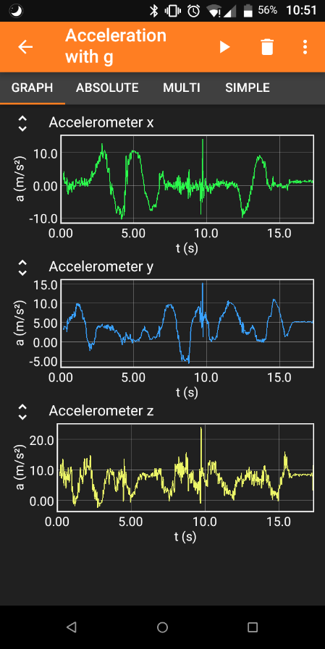Download: in all common app stores

1. **Step: Start your experiment**

**(B)**

**(C)**

* 1. Launch the app on your smartphone.
  2. On the start page, all sensors that you can read out are displayed. Select the desired sensor.

1. **Step: Record your data**
   1. Click the play button () to start data collection (A).
   2. In the tabs, the data is displayed graphically and numerically in real time (B).
   3. Click the Pause button () to pause/stop your data collection.
2. **Step: Save your data**
   1. Click the three dots () to open the menu (C). Select **Export data** (D).
   2. Select the desired data format (usually *Excel*) (E). Press **OK** (F).
   3. Save the file to the desired program (local memory or a file management app such as *Total Commander* that receives the file).
   4. Transfer the file via cable, *Bluetooth*, *Airdrop,* or Internet to the data analysis computer.

**(F)**

**(E)**

**(D)**

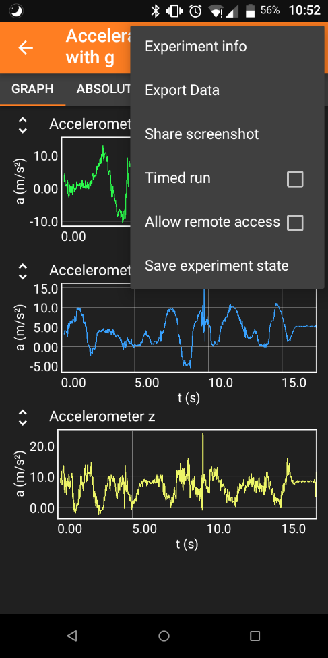Ein Bild, das Text enthält.

## (II) Instructions for Python

With *Python*, you are using a popular programming language in science, which can be used to analyse experimental data. The following instructions are for the jupyter notebook. Whichever platform you use, please upload the notebook and follow its instructions and later use python for your data analysis.

1. **Jupyter and Python**
   1. After launching *jupyter*, you will see the home screen. On the right, you can choose between various programs. We will work with Python notebooks.
   2. You will find a list with all your files in the sidebar on the left. Here you can create a folder for your project and take further actions by right-clicking. The program code can access files (e.g., raw data) uploaded to this directory and also store analysis files there.
   3. Upload and launch the **rotation_and_rolling_notebook_english.ipynb** file.
   4. The file consists of different cells to which you can add more using (A). With (B), you can change the type of cells. For programming, you need to use the type “**code**”.
   5. You can now write your programming code into the code cell and compile it using the play button (C). Once compiled, the variables are set for the entire notebook until you overwrite them or terminate the notebook (shutdown).

An image that contains text.

Automatically generated description

**(D)**

**(A)**

**(B)**

**(C)**

1. **Using the self-explanatory notebook**
   1. Work through the notebook to learn the basics on how data can be processed with *Python*.
2. **Working with data in your code**
   1. Create a text file in the folder of your project. To label it, you can use the file extension “*.dat”*.
   2. Open the Excel file with your data. Copy the relevant data columns into the text file.
   3. Remove empty lines and strings of letters and replace the decimal commas with periods (ctrl + f or edit (D)>> find...)

### (III) Instructions for SciDAVis

*SciDAVis* is a free data analysis tool similar to the licensed tools *Origin Pro* or *qtiplot*. Below you will find a step-by-step guide on how to use this tool to fit different formulas in a dataset.

Download for Windows: <https://sourceforge.net/projects/scidavis/>

Download for Mac: <https://sourceforge.net/projects/scidavis/files/SciDAVis-beta/>

1. **Step: Import your data**
   1. Extract the data from your data acquisition device. Copy the data to *Excel*.
   2. Select the data you want to analyze. Copy them to the table in *SciDAVis* (A). (Attention: *SciDAVis* can only distinguish columns and not rows or single cells like *Excel*.)
   3. On the right, you can adjust the settings for each column. Make sure that **numeric** is always selected as the **type**. Click **Apply** to save changes (B).
   4. 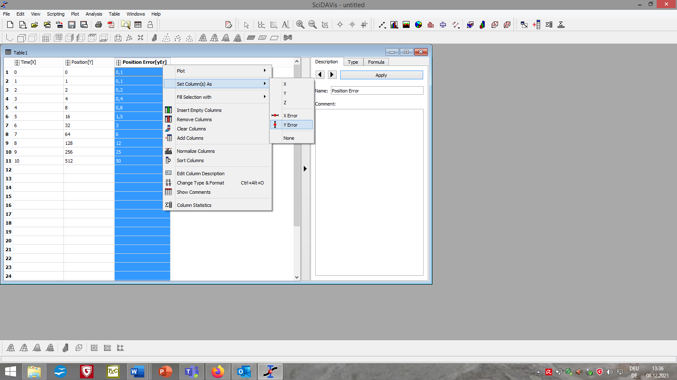Right-click the header and select **Set Column(s) as** you can determine which columns should contain $x$-, $y$-, $x$-error and $y$-error data (C).

**(A)**

**(B)**

**(C)**

1. **Step: Plot your data**
   1. Select the columns you want to plot. On the menu bar, click **Plot** à **Scatter** (D).
   2. 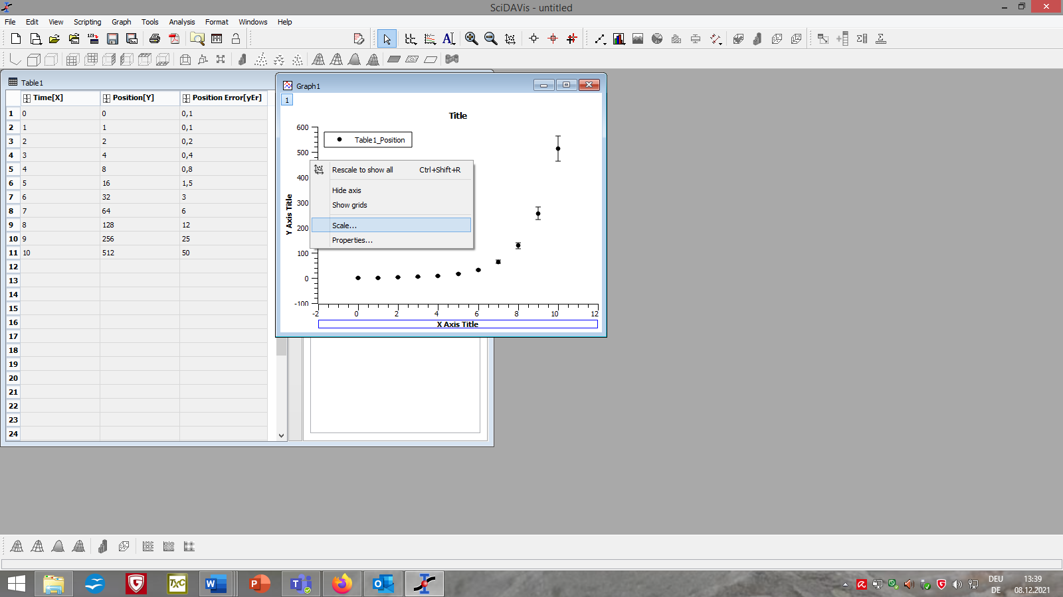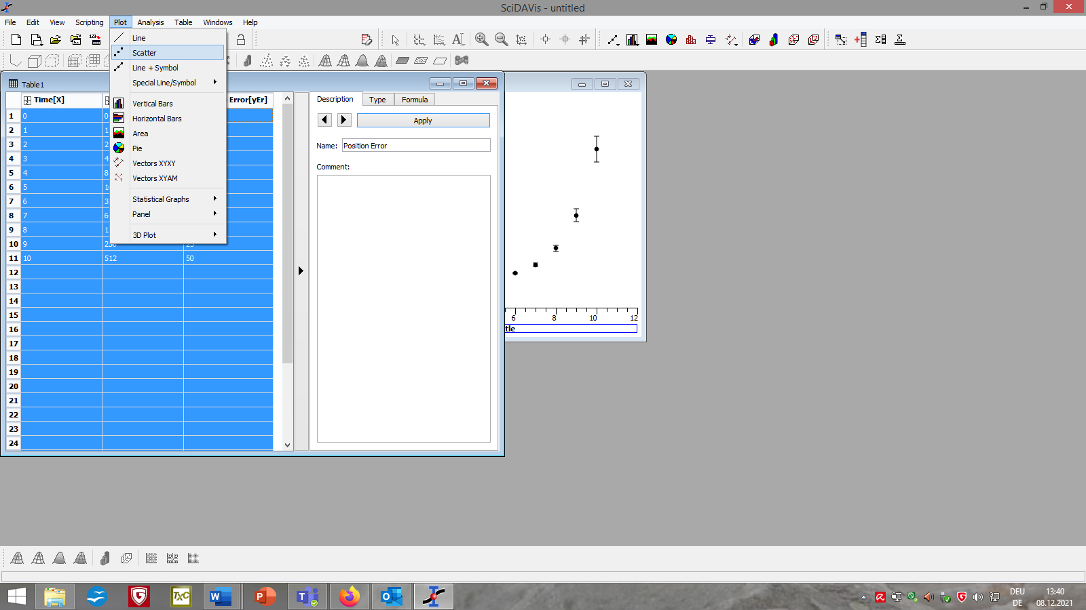By right-clicking the axes or background and select **Scale…** or **Properities…** you can customize the layout of your graph or delete unwanted fits (E).

**(E)**

**(D)**

1. 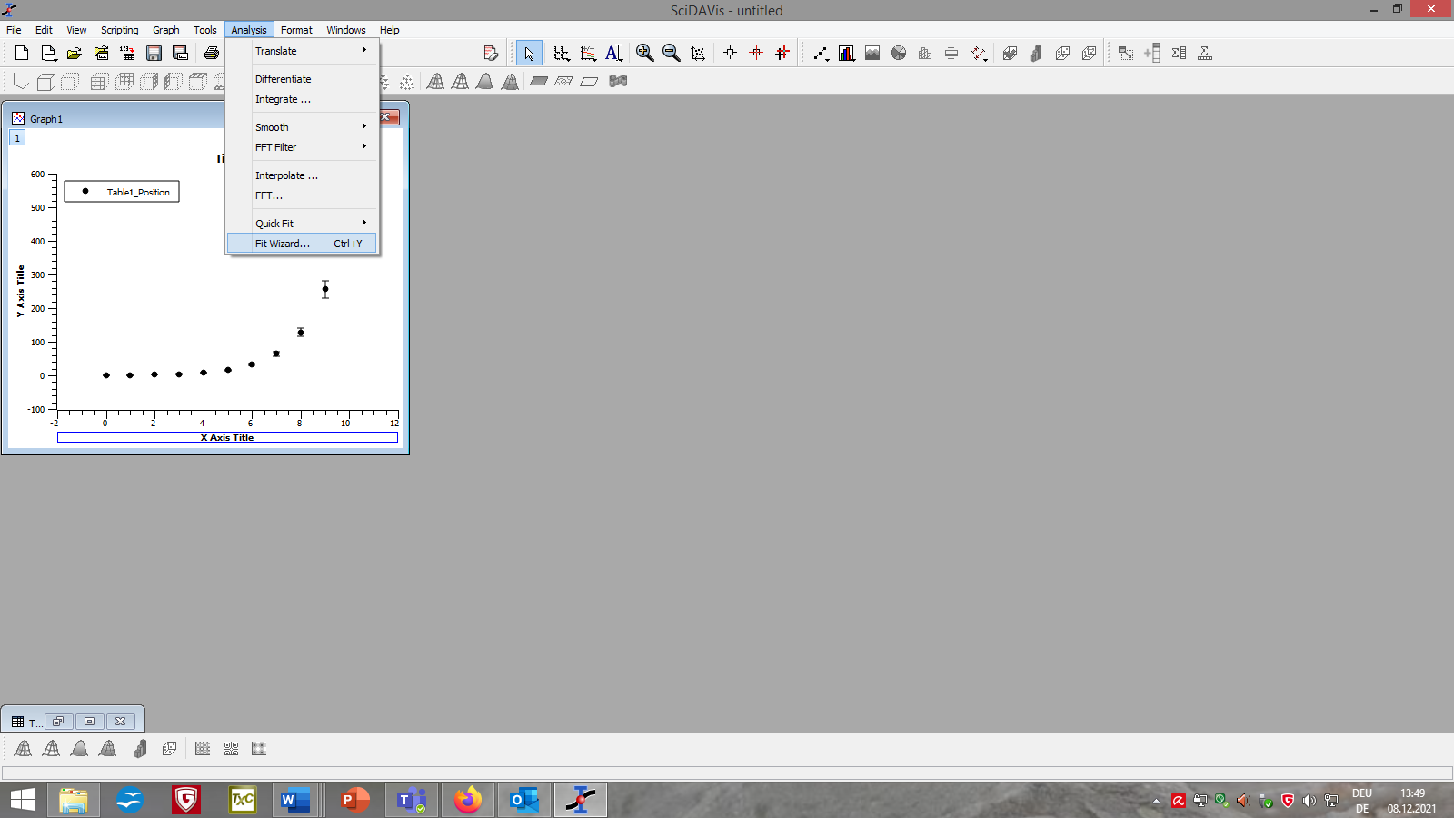**Step: Fit your data**
   1. Click on your graph. From the menu bar, select **Analysis** à **Fit Wizard...** (F)**.**
   2. Select **User defined** in the left column of the newly opened window (G).
   3. Choose a name for your fit function, list the parameters you want separated by a comma and add the formula of your fit function in the large field below (H).

**(F)**

* 1. Click **Save** (I) for later use of the function. Click **Fit >>** (J) to apply the function to your graph.
  2. If necessary, adjust the settings for the fit (e.g. the range of data points considered, the iterations and tolerance of the algorithm, or the source of the $y$-errors) (K).
  3. Use **initial guesses** (L) to tell the algorithm which values you theoretically expect for each parameter. Depending on your input, the fits will be different.
  4. At the bottom, click **Fit** (M). Close the window.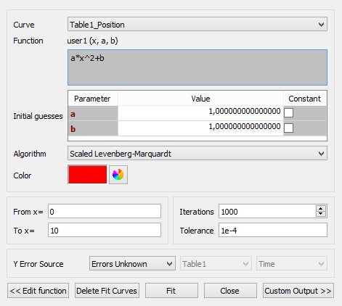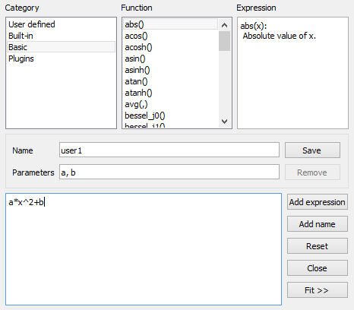

**(S)**

**(K)**

**(M)**

**(J)**

**(I)**

**(H)**

**(G)**

1. **Step: Evaluate your fit**
   1. The window **Results Log** appears automatically and receives various information about the data used and fit functions (N), the algorithm (O) and whether it was successful (P).
   2. You can also find the parameters of your fit with an error range (Q) calculated from the position of the data points and the -error.
   3. An image that contains text.

      Automatically generated description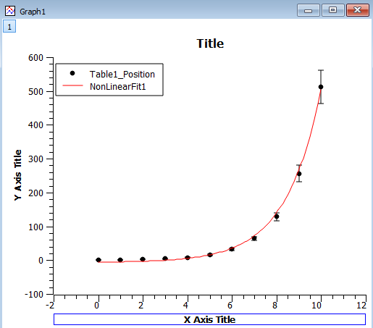You can also find the degree of certainty **R^2** (R) which describes on a scale from 0 (worst case) to 1 (optimal case) how well the data fits the model (used fit formula).

**(R)**

**(Q)**

**(P)**

**(O)**

**(N)**