This document has been created as a part of the Erasmus+ -project “Developing Digital Physics Laboratory Work for Distance Learning” (DigiPhysLab). More info: [www.jyu.fi/digiphyslab](http://www.jyu.fi/digiphyslab)

How to model a bottle?

Instructor version

12.1.2023

[Creative Commons License](https://creativecommons.org/licenses/by-sa/4.0/)  
This work is licensed under a [Creative Commons Attribution-ShareAlike 4.0 International License](https://creativecommons.org/licenses/by-sa/4.0/).

# How to model a bottle? – Instructor version

## Overview of the experiment

* Topic: Acoustics, standing waves, physical models
* Target group: Physics and physics teacher training students. Suitable for various phases of studies with varying openness of the experiment and the optional extra investigations.
* Timeframe: 2 to 2.5 hours for the basic task with reporting left as homework. 4 hours when including extra investigations. For students with little experience with graphing it is advised to reserve extra time for doing the graphs.
* Recommended to work in pairs

It is quite common in various study materials to refer to a bottle as an example when discussing standing waves forming in an open-closed tube. In this experiment students get to test this tube model and another model describing the resonance frequency of a bottle-like object (the Helmholtz resonator model).

An important note about this experiment is that students *very* often doubt themselves and their measurements when the measured frequencies do not line up with model predictions. There are interesting conversations to be had about what a model means, and how, even if you plan to use a model to interpret your experimental results, one should not go into an experiment expecting the model to be exactly correct.

## Required equipment

Smartphone (frequency analyzer), at least one bottle (long neck preferred), water, a measuring cup of one dl (100 ml) or similar, ruler or tape measure, graphing and analysis software. Spreadsheet software will also be useful. You can access the frequency data by using the free smartphone app phyphox (RWTH Aachen University) or Physics Toolbox Sensor Suite (Vieyra Software / Chystian Vieyra).

This experiment requires little preparation beforehand besides having the listed equipment available. Students will benefit of downloading and installing one of the free smartphone apps phyphox or Physics Toolbox Sensor Suite (or similar) before the session if the lab is done in presence. Especially in a distance learning scenario, make sure that students have access to a spreadsheet program and a graphing tool.

## Quick guide to the measuring apps

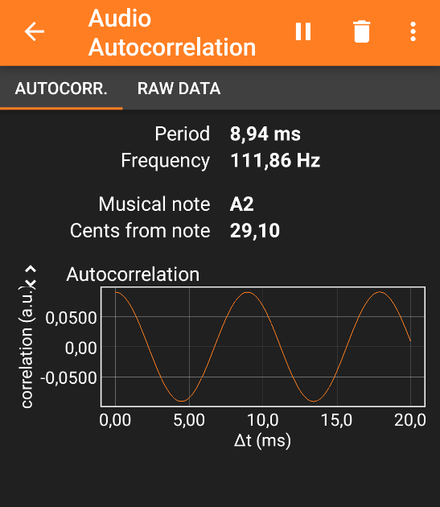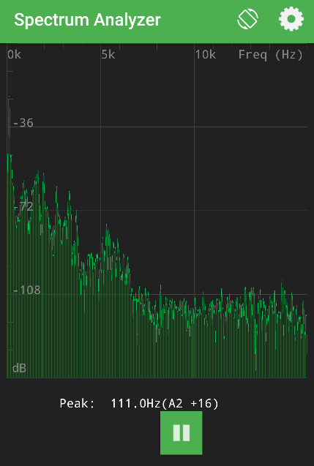

Figure 1: Example view of a measurement of frequency in the apps phyphox (left panel) and Physics Toolbox Sensor Suite (right panel).

For this experiment one needs a way to measure the frequency of a tone. There are lots of possibilities to do this, but in Figure 1 we have shown the tools Audio Autocorrelation from the app phyphox, and Spectrum Analyzer from the app Physics Toolbox Sensor Suite. When one starts the measurement, these tools give a numerical value of the frequency of the dominant peak in the spectrum. Note that there might be slight differences in these tools between for example the Android and iPhone versions of the apps. As a default, students are not given this information, but they should rather look for and make the decision of what tool best suits this measurement themselves.

## Key questions for the experimental process

To structure the experimentation process, one can give a subset of or the full list of following orienting questions and prompts to students:

1. What tools in your measuring app are suitable for the required measurements? What are the pros and cons of each of these tools?
2. Which variables are you able to change in your setup, and which variables are forced to be constant?
3. How many data points is reasonable to collect with the available equipment?
4. Does the way you blow on the bottle affect the frequency? What significance does this have on your experimental design?
5. Where does the bottle neck end and the bottle cavity start? How can you take this into account in your analysis?
6. Remember to estimate the measurement uncertainty.
7. How to probe the limits of the models?
8. How to represent the data in such a way that a comparison with the model predictions is the most effortless?
9. What are the important parts of this experiment to communicate to the audience of the presentation/report?
10. Reflect on other possible ways to test the models, and whether there would be other digital/analog measuring devices that could be used to do this experiment.
11. Reflect on what you learned in this experiment. What importance does this have for your further studies and your later professional activity?

## Example narrative with comments and suggestions

In its basic form the experiment is quite open and there is a lot of decision-making left for the student. In the following we will outline possible directions that the experiment can take and some common problems that students faced in our pilot runs.

#### Possible pre-lab exercise

Instructors might want to give the derivation of the Helmholtz resonance frequency (see below) as a pre-lab exercise. One could also ask for a written experiment plan from the students beforehand to be able to give feedback before experimentation.

#### Planning

Here the students need to consider a few things:

* Which tool in the measuring app they want to use?
  + Finding a suitable tool can require some testing. In phyphox, for example, possible tools are essentially Audio Autocorrelation, Frequency history, and Audio Spectrum. Of these Audio Autocorrelation gives the most straightforward way of obtaining a numerical value for the frequency. Audio Spectrum and Frequency history do not give the exact frequency directly, but with additional effort these tools are also usable.
* Which quantities to measure?
  + Essentially the quantities to measure are the volume of water in the bottle, the height of the air column in the bottle, frequency of sound for each water level, the inside radius/diameter of the bottle neck, the length of the bottle neck, and the volume of the bottle cavity. Some might plan measurements for the two models separately and some might do it in one go.
  + Defining where the bottle neck starts and becomes the bottle cavity is essential. It is interesting to think about the uncertainty involved in this.
* How many data points to take (how many water levels in the bottle)
  + This can depend on the size of the bottle and “resolution” set by the measuring cup in use. Data collection in this experiment is rather quick, so as many data points as possible is a reasonable choice. Some might be tempted to compare a model prediction to data in a single point and make conclusions, but a broader scope should be promoted. The decisions can always be revised later.
* How to estimate measuring uncertainty.

#### Testing the equipment

Finding the tool from the measuring app probably requires some testing. It is advisable to do some tests to familiarize with the digital tool and to make sure one is measuring the correct thing. One could check that the frequency changes when water is added to the bottle.

#### Data collection

Let’s use a standard long-necked wine bottle as an example. One first measures the relevant basic geometry of the bottle: inside diameter of the neck, length of the neck, and perhaps already the full volume of the bottle cavity. Then one can measure the frequency from the empty bottle and proceed to fill the bottle gradually with water in 0.5 dl (50 ml) or 1,0 dl (100 ml) steps, depending on the available measurement cup, while logging the frequency of sound, length of the air column in the bottle and the volume of water added. To estimate the volume of air in the bottle and to get data points when the bottle is filled up to the neck, one might need to add approximated smaller amounts of water.

One can then represent the data and model predictions as a function of the length of the air column, or the volume of air in the bottle cavity.

Some common problems and notes related to data collection:

* The apps can have problems with measuring the lowest frequencies for large bottles. If it is impossible to get a reading, consider adding some water to the bottle and see if higher frequencies are measurable.
* Even if there is no solid audible pitch from the bottle, it is possible that the resonance frequency is activated and measurable. If at some water levels there are problems in obtaining a solid sound, this could be checked.
* In one instance the measured frequency did not change even when a significant amount of water was added to the bottle. Restarting the app and the phone can help.
* In this stage students might feel like they are doing something wrong if the measured frequencies do not match the frequencies predicted by the models. It should be emphasized that the objective is to test the models, not prove them correct.

#### Data representation and analysis

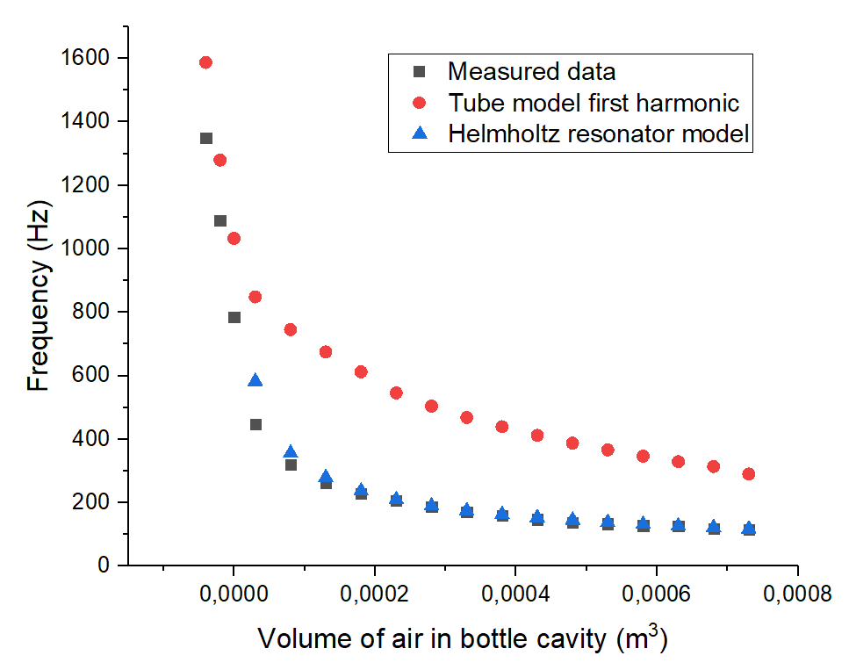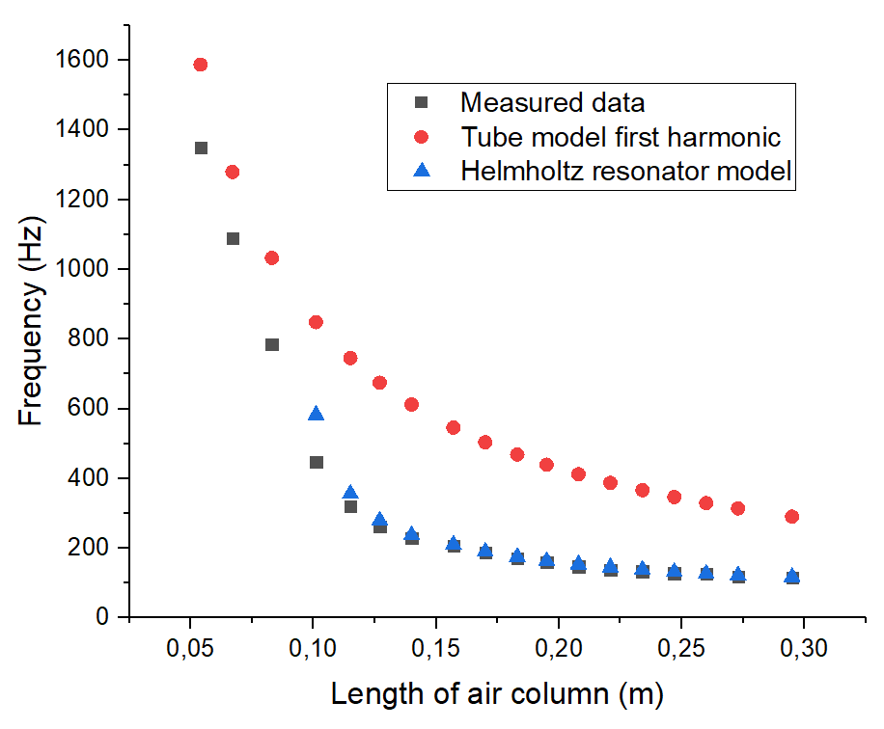Students may choose to represent their data using tables or figures. Arguably the most suitable way to present the data is to show both model predictions and measured data in the same figure.

Figure 2: Example figures (without error bars) of the frequency as a function of the length of the air column in the bottle (left panel) and as a function of the volume of air in the bottle cavity (right panel). The effective length is not accounted for in this figure.

Figure 2 shows examples of what the data might look like when the effective length is not accounted for. In Figure 3 we show results for both models in the same figure with error bars and with an estimate for the effective length taken from literature.

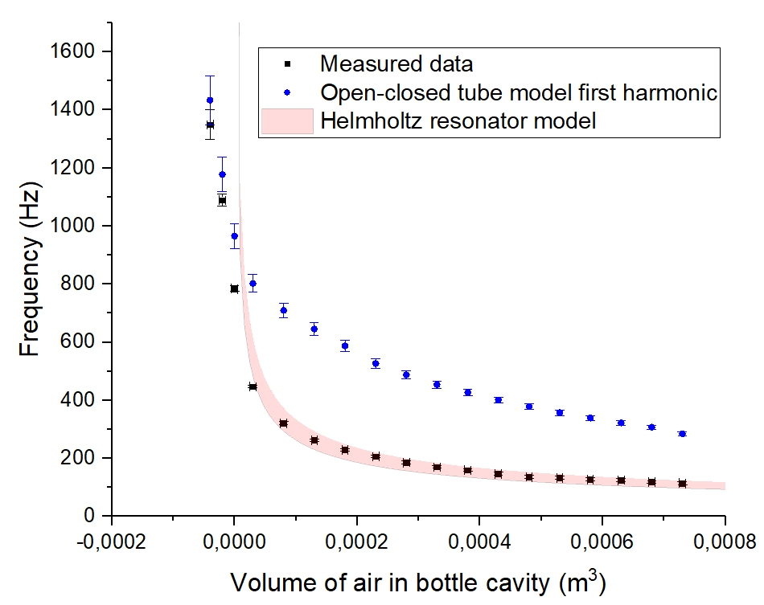

Figure 3: Example figure of the frequency as a function of the volume of air in the bottle cavity. The values a = 0.61 and a = 1.4 were used as the parameter for effective length for the open-closed tube and Helmholtz resonator models, respectively.

Here it is noteworthy that it is especially interesting to observe what happens when the bottle is filled close to the neck and beyond. Different shapes and sizes of the bottle of course affect the results a lot, and to be able to explore the limits of the models, a long-necked bottle is preferred.

Students may also attempt to linearize the graphs like in Figure 4 to better visualize the behavior of the data and model predictions with respect to the independent variable.

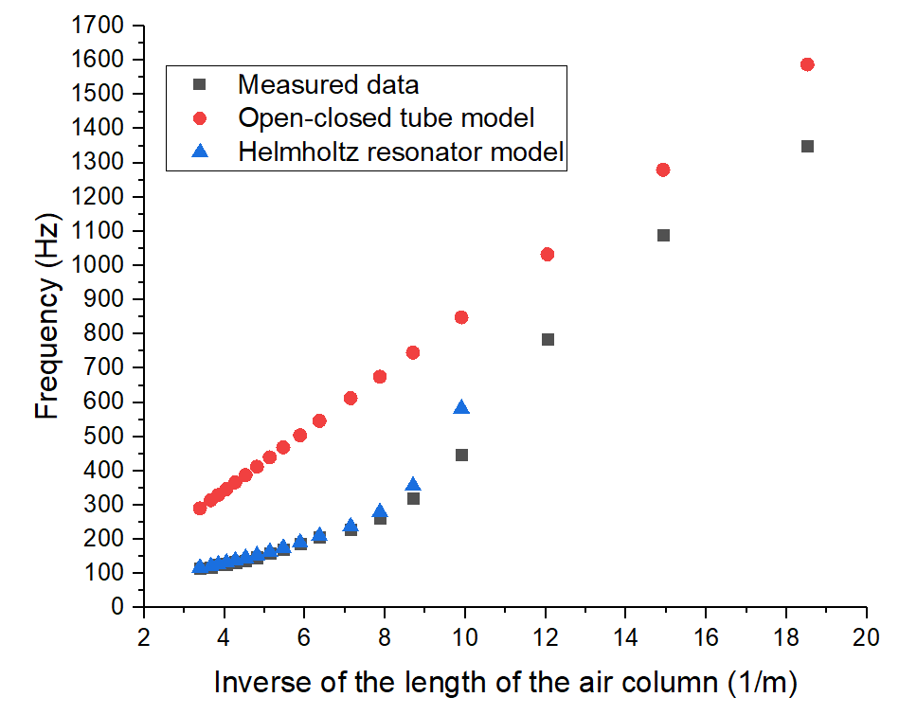

Figure 4: Example figure of the frequency as a function of the inverse of the length of the air column in the bottle. One can see that the data does not behave linearly like an open-closed tube, except when the bottle is filled up to the cylindrical neck.

#### Reporting

We have used a concise slideshow as an example of a report that students can create from this experiment. It is important that instructors provide students with their own criteria for what is expected of students in this assessment. The derivation of the Helmholtz resonance frequency can also be given as a post-lab exercise.

## Possible modifications

* If time for the experiment is limited, instructors might want to provide students with the tool to use in the measuring app (Audio autocorrelation in phyphox, for instance).
* More scaffolding can be provided to students in the data representation phase. Students may not be familiar with plotting more than one set of data points in one figure and providing instruction can aid students to practice this. One can also accept plots of the data with each model separately.

## Derivation of the Helmholtz resonance frequency

The derivation of the resonance frequency can be given as an assignment to students either before or after experimentation.

Let there be a mass *m* of air in the resonator neck of length *L*. When this air is displaced by a small length $γ$, the volume in the cavity becomes $V + δV$, and the pressure becomes $p + δp$. We can assume that this process is fast, and heat has no time to transfer. This is an adiabatic process, for which

$$pV^{γ}=constant,$$

and we can write

${pV}^{γ}=(p+δp){(V+δV)}^{γ}≈(p +δp) (V^{γ}+ γV^{γ-1}δV$) ,

${pV}^{γ}=pV^{γ}+pγV^{γ-1}δV +V^{γ}δp+ γV^{γ-1}δVδp$,

where $pV^{γ}$ cancels on both sides and $γV^{γ-1}δVδp$ is negligibly small. We get

$$\frac{δp}{p}=-γ\frac{δV}{V}.$$

Next, we will write down the equation of motion for the mass *m* of air in the resonator neck. The net force $F_{net}$ $a$ cting on the air is due to the pressure difference $δp$. We therefore have

$F_{\text{net}}=m\ddot{y}$, $F_\{net\}=m$

$Aδp=m\ddot{y} ,$

$$-γpA\frac{δV}{V}=m\ddot{y} ,$$

$$\ddot{y} = -\frac{γpA}{m}\frac{δV}{V}.$$

Now we can write $δV = yA$, $c=\sqrt{γ\frac{p}{ρ}}$, and $m=ρV_{\text{neck}}=ρAL$ to get

$$\ddot{y}+c^{2}\frac{A}{VL}y = 0.$$

The differential equation of a harmonic oscillator with angular frequency $ω$ is

$$\ddot{x}+ω^{2}x = 0.$$

Therefore, we identify the resonance frequency of the Helmholtz resonator as

$$f_{\text{H}}=\frac{c}{2π}\sqrt{\frac{A}{VL}}.$$