# Instructions for using digital technology

## PhyPhox

You can export the data you have collected in the PhyPhox app to your computer by selecting ***Export Data*** (in the menu at the right top of the app) à ***Excel format***, and then send them to your email (drive or any platform that you can access on your computer). Download the data to your computer and open it in Excel.

*You can always save the experimental data by**selecting* ***Save experiment state*** *in the menu. Data will then remain visible to you at the homepage of the app.*

## Excel

### Draw a graph

First, you need to select the data that you want to display in the graph ($a-t$). Select the time column by clicking the letter of that column. To select the second column with the first column still being selected, you must hold down **CTRL** when selecting a new column. (The data that is marked first will be the $x$-axis of the graph, and the one marked second $y$-axis of the graph)

Picture showing the table

Description is automatically generated

To draw a graph select ***Insert*** à ***Scatter*** à ***Scatter with Smooth Lines****.*

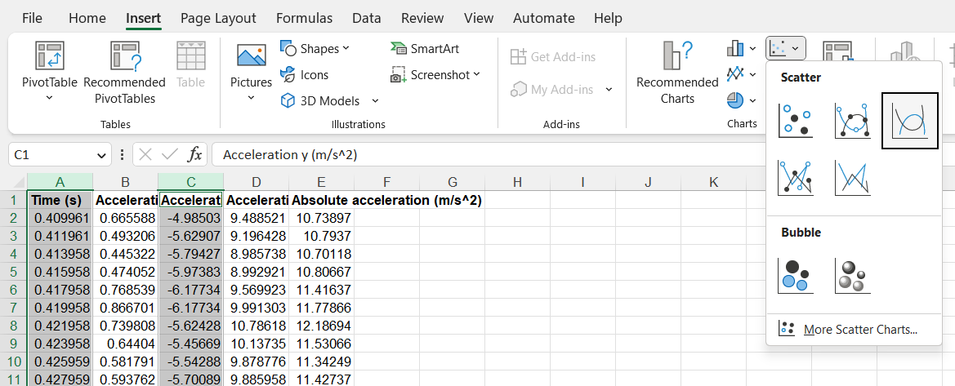

### Determination of mean and standard error

From the graph, determine in which time interval the acceleration is approximately constant. When you place the mouse cursor on a point on a graph, the coordinates of that point will appear on the screen.

Picture showing the table

Description is automatically generated

You can calculate the mean by using the **AVERAGE** function. In the cell where you want to calculate, type =AVERAGE( . Then select the array of cells for which you want to count the mean, close the parenthesis, and press Enter.

Picture showing the table

Description is automatically generated

Standard error of the mean can be calculated with the command **=STDEV(array of cells)/SQRT(n)**, where n is the number of data you have taken into the calculation. You can determine n with command **=COUNT(array of cells)**.

Picture showing the table

Description is automatically generated

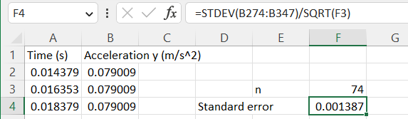

*Note: Make sure you start each command with "=" because without it, Excel will take your command as text.*