This document has been created as a part of the Erasmus+ -project “Developing Digital Physics Laboratory Work for Distance Learning” (DigiPhysLab). More info: [www.jyu.fi/digiphyslab](http://www.jyu.fi/digiphyslab)

Magnetic field

Student version

2.2.2023

[Creative Commons License](https://creativecommons.org/licenses/by-sa/4.0/)  
This work is licensed under a [Creative Commons Attribution-ShareAlike 4.0 International License](https://creativecommons.org/licenses/by-sa/4.0/).

# Magnetic field

In this task, you will use the *PhyPhox* application to measure the Earth's magnetic field as well as the magnetic field of a permanent magnet and determine how the magnetic field depends on the distance from the permanent magnet.

## I) Measurement of the Earth's magnetic field

1. Use the *PhyPhox* application in *Magnetometer* mode to measure the magnetic field. Take measurements in the *Simple* tab. When you start the measurement, which magnetic field does the mobile phone measure?

2. The sensor in the mobile phone measures the magnetic field components in *, $x, y$* and $z$ directions, and calculates the total magnitude of the magnetic field as the vector sum of the field components. Rotate the cell phone to find the $x, y$ and $z$ directions and draw them on the picture.

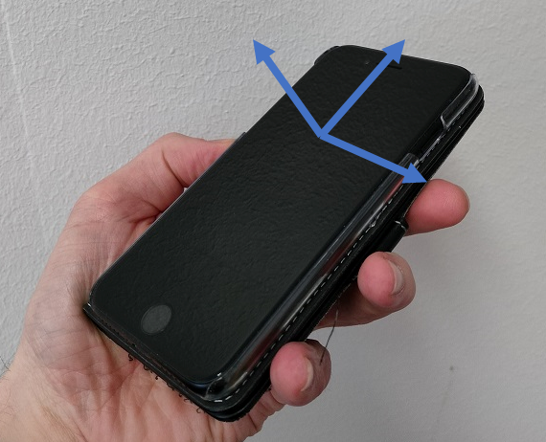

3. Determine the magnitude of the Earth's magnetic field and estimate the measurement error. How did you came to the estimated error?

4. Determine the direction of the Earth's magnetic field. When you find the direction of the magnetic field, point your finger in that direction. When you and all your colleagues have done so, take a group photo and attach it.

## II) Measuring magnetic field of a permanent magnet

**Research question:**

**How does the magnetic field of a permanent magnet depend on the distance from the permanent magnet?**

Equipment list: Mobile phone with *Phyphox* application, permanent magnet, paper, pen, ruler.

Design an experiment to determine how the magnetic field depends on the distance from the magnet. Before you start collecting and analyzing measurement data, answer the following questions:

What do I want to test with this experiment?

What is my prediction?

What physical quantities do I need to measure?

How will I measure those physical quantities?

How will I record the measurement data?

What does an experimental setup look like? (description or image)

5. Show the obtained measurements as a table and graph of the dependence of the magnetic field on the distance from the magnet made in *Excel*.

6. Can you conclude from the obtained graph what is the dependence of the magnetic field on the distance from the magnet?

To determine how the magnetic field of a permanent magnet depends on the distance from the permanent magnet, the equation has to be linear.

The magnetic field $B$ of the permanent magnet along the axis of symmetry is proportional to $x^{n}$

$$B= \frac{μ_{0}mx^{n}}{2π},$$

where $μ_{0}=4π∙{10}^{-7}\frac{Tm}{A}$ is vacuum permeability, $m$ is the magnetic moment, and $x$ is the distance from the permanent magnet.

Since $B$ is proportional to $x^{n}$, it is not a linear function. By logarithming the equation we can linearize it and get an expression similar to equation

$$y=ax+b,$$

and thus calculate the value of the exponent $n$.

By logarithming the expression we get:

$$\log{B=n\log\left(x\right)+\log\left(\frac{μ_{0}m}{2π}\right)}.$$

If we compare the obtained expression with the equation of direction, we see that:

$$y=log{B}$$

$$a=n$$

$x{=\log\left(x\right)}$

$b= log\left(\frac{μ_{0}m}{2π}\right)$

Attach the obtained $log \left(B\right)-{\log\left(x\right)}$ graph as an image of the graph obtained from *Excel*.

*Note*: Read the instructions for Excel.

8. What can you conclude from the analysis of your measurements, how does the magnetic field of a permanent magnet depend on the distance from the permanent magnet?

9. Additional task: Determine the magnetic moment $m$ from the obtained measurement results.