This document has been created as a part of the Erasmus+ -project “Developing Digital Physics Laboratory Work for Distance Learning” (DigiPhysLab). More info: [www.jyu.fi/digiphyslab](http://www.jyu.fi/digiphyslab)

Paper Parachute

Instructor version

15.3.2022

[Creative Commons License](https://creativecommons.org/licenses/by-sa/4.0/)  
This work is licensed under a [Creative Commons Attribution-ShareAlike 4.0 International License](https://creativecommons.org/licenses/by-sa/4.0/).

# Paper parachute – Instructor version

## Overview of the experiment

* Topic: Mechanics, air resistance, trends
* Target group: Physics and physics teacher training students. Suitable for various phases of studies with varying openness of the experiment.
* Timeframe: At least 4 hours for planning, data taking, and analysis. More time needed for possible reporting and further revising the experimental design.
* Recommended to work in pairs.

The objective of this task is to experimentally observe the trend of the drag force versus the vertical speed of a falling object. Students get to deal with problems involved in measuring acceleration accurately, and processing data with random noise.

## Required equipment

Smartphone (camera), Computer with tracker software (for example https://tracker.physlets.org/), a way to measure length or a known reference length, muffin cups, coffee filters, or similar light conical paper objects. Spreadsheet software and software for graphing and analysis will be useful. A cable for data transfer from the phone to computer can be used.

This experiment requires some preparation beforehand besides having the listed equipment available. If done on campus, students should install Tracker and do a simple video analysis like the example exercise in the student document, restated below.

**Pre-lab exercise**: download and install tracker (https://tracker.physlets.org/). Take a video of an object (ball, pen, etc) in free fall, and get to know Tracker by tracking the object’s position. You can follow the instructions on https://tracker.physlets.org/help/frameset.html, pages Installation and Getting started.

## Guide to Tracker

In addition to the instruction sheet and online instructions provided for using Tracker, we have made the following notes:

* Tracker does not work on a Chromebook. Other similar software might exist for Chromebook.
* Doing data analysis on Tracker can sometimes cause the program to freeze (Tracker 5.1.5). It is usually better to export the data and use a separate graphing and analysis tool. There have been no issues with obtaining the position/velocity/acceleration data.

## Key questions for the experimental process

To structure the experimentation process, one can give a subset of or the full list of following orienting questions and prompts to students:

1. Remember to make tests before committing to an experimental idea in your design.
2. How does the distance from the camera affect the measurement of the object’s position from the video?
3. What forces act on the object while it is falling?
4. What does Newton’s II law say about these forces?
5. What is the acceleration that is measured in Tracker?
6. Remember to estimate the measurement uncertainty.
7. Only make conclusions that can be backed up by collected data. Remember that an experiment can be inconclusive.
8. Reflect on other digital/analog instruments that this experiment could also have been carried out with.
9. Reflect on what you learned in this experiment. What importance does this have for your further studies and your later professional activity?

During our pilot runs students had some difficulties in figuring out how to obtain the magnitude of air resistance from the acceleration data. Another part where guidance was needed was representing the data in a suitable graph, and how to achieve this technically. The above questions can help students especially in a distance-learning scenario, but this experiment can benefit from doing some parts on-site with instructors available.

## Example narrative with comments and suggestions

While the pre-set method of using video analysis narrows down the decision making the students face in this experiment, there is still plenty of openness in the experimental setup. In the following we will outline possible directions that the experiment can take and some common problems that the students faced in our pilot runs.

#### Planning

It is advisable that the students come up with a plan for what measurements they need to perform to obtain the desired result before jumping into experimentation. The process can be iterative, and the first plan probably needs to be changed along the way. Some things that students need to consider:

* What quantities are they able to measure from a video with Tracker? How does this relate to air resistance?
  + Students need to acquire acceleration data for the falling object. This total acceleration can be related to the forces (gravitation and air resistance) acting on the object.
* How to set up the video so that it’s easy to calibrate the height of the fall, and to minimize error from perspective?
  + Setting a reference length (for example an open door) and dropping the objects in the same plane with the reference length. Increasing distance from the camera makes the error from perspective smaller, at least until the distance starts to affect the clarity of the object.
* How to make use of more than one muffin cup, coffee filter, or other paper object?
  + By stacking the objects, one can alter the mass while keeping constant the area perpendicular to the motion. Therefore, the air resistance should remain the same, but acceleration changes due to the increase in the gravitational force.

#### Testing the equipment

Here it is strongly advisable that the students test their idea by taking and analyzing one video first. Then they can make changes based on findings before committing fully to their method. One might for instance realize after the first analysis, that dropping the cones from a 2 meters height would better serve the purpose than dropping from 1 meter height.

#### Data collection

Students can collect data from dropping, say, one to five stacked objects, taking a video of each fall. Another choice could be to analyze videos of two or more different objects, perhaps also stacking a few of each.

#### Data analysis

Students should collect data which they are able to represent in a graph of air resistance as a function of the object’s vertical speed. For this one needs the speed and acceleration data in the vertical direction obtained via Tracker. Only the part of the video where the object is actually falling should be analyzed. Tracker gives the total acceleration of the object, which is related to the total force acting on the object via Newton’s II law. Assuming only gravitation and air resistance act on the object, one can access the magnitude of air resistance as a function of time.

One then tries to find a suitable fit that follows the trend in the data. A typical outcome here is that there is a clear dependence of air resistance on the speed in the data, but it is difficult to say whether the dependence is linear or quadratic. Students may proceed to discuss and think about possible ways to reduce the uncertainty or collect more data to make a more robust conclusion. In Figure 1 we show example data which by eye appears more quadratic than linear, and it could contain some systematic error (intercept is not zero). Students could, for example, explore a linear and quadratic fit and argue which better describes the behavior of the data.

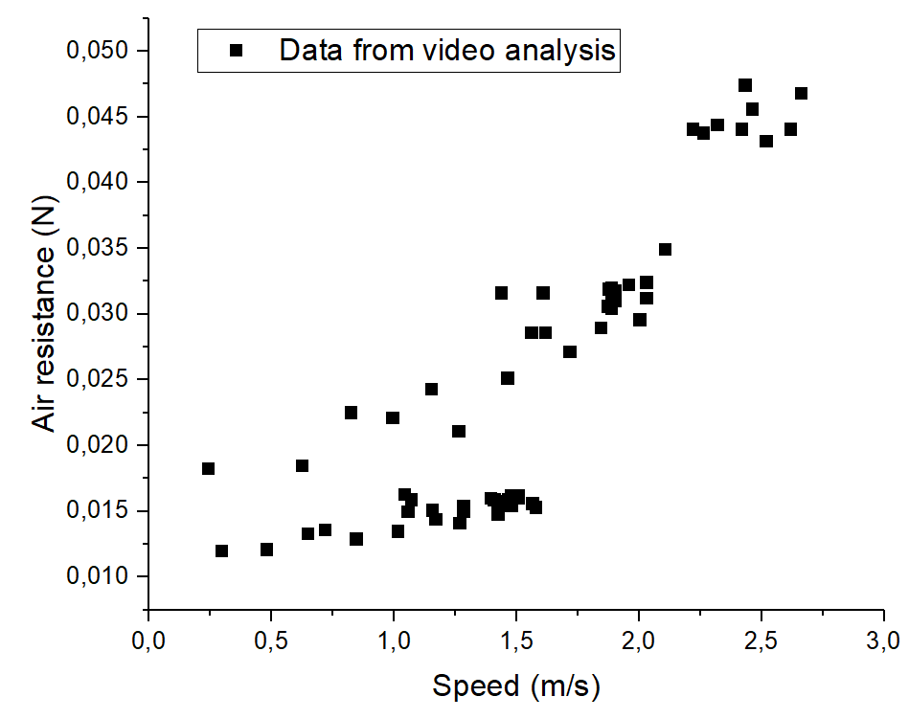

Figure 1: Example data obtained by tracking the fall of one, two, and three stacked round coffee filters.

#### Reporting

We have used an oral assessment discussion with an instructor as an example of how to assess this experiment. The data collected in this experiment is typically not as clean nor the conclusions as clear-cut as in traditional lab exercises. There is very fruitful discussion to be had about the choices made in data collection, problems encountered during experimentation, and the interpretation of data. In a discussion with the instructor, students can practice delivering evidence-based argumentation to back up their conclusions, while also being able to ask about things remaining unclear.

## Possible modifications

* The idea of using Tracker to investigate air resistance can be explored in several different ways. One could for instance
  1. craft paper cones out of paper and investigate the relation of the opening angle and cross-sectional area to the air resistance or terminal speed.
  2. simplify the experiment and only measure the terminal speeds of the falling paper objects.
  3. test different given models for air resistance, e.g., linear vs quadratic drag.