This document has been created as a part of the Erasmus+ -project “Developing Digital Physics Laboratory Work for Distance Learning” (DigiPhysLab). More info: [www.jyu.fi/digiphyslab](http://www.jyu.fi/digiphyslab)

Paper Parachute

Student version

10.1.2023

[Creative Commons License](https://creativecommons.org/licenses/by-sa/4.0/)  
This work is licensed under a [Creative Commons Attribution-ShareAlike 4.0 International License](https://creativecommons.org/licenses/by-sa/4.0/).

# Paper parachute

## Motivation

Air resistance is often depicted with models in which the magnitude of the force is in some way dependent on the speed of the object. This speed dependence becomes obvious, for example, when riding a bike: increasing the speed of the bike becomes harder and harder the faster you go. Similarly, the velocity dependence of air resistance causes the fall of a skydiver to settle to a constant speed when the parachute is opened. In this task we will plan an experiment to develop a simple model for the speed dependence of air resistance. We will also think about what challenges and limitations we face when designing such an experiment.

Here we utilize a video taken of a falling paper object followed by a frame-by-frame tracking of the object’s vertical position to analyze its movement. Frame-by-frame analysis is a handy tool for analyzing many kinds of movement, and it can be used to analyze for example trajectories, speeds, and accelerations of athletes doing sports. An integral part of this task is estimating the uncertainty involved in the data collection method and reducing the uncertainty by carefully planning the experimental setup.

## **Pre-lab exercise**

Download and install tracker (<https://tracker.physlets.org/>). Take a video of an object (ball, pen, etc.) in free fall, and get to know Tracker by tracking the object’s position. You can follow the instructions on [https://tracker.physlets.org/help/frameset.html](https://tracker.physlets.org/help/), pages *Installation* and *Getting started.*

## Equipment list

Smartphone (camera), Computer with tracker software (for example https://tracker.physlets.org/), a way to measure length or a known reference length, muffin cups, coffee filters, or similar light conical paper objects. Spreadsheet software and software for graphing and analysis will be useful. A cable for data transfer from the phone to computer can be used.

## Experimental skills in focus

Planning an experiment, uncertainty analysis, data collection and analysis, modeling

## Task description

Using the given equipment, design and perform an experiment which allows you to determine the relationship between air resistance and the speed of the object. In the end you should have an estimate for the speed dependence of air resistance based on the data you have collected. Keep a notebook of your measurements in which you document your work.

Hints and notes:

* Remember Newton’s second law.
* Think carefully about how to reduce the uncertainty of determining the object’s position from the video.
* What happens to the air resistance if you stack multiple paper objects of similar shape?
* Research rarely progresses linearly. Feel free to make changes in your initial plans while experimenting.
* This is an open investigation with no pre-set correct answer. Experiment bravely!

## Assessment

Prepare to discuss the following questions with the instructor. Base your arguments on your data and graphical representations of it.

1. What measures did you take to reduce error in the data collection phase? What factors were important when taking the video?
2. How did you find the magnitude of the air resistance on the object? How did you estimate the reliability of the results?
3. Did you face any difficulties during the task? How did you overcome them?
4. Based on your data, what seems to be the relationship between the air resistance and the speed of the object?
5. What would be the next step in refining your experimental setup given more time to experiment?

## Appendix: Quick guide to using Tracker

Tracker is a free video analysis and modeling tool designed for use in physics education.    
Installation link: <https://physlets.org/tracker/>

## Instructions for recording videos and using the application

Record a video of a free falling object (ball, pen, etc). Place a stick or some other object of known length in the same plane with the falling object. When analyzing the video, you will use that object to calibrate the length.

When you install and open Tracker, the user interface looks like the image below.   
Red numbers 1-7 in the image (and numbers 8-11 in the second image) indicate the parts of the interface that you will use in the following tasks.

 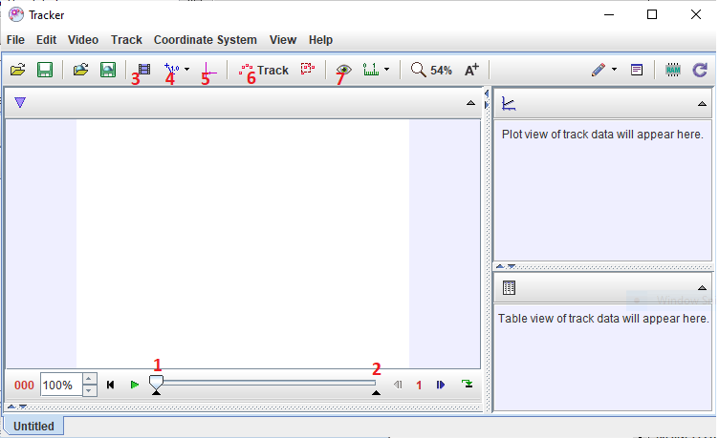

1. **Opening a video or tracker file**

Click the **File** -> **Open File**button to open a video from your computer in Tracker. The video can be rotated by right-clicking on the video and on the **New -> Filters -> Rotate** buttons. The mouse wheel can be used to zoom the image.

1. **Determining video frames**

You can (if you wish) only choose the part of the video in which the object is in motion. The start and end frames are determined by moving the sliders marked with numbers **1** and **2** in the figure. You can also set the start and end frames by clicking on **Clip Settings** (**3**). In this menu you also specify the **Step size**, which determines if every frame of the video is to be analyzed (step size 1) or, for example, every other step (step size 2). If there are more than 30 frames per second on the video, increasing the step size can reduce the noise in the acceleration data.

1. **Scale calibration**

Click the **Calibration tools** button (**4**) and **New -> Calibration stick** to start calibration. Place the ends of the stick on the ends of an object of known length and change the preset value of 1 m to the actual length of your object.

1. **Setting the coordinate system**

Clicking the **Axes** button (**5**) will bring up the coordinate system in the video. Pick an origin for the coordinate system by dragging it into the desired position and choose the direction of the x- and y-axes by rotating the axes.

1. **Tracking the object**

Click the **Track** button (**6**) and **New -> Point Mass** to create a new point mass representing the tracked object. The path of the object can be marked manually, or in very clear cases automatically (Autotracker). To manually mark positions, hold down the Shift key on your keyboard and left-click to mark the starting position of the object. The frame moves automatically after each marked position. It is important to mark the object in each frame in order to correctly calculate the velocity and acceleration of the ball. Always mark the same point on the object (e.g. the center or some marked point). The moving object can get blurry in the frames, so you may have to estimate the position of the center of the marked position.

Using the **Visibility** button (**7**) you can choose whether you want to see all the positions of the object or vectors of velocity and acceleration, etc.

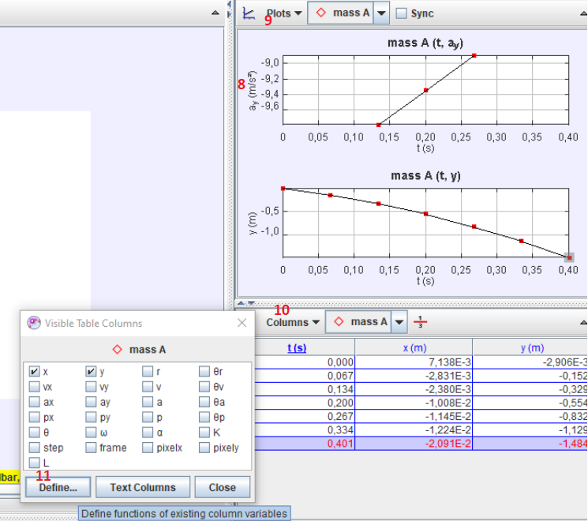

1. **Graphs**

At the top right of the screen is the **Plot View** window which displays graphs of track data. By clicking on the x or y axis of the graph (**8**) you can change the variables you wish to plot. You can choose the number of graphs to be displayed from the **Plots** menu (**9**).

1. **Defining functions and analyzing graphs**

The data obtained by tracking the object also appears in a table at the bottom right of the screen. Clicking on the **Columns** button (**10**) opens the **Visible Table Columns** window and in it you can choose what to display in the table. You can define a function that is not offered by clicking the **Defin**e button (**11**). Under the **Data Functions** option, enter the name and formula for that function.

Right-clicking on the graph opens a menu where you can also select the **Define** option and create a new function. Clicking **Analyze** -> **Curve fitter** in the same menu opens a window where you can adjust the curve and get some useful information such as the slope of a line. Note: the graphing and analysis tools were found to have some bugs at least in Tracker version 5.1.5. We recommend using some other software for graphing and analysis.

1. **Saving**

You can save the analysis in two ways:

a) **File -> Save Tab As** saves the analysis with the ".trk" extension (but does not include video, only a reference to it)

b) **File -> Save Project As** saves saves the analysis with the ".trz" extension and includes video