This document has been created as a part of the Erasmus+ -project “Developing Digital Physics Laboratory Work for Distance Learning” (DigiPhysLab). More info: [www.jyu.fi/digiphyslab](http://www.jyu.fi/digiphyslab)

Rolling motion with smartphone

Student version

27.2.2023

[Creative Commons License](https://creativecommons.org/licenses/by-sa/4.0/)  
This work is licensed under a [Creative Commons Attribution-ShareAlike 4.0 International License](https://creativecommons.org/licenses/by-sa/4.0/).

# Rolling motion with smartphone

## Motivation and goal

In principle, depending on the trajectory curve on which a body moves, translational movements and rotational movements can be distinguished. In a translational movement, all points of the body undergo the same displacement (cf. Parallel displacement in geometry); in rotational motion, however, all points of the body rotate around a common axis (cf. Rotations in geometry). Each movement can be described as a superposition of translational and rotational movements. A simple example of this is the rolling motion, in which, for example, a cylindrical body rotates around its own axis and also exerts a translational movement due to a frictional force of the substrate that counteracts the torque.

One way to rotate such a cylinder is to let it roll down an inclined plane. Historically, this allowed the investigation of gravitational effects, since the downhill force required for the movement parallel to the inclined plane is smaller than the gravitational force (but proportional to it!) and thus gravitation could be investigated in "slow motion".

Nowadays, it is possible to use a sensor inside such a cylinder to measure the central variables during a rolling motion. The aim of this task is therefore to investigate the time-dependent rolling behavior of a cylinder with your smartphone inside at different inclination angles of an inclined plane. In the analysis, you should also discuss the influence of static friction and the energy converted into friction.

## Equipment needed

Smartphone with *phyphox*, scale, roll (e.g., a can), filling material, inclined plane (e.g., an angled table), computer for data analysis, folding ruler

## Fostered experimental skills and topics

**Experimental skills**: collection of measurement data, analysis of data

**Topics Experimental physics:** rotation, moment of inertia, conservation of energy, friction

**Mathematical methods:** multidimensional integrals, differential equations

**+ for physics students:** reproduction/analysis of a known problem

**+ for teaching:** Analysis of a school-related experiment

You will now receive all the materials for the experiment *Rolling motion with Smartphone*, in which you examine rolling movements with your smartphone on an inclined plane. Below you will find materials to prepare for the experiment, followed by the actual task document for the experiment and the auxiliary materials (I) to (III).

### Preparation

Use the following supportive materials to prepare for content before you plan and carry out your experiment. To do this, also edit the corresponding subtasks.

## Technical preparations

1. Please install the free app *phyphox* on your smartphone. Please check whether data from *phyphox* can be stored locally on your smartphone. For Android devices, this usually requires a free file management app such as *Total Commander*.
2. Please organize a program to use for data analysis. You can either use Python via browser-based jupyter notebooks (e.g., google colab or directly under jupyter.org) or SciDAVis or Origin.

## Content preparation I

1. **Read the following information text about rolling motions on an inclined plane and work through the corresponding tasks.** The focus should be on a conceptual understanding of the relevant quantities (moment of inertia, rotational energy, etc.) and a comprehension of the formulas/derivations. For more information, read the paper by Puttharugsa et al. (2016) <https://iopscience.iop.org/article/10.1088/0143-0807/37/5/055004> on which this task is based.

## Rolling body on inclined plane

A gyroscope sensor is installed in a smartphone to determine its spatial orientation. Gyroscopes often consist of three gimbal mounted spinning tops (see Figure 1) that can rotate depending on external influence. Due to the moment of inertia of the spinning top, its orientation of the axis of rotation does not change when the smartphone rotates. This allows the angular velocity to be specified for the three main axes of the smartphone during a rotation.

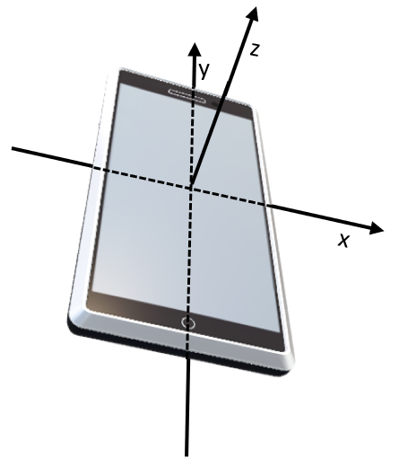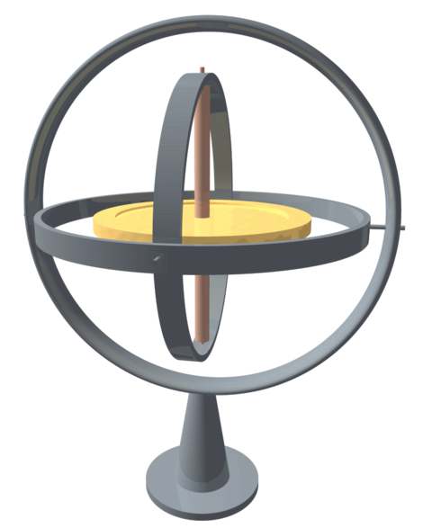

Figure 1: Structure of a gyroscopes

Figure 2: Smartphone with axes through the center of gravity. The orientation of the axes is different for each model. The derivation of the formulas in the text is based on the orientation shown here.

Using the gyroscope sensor of a smartphone, this experiment can therefore investigate the behavior of a roll on an inclined plane when the smartphone is positioned within the roll. It is therefore advisable to use a hollow cylinder (e.g. an empty can) as a roll, in which the smartphone can be positioned so that one of the main axes of the smartphone is aligned with the main axis $ϕ$ of the cylinder.

The rotational motion of a rigid body, in this case the rolling motion of the roll, is largely determined by the moment of inertia resulting from the arrangement of its mass $m$ around the axis of rotation. With regard to the axis of rotation $ϕ$, the total moment of inertia of the rolling body can be determined by adding together the moments of inertia of the smartphone and the cylinder. The individual moments of inertia are calculated according to the general definition $I_{ϕ}=ρ\int_{V}{r^{2}dV}$, where $ρ$ is the density distribution and $r$ the respective distance from the axis of rotation $ϕ$. The smartphone can be assumed to be a cuboid with a homogeneous mass distribution, total mass $m$ and edge lengths $a,b$, and $c$ so that $ρ=\frac{m}{a∙b∙c}$ follows for the density distribution, and though integration we then get $I_{ϕ}=\frac{m}{12}(a²+c²)$ if the axis of rotation $ϕ$ runs parallel to the edge $b$.

If the moment of inertia of the rolling body with respect to the axis of rotation $ϕ$ is known, the angular momentum can be determined using $\vec{L}=I_{ϕ}{\vec{ω}}_{ϕ}$ and the rotational energy can be determined using $E_{rot}=\frac{1}{2}I_{ϕ}ω_{ϕ}^{2}$.

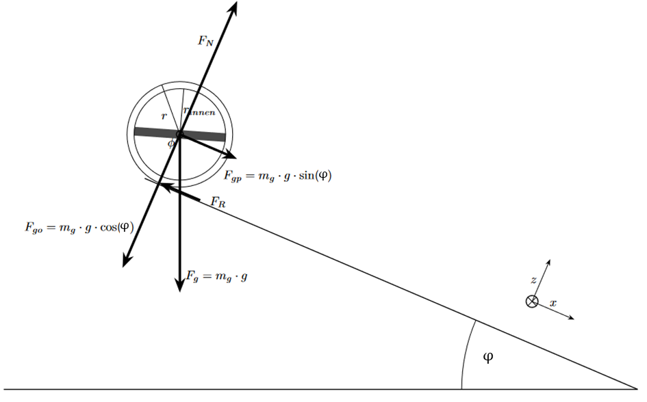

If the rolling body (roll + smartphone) with a total mass $m_{t}$ is now on an inclined plane with an inclination $φ$ to the horizontal, the weight force acting on it can be divided into partial forces running parallel and orthogonal to the inclined plane (see figure). For the orthogonal component of the weight force $F_{go}$ follows $F_{go}=cos(φ)∙m_{t}∙g$, and for the parallel force $F_{gp}=sin⁡(φ)∙m_{t}∙g$

Assuming that the roller does not slip and rolling friction is negligible, only a static frictional force $F_{f}$ counteracts the parallel force $F_{gp}$ (attention:|). This frictional force generates a torque on the rolling body, which leads to a rotational movement around the axis of rotation $ϕ$. This rotational movement is accompanied by a translational movement of the center of gravity of the roll along the inclined plane.

Two formulas can now be derived from these considerations: Since the frictional force $F_{f}$ exerts a torque on the cylindrical rolling body with total mass $m_{t}$, moment of inertia $I$ and external radius $R$, the relation

$F_{f}∙R=I∙\dot{ω}$ (1)

Must be valid, where $\dot{ω}$ is the temporal change of angular velocity, i.e., the angular acceleration of the rotational motion caused. At the same time, Newton's second axiom for the translational acceleration $a$ of the rolling body’s center of gravity follows along the inclined plane:

$m_{t}∙a=F_{gp}-F_{f}$*.* (2)

In this expression $F_{f}$ can now be substituted with formula (1). Furthermore, under the assumption from earlier stating that the roller does not slip, the relationship $a= R∙\dot{ω}$ follows, i.e., the translational acceleration depends directly on the angular acceleration, since only the rotational motion causes the translational movement of the center of gravity. Together with the initial condition $ω\left(0\right)=0$ follows:

$ω\left(t\right)=\sin\left(φ\right)\frac{m_{t}∙g}{m_{t}∙R+\frac{I}{R}}∙t =: α ∙t .$ (3)

Thus, a constant angular acceleration $α$ can be expected (and calculated) for each angle of inclination $φ$. It should be noted that this equation only applies under the assumption that the rolling body does not slip. This is exactly the case if the frictional force $F_{f}$ required for the rolling motion is greater than the static friction force $μF_{go}$ of the rolling body, where $μ$ describes the static friction coefficient between the rolling body and the inclined plane. However, the static friction force $μF_{go}$ now becomes smaller and smaller with a larger angle of inclination $φ$, so that from a critical angle of inclination $φ_{krit}$ follows: $F_{R}≥ μF_{go}$.

**Preparatory tasks:**

3a) Find out (e.g., through appropriate test measurements with *phyphox*) how the axes of your smartphone are named and aligned.

3b) Calculate the moment of inertia of your rolling body with respect to the axis of rotation $ϕ$, i.e., the longitudinal axis of the roll. To do this, explicitly calculate the integral $I_{ϕ}=ρ\int_{V}{r^{2}dV}$ for the individual bodies (e.g., smartphone and roll, if necessary including the filling material) and use Steiner's theorem to assemble the individual results to the total moment of inertia of the rolling body.

3c) Using the information from the text above, derive a formula for the coefficient of static friction $μ$ between the roller body and the inclined plane as a function of the critical angle $φ_{krit}$ at which the body not only rolls but begins to slide simultaneously. You can determine $φ_{krit}$ later using your measured angular accelerations.

3d) In this subtask, you determine a reference value for the static friction coefficient $μ$ between the rolling body and the inclined plane. You can use this later in the discussion of your results once you have determined the static friction coefficient with the formula from subtask 3c).

$$φ_{max}$$

To determine this reference value, modify your rolling body so that it can no longer roll, for example by gluing two similar rolls together (see figure). By slowly increasing the tilt angle of the inclined plane, you can determine the maximum angle $φ_{max}$ ( ${≠φ}_{krit}$– why?) up to which the two connected rollers just do not begin to slip. Then the static friction coefficient can be determined with $μ=\tan{(φ_{max})}$ (why?).

## Content preparation II

1. **Read the instructions for the *app phyphox*** (**supportive material (I)). Try the workflow** with the data from any sensor (e.g., acceleration with/without $g$). Try out how you can read this data into your data analysis program.
2. **Read the instructions on using the data analysis program. Use supportive material (II) for Python. In the notebook you will find the basics for processing and presenting the data.** With this basic understanding, the analysis of the data of your experiment should succeed well. Note which parameters are important for the analysis and which sources of error could occur. **Alternatively, if you use SciDAVis or OriginLab to analyze the data, see supportive material (III).**

### The experiment

After preparation, you can plan and carry out your experiment. As described above, your task is **to investigate the time-dependent rolling behavior of a cylinder with your smartphone inside at different angles of inclination of an inclined plane. In your analysis, also address the influence of static friction and energy conservation.**

Specifically, this results in the following subtasks:

* Using your smartphone, measure the angular velocity of your rolling body as a function of the angle of inclination of your inclined plane. Graph the data and see how the data can be modeled/fit using formula (3). Analyze your results by comparing the moment of inertia determined in subtask 3b) with that obtained by a suitably defined parameter from the fit equation.
* Determine the respective angular acceleration from the measurement data and display it graphically as a function of the inclination angle of the inclined plane.
* Then analyze this diagram to see from which angle of inclination of the inclined plane your rolling body not only rolls, but also begins to slip. Using the formula from task 3c), then determine the static friction coefficient between the rolling body and the inclined plane and compare it with your reference value from subtask 3d).
* For different inclination angles of the inclined plane, determine the kinetic energy of your rolling body at the end of the inclined plane from the measurement data. By comparing it with the potential energy of the rolling body at the beginning of the movement, investigate how much potential energy has been converted into frictional energy at each angle of inclination.

## Guiding questions for the experimental process

To structure your experimentation process, you can use the following questions for guidance:

1. Which measurement uncertainties occur when determining the moments of inertia of your smartphone and your rolling body and what influence does this have on the later data analysis?
2. What are the limitations (e.g., measurement uncertainties, measuring range) of the sensors you use? What impact does this have on your approach?
3. What influence does the positioning of the smartphone on or inside the rolling object have on your data acquisition and results?
4. What influence does the way the roll is released at the top have on the actual rotational motion?
5. What influence do the parameters of the inclined plane have on the rolling motion?
6. How can you measure the inclination of your inclined plane as precisely as possible?
7. To what extent can you reproduce measurement processes and later take the measurement repetitions into account in the data analysis?
8. What other measurement uncertainties occur during the experiment? How can these be quantified?

## Key questions during analysis

During the analysis, you can also use the following questions for guidance:

1. Which part of the data set is (ir-)relevant for further data analysis?
2. How can you graphically represent the determined angular velocities?
3. To what extent are the angular velocities in a realistic order of magnitude and to what extent can the measurement data be modelled with formula (3) for the angular velocity $ω\left(t\right)$?
4. How can you determine the corresponding angular acceleration for the individual rolling processes and how does this depend on the inclination angle of the inclined plane?
5. At what angle of inclination does the roller not only begin to roll, but also to slide? How can you tell this? And what influence does this have on your results and their interpretation?
6. How can you determine the static friction coefficient between rolling body and inclined plane from the measurement data?
7. How can you draw conclusions from your measurement data about the potential energy at the beginning and the kinetic energy of your roll towards the end of the rolling motion and determine them as precisely as possible? What statements can you then make about the energy conservation during the rolling process?
8. How can you take into account the identified and quantified measurement uncertainties in the individual steps of the analysis ("error calculation")?

## Assessment

Create a scientific poster where you summarize your findings. This should include, but not be limited to, the following aspects:

* Information on the design, execution, and analysis of the experiment
* Visualization of rolling motion parameters (e.g., angular & translational speed, rotational energy, ...) depending on the angle of inclination of the inclined plane.
* Justified decision from which angle of inclination the slipping of the roll can no longer be neglected and how much this affects the parameters of the rolling motion.

### (I) Instructions for phyphox

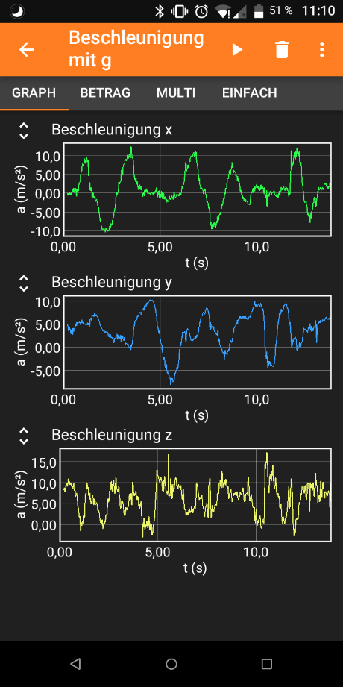*PHyphox* is a free app with which all data from the sensors installed in the smartphone can be read. But there are also ready-made experimental programs such as determining the angle of inclination of your phone with their accelerometers. Below is a step-by-step guide on how to use this app to record measurement data.

**(C)**

**(A)**

Download: in all common app stores

**(B)**

1. **Step: Start your experiment**
   1. Launch the app on your smartphone.
   2. On the start page, all sensors that you can read out are displayed. Select the desired sensor.
2. **Step: Record your data**
   1. Click the play button () to start data collection (A).
   2. In the tabs, the data is displayed graphically and numerically in real time (B).
   3. Click the Pause button () to pause/stop your data collection.
   4. Alternatively, it is also possible to record data via the remote access. (If the phone in the roll is not easily accessible.) Click on the three dots () (C) and open **Enable remote access** (D) in the menu. This requires the creation of a hotspot or a private Wi-Fi network.
   5. Phyphox provides an internet address that you can open on another device. From there you can start the measurement process.
3. **Step: Save data**
   1. Click the three dots () to open the menu (C). Select **Export data** (E).
   2. Select the desired data format (usually *Excel*) (F). Press **OK** (G).
   3. With network or Wi-Fi network, sending by mail is the most effective. In this case, you do not need to save the data on your phone.
   4. Otherwise, save the file to the desired program (local memory or a file management app such as *Total Commander* that receives the file).
   5. An image that contains text.

      Automatically generated description Transfer the file via cable, *Bluetooth*, *Airdrop,* or Internet to the data analysis computer.

**(g)**

**(F)**

**(E)**

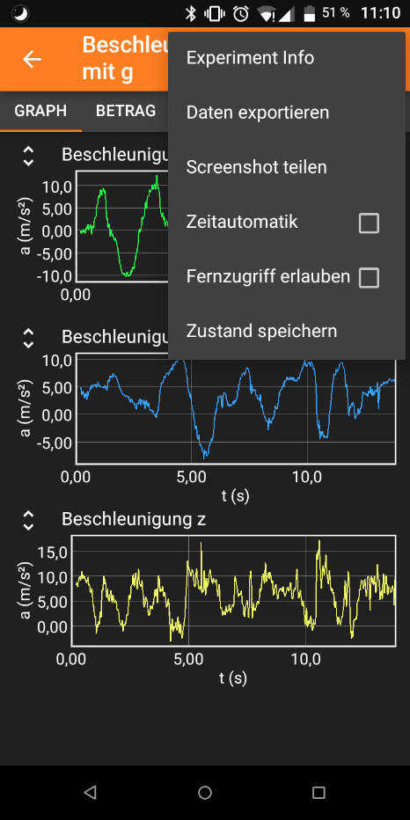

**(D)**

## (II) Instructions for Python

With *Python*, you are using a popular programming language in science, which can be used to analyse experimental data. The following instructions are for the jupyter notebook. Whichever platform you use, please upload the notebook and follow its instructions and later use python for your data analysis.

1. **Jupyter and Python**
   1. After launching *jupyter*, you will see the home screen. On the right, you can choose between various programs. We will work with Python notebooks.
   2. You will find a list with all your files in the sidebar on the left. Here you can create a folder for your project and take further actions by right-clicking. The program code can access files (e.g., raw data) uploaded to this directory and also store analysis files there.
   3. Upload and launch the **rotation_and_rolling_notebook_english.ipynb** file.
   4. The file consists of different cells to which you can add more using (A). With (B), you can change the type of cells. For programming, you need to use the type “**code**”.
   5. You can now write your programming code into the code cell and compile it using the play button (C). Once compiled, the variables are set for the entire notebook until you overwrite them or terminate the notebook (shutdown).

An image that contains text.

Automatically generated description

**(D)**

**(A)**

**(B)**

**(C)**

1. **Using the self-explanatory notebook**
   1. Work through the notebook to learn the basics on how data can be processed with *Python*.
2. **Working with data in your code**
   1. Create a text file in the folder of your project. To label it, you can use the file extension “*.dat”*.
   2. Open the Excel file with your data. Copy the relevant data columns into the text file.
   3. Remove empty lines and strings of letters and replace the decimal commas with periods (ctrl + f or edit (D)>> find...)

## (III) Instructions for SciDAVis

*SciDAVis* is a free data analysis tool similar to the licensed tools *Origin Pro* or *qtiplot*. Below you will find a step-by-step guide on how to use this tool to fit different formulas in a dataset.

Download for Windows: <https://sourceforge.net/projects/scidavis/>

Download for Mac: <https://sourceforge.net/projects/scidavis/files/SciDAVis-beta/>

1. **Step: Import your data**
   1. Extract the data from your data acquisition device. Copy the data to *Excel*.
   2. Select the data you want to analyze. Copy them to the table in *SciDAVis* (A). (Attention: *SciDAVis* can only distinguish columns and not rows or single cells like *Excel*.)
   3. On the right, you can adjust the settings for each column. Make sure that **numeric** is always selected as the **type**. Click **Apply** to save changes (B).
   4. 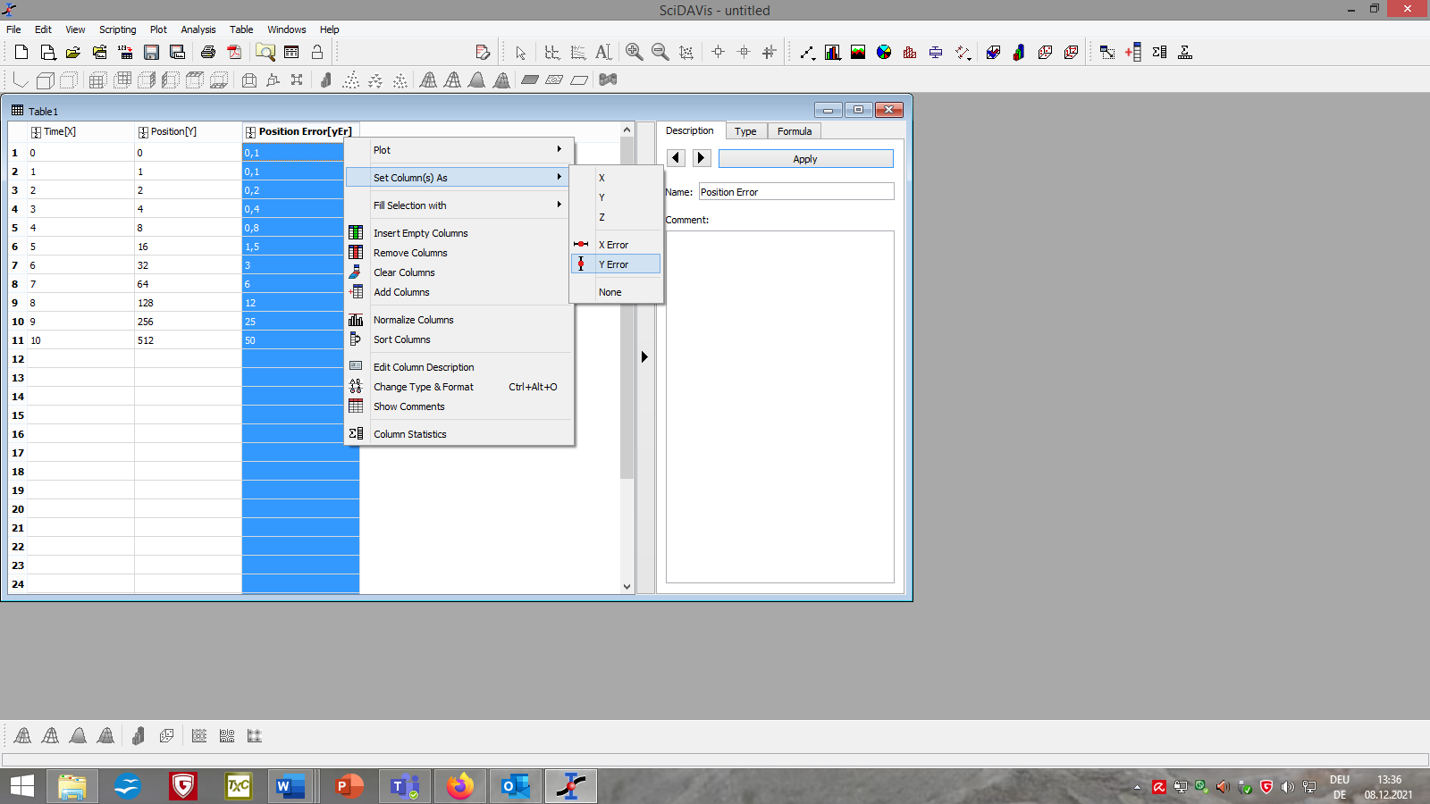Right-click the header and select **Set Column(s) as** you can determine which columns should contain $x$-, $y$-, $x$-error and $y$-error data (C).

**(A)**

**(B)**

**(C)**

1. **Step: Plot your data**
   1. Select the columns you want to plot. On the menu bar, click **Plot** à **Scatter** (D).
   2. 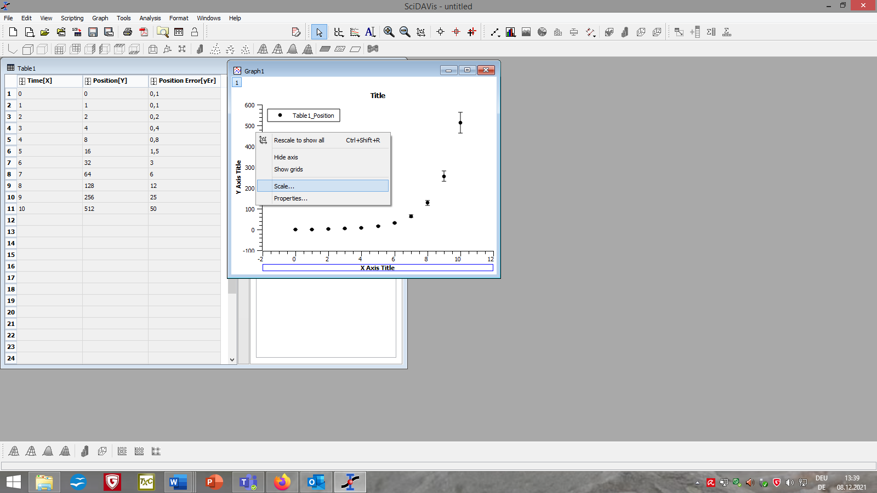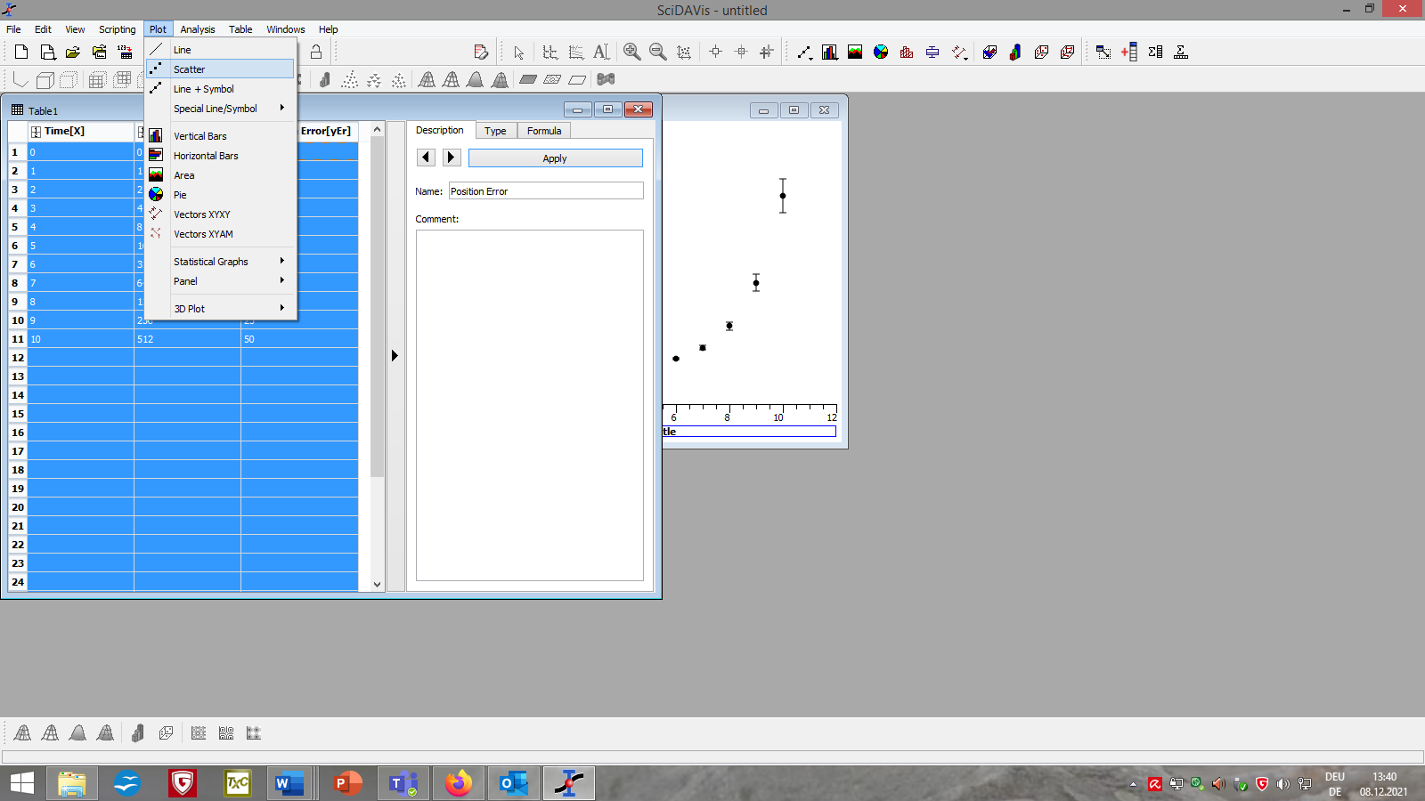By right-clicking the axes or background and select **Scale…** or **Properities…** you can customize the layout of your graph or delete unwanted fits (E).

**(E)**

**(D)**

1. 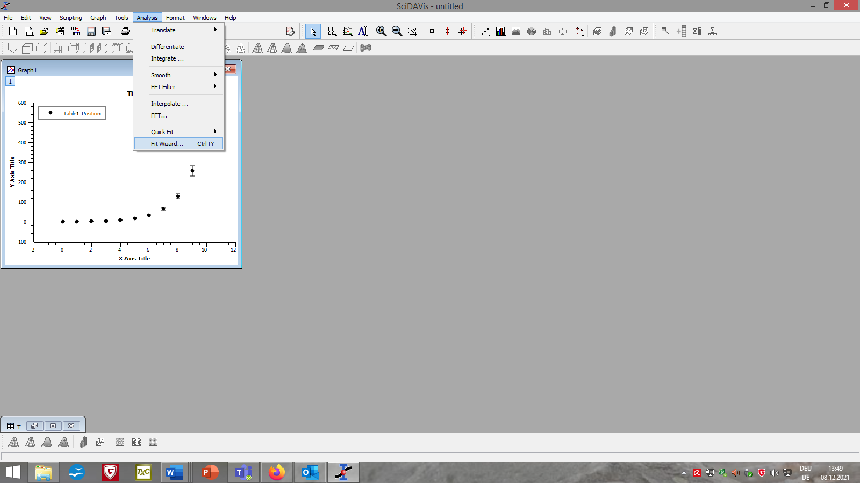**Step: Fit your data**
   1. Click on your graph. From the menu bar, select **Analysis** à **Fit Wizard...** (F)**.**
   2. Select **User defined** in the left column of the newly opened window (G).
   3. Choose a name for your fit function, list the parameters you want separated by a comma and add the formula of your fit function in the large field below (H).

**(F)**

* 1. Click **Save** (I) for later use of the function. Click **Fit >>** (J) to apply the function to your graph.
  2. If necessary, adjust the settings for the fit (e.g. the range of data points considered, the iterations and tolerance of the algorithm, or the source of the $y$-errors) (K).
  3. Use **initial guesses** (L) to tell the algorithm which values you theoretically expect for each parameter. Depending on your input, the fits will be different.
  4. At the bottom, click **Fit** (M). Close the window.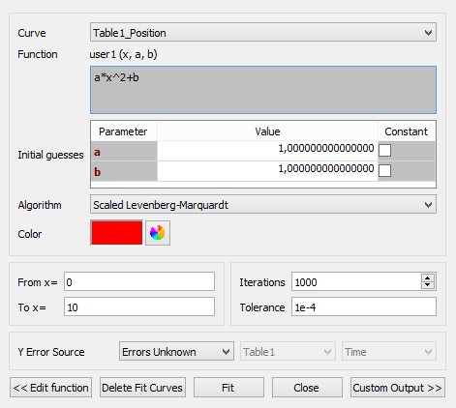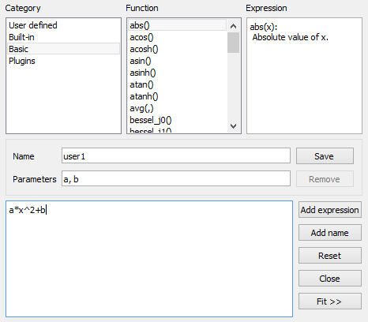

**(S)**

**(K)**

**(M)**

**(J)**

**(I)**

**(H)**

**(G)**

1. **Step: Evaluate your fit**
   1. The window **Results Log** appears automatically and receives various information about the data used and fit functions (N), the algorithm (O) and whether it was successful (P).
   2. You can also find the parameters of your fit with an error range (Q) calculated from the position of the data points and the -error.
   3. An image that contains text.

      Automatically generated description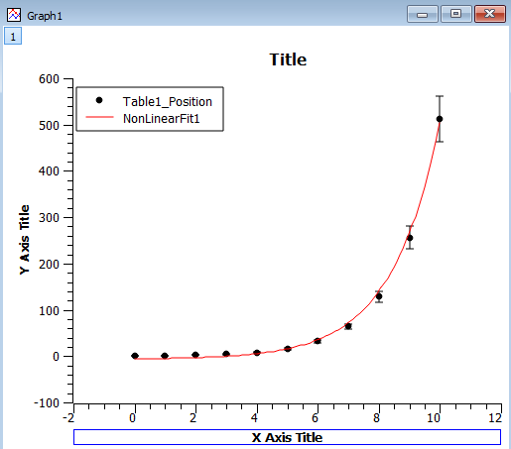You can also find the degree of certainty **R^2** (R) which describes on a scale from 0 (worst case) to 1 (optimal case) how well the data fits the model (used fit formula).

**(R)**

**(Q)**

**(P)**

**(O)**

**(N)**