This document has been created as a part of the Erasmus+ -project “Developing Digital Physics Laboratory Work for Distance Learning” (DigiPhysLab). More info: [www.jyu.fi/digiphyslab](http://www.jyu.fi/digiphyslab)

Rolling motion with smartphone

Instructor version

27.2.2023

## [Creative Commons License](https://creativecommons.org/licenses/by-sa/4.0/) This work is licensed under a [Creative Commons Attribution-ShareAlike 4.0 International License](https://creativecommons.org/licenses/by-sa/4.0/).

## **Rolling Bodies and Inclined Planes – Instructor version**

## **Task Overview**

* Topic: Investigation of rolling movements on inclined planes
* Target group: Physics and physics teacher training students in the introductory phase
* Time frame: approx. 15 hours including data analysis, but excluding poster creation
* Recommended social form: in pairs or groups (2-3 students per group)

## **Preparation**

The aim of the experiment is to investigate the rolling properties of a rolling body on an inclined plane, whereby the smartphone is integrated in the rolling body. For the appropriate physical investigation of this topic, it is necessary to familiarize the students with the theory of rolling processes on the inclined plane, but also with the concepts of moment of inertia, rotational energy, etc. To do so, the introductory tasks in the task description can be used, which already use the dimensions of the smartphone to, for example, calculate its moment of inertia. The data is recorded with *phyphox*, for which instructions on how to install and get started are provided in the materials. Optionally, a *jupyter* notebook is available that includes the essential steps for data analysis. However, the analysis can also be done using *Excel*, *Origin* or *SciDAVis*. For the latter program, instructions are also provided in the task documents.

## **Set-up and implementation**

The gyroscope sensor of the smartphone is used to conduct the experiment. This directly provides the angular velocities around the three main rotation axes of the smartphone. (The respective orientation/designation of the axes is device-specific and must therefore be determined in advance for each device.) Most gyroscope sensors have a maximum value up to which angular velocities can be measured. In the devices we tested, this was about 35 rad/s. For longer planes with high inclination angles, it can happen that the actual angular velocity can no longer be measured and only the (constant) maximum value is output. This is particularly relevant if the rotational energy of the motion can no longer be correctly determined from the angular velocity at the end of the inclined plane.

When positioning the smartphone, make sure that it is centrally located inside the roll so that the main axis of rotation of the smartphone is aligned with the central axis of the roll and the rotation of the rolling body takes place simultaneously around the center axis of the roll and the main axis of rotation of the smartphone. It can be a bit difficult to secure the smartphone accordingly inside the roll. The specific placement and fixing depends on the materials used; According to our own experience, empty cans, stacking chip cans, cappuccino cans or PVC pipes are suitable as rolling bodies and as filling material, e.g., paper towels, plastic bags filled with rice or bubble wrap.

In order for the smartphone to remain within the roll during data acquisition, it makes sense to use the remote function of *phyphox*. Further information can be found directly on the website of *phyphox*: [Remote control – phyphox](https://phyphox.org/remote-control/). Alternatively, external sensor boxes can be placed in the roll so that the smartphone can remain completely outside the roll body and remain to control data acquisition.

As an inclined plane, for example, a normal table is suitable, which can be tilted at different angles by underbuilding the table on one side, e.g., by books or other objects. Even an inclined book can already act as an inclined plane, but then the length of the runway is so short that most rolls can perform a maximum of two revolutions, which ultimately affects the precision of the measurements. The length of the layer should therefore exceed one or two circumferential lengths of the roll.

The angle of inclination of the inclined plane can be determined either by length measurements (measuring the heights of the individual table edges and measuring the length of the runway) and subsequent geometric considerations or by using the tool "Inclination" in *phyphox*.

The surface of the inclined plane has an influence on the rolling and slipping properties of the roll. From a certain angle of inclination, the roll will hardly perform any rolling movement, but mainly slide or fall. Therefore, it is not possible to just choose any angle of inclination of the inclined plane. Realistic tilt angles are between 0° and about 45°.

An example of an experimental setup is shown in Figure 1.

A picture that contains person.

Automatically generated description

Figure 1: Possible setup and execution of the rolling experiment.

## **Transferring the data to the PC**

There are three main methods available for data transmission:

1. One option is to use the remote-control function offered by *Phyphox*. Here, the data recorded by the smartphone is transferred to a computer in real-time (only works with appropriate network availability). It is also possible to start and stop recording remotely.
2. The data is transferred directly to the computer via e-mail, Bluetooth, airdrop, etc.
3. *Only useful for Android devices*: The data is initially stored on the smartphone. Since *Phyphox* cannot access the internal memory directly, this requires a file management app such as *TotalCommander*, which can receive the file and save it internally. The file can then be transferred, e.g., via data cable or e-mail.

## **Data analysis**

A central goal in the course of the data analysis in this task is the representation of the angular acceleration as a function of the inclination angle of the inclined plane. For this (and for the other analysis steps), the data must be prepared accordingly. The following aspects should be pointed out:

* The relevant data must be selected from the data set. The correct coordinate axis and only the periods in which the intended rolling movement took place must be selected. Otherwise, other artifacts (e.g. moving the smartphone when starting/stopping data ingestion) will affect the results. The rolling movement is easy to identify.
* If the measured angular velocities are plotted against time, the angular acceleration can be determined from the slope with the aid of a linear fit. Here, only the data from before the roll reaches the end of the inclined plane must be taken into account. In addition, data must not be taken into account when the angular velocities exceed the measuring range of the smartphone; in this case, however, the angular acceleration can also be determined if only the data from before reaching this maximum is selected. It should also be noted that from a certain angle of inclination of the inclined plane, the angular acceleration will decrease due to the slipping of the rolling body. However, this does not need to be taken into account at this point, as this can be read from the following angular acceleration-tilt angle-diagram.
* For the more precise determination of the angular acceleration per angle of inclination, the values determined from the fit equations of several experimental runs can be averaged.
* The limitation of the measuring range of the gyroscope sensor also affects the determination of the kinetic energy of the rolling body at the end of the inclined plane. For these inclination angles, no exact determination of the kinetic energy can be made once the upper limit of the measuring range is reached. If necessary, this must already be taken into account when choosing the inclined plane (or its length).

## **Expected results**

The results depend very much on the selected experimental materials, especially on the roll and filling material. Not only are the friction properties on the inclined plane different depending on the roll used. Rather, the choice of rolling bodies and filling materials also has an intrinsic influence on the moment of inertia of the rolling body, so that the corresponding moments of inertia must be specifically calculated for the data analysis. Whether the smartphone rotates stably around the main axis of rotation (and the rolling body has no imbalance overall) can be easily checked in a test measurement: To do this, the roll is simply rolled down along an inclined plane and the angular velocity is measured depending on the time. If the data is plotted graphically (as in Figure 2), the relationship between angular velocity and time should be linear. If the smartphone has been placed incorrectly, has play within the roll or the rolling body has an overall imbalance, there are slight oscillations of the angular velocity around the expected linear relationship at periodic intervals (as marked by the red arrows in Figure 2, for example). Generally, it is not possible to completely avoid this systematic uncertainty, but it can at least be reduced. For each inclination angle of the inclined plane, the time-dependent angular velocity can now be modeled using a linear fit (see examples in Figures 2 and 3), because as described in the instructions for the students, the following relationship applies:

$$ω\left(t\right)=sin\left(φ\right)\frac{m_{g}∙g}{m_{g}∙R+\frac{I_{total}}{R}}∙t =: α ∙t .$$

The prefactor $α$ in this formula, i.e. the slope of the fit describes the angular acceleration of the roll. With a linear fit, the angular acceleration can be determined directly from the measurement data (see the value $α$ in the legend for the fit in Figure 2 and 3). The results can be compared with the theoretically expected reference value by plotting the above formula or calculating the angular acceleration $α$. This requires the inclination $φ$ of the inclined plane, the total mass $m_{t}$, the radius $R$ of the rolling body and its moment of inertia $I_{total}$ with respect to the central axis of the roll. For the latter, the moments of inertia of the smartphone, of the can used for the roll and of its bottom must be determined and combined. Assuming that the filling material has no influence on the moment of inertia and that the mass of the can and smartphone are homogeneously distributed, $I_{total}$ can be calculated by:

$$I_{total}=I_{\text{Phone}}+I_{\text{Can}}+I_{\text{Bottom}}=\frac{1}{12}\left(x^{2}+z^{2}\right)m_{\text{Phone}}+\frac{1}{2}m_{\text{Can}}\left(r_{\text{outside}}^{2}+r_{\text{inside}}^{2}\right)+\frac{1}{2}m_{\text{Bottom}}r_{\text{outside}}^{2}$$

where $r_{\text{outside}}=R$ is the outer and $r_{\text{inside}}$ the inner radius of the rolling body, $x$ and $z$ the width and depth of the smartphone and $m_{\text{Phone}}$, $m_{\text{Can}}$ and $m_{\text{Bottom}}$ the masses of the smartphone, the can and its bottom. With a corresponding measurement uncertainty propagation, the students could then also determine the uncertainty of $I_{total}$ and then of $α$ in order to compare whether both determination methods of $α$ (by fitting the angular velocity and by manually calculating the theoretically expected value) lead to the same result.

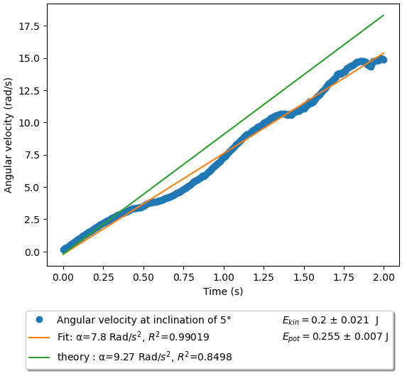

Figure 2: Angular velocity of the roll over time at an inclination angle of 5°. The linear fit of the measurement data is shown in orange, α indicates the slope of the origin line and corresponds to the empirically determined angular acceleration. Green shows what the theoretically expected relationship is, determined by the formula for $ω\left(t\right)$ and a calculation of the parameters of the rolling body. Depending on how well the parameters were measured and calculated, theoretically expected and observed relationships fit together differently. In addition, the kinetic energy (rotational energy) of the roll at the end of the inclined plane is determined from the maximum angular velocity and the potential energy by measuring the height difference at a given inclination angle of the inclined plane and known length of the runway. This way, it is also possible to directly estimate how much energy has been converted into frictional energy.

After the corresponding angular accelerations have been determined for each inclination angle of the inclined plane, these can be displayed in a new diagram (see Figure 4). Depending on the surface and material or parameters of the roll, a lower angular acceleration than that theoretically expected should be observed from a certain angle. This is due to the fact that at a certain angle of inclination, the roller starts to slip and no longer transfers the full friction to the rotation. The sample data in Figure 4 shows this behavior from a critical tilt angle $φ_{krit}$ of about 35°. This results in case of the used materials in the example ($m_{g}=0,397$ kg, $R= 0,0495$ m and $I=8,397 ∙{10}^{-4}$ kgm²) in a static friction coefficient of

$$μ=\frac{tan\left(φ_{krit}\right)∙I}{I+m_{g}R^{2}}≈0,324.$$

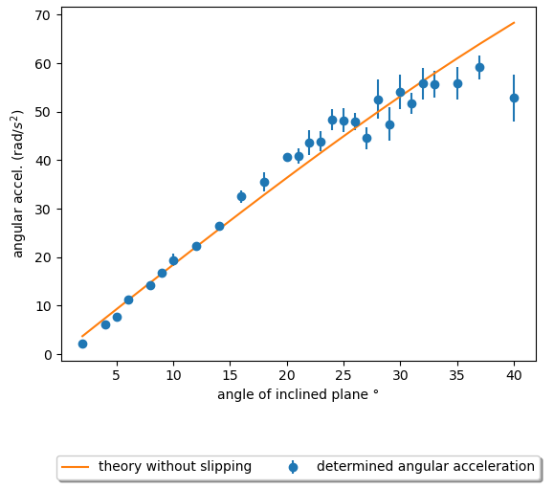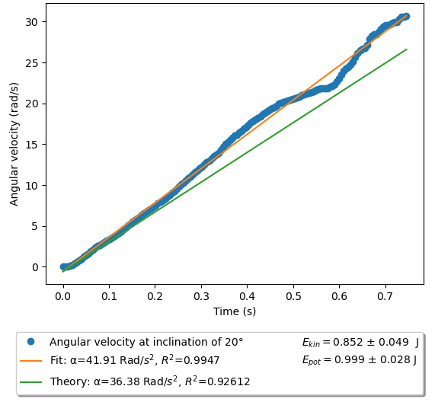Figure 3: Angular velocity of the roll over time at an inclination angle of the inclined plane of 20°. For a description of the other parameters output, refer to the figure caption in Figure 2.

Figure 4: The angular accelerations determined by fits as a function of the inclination angle of the inclined plane. It can be seen that from an angle of inclination of about 35°, the results deviate significantly from the theoretically expected connection (orange line) without friction effects and lie below this curve, since the potential energy is converted by slipping not only into rotational but also translational energy.

In addition, the conservation of energy can also be investigated for individual angles of inclination of the inclined plane. For this purpose, the kinetic energy of the rolling body is determined as the sum of its translational energy of the center of gravity and the rotational energy by the final rotation speed at the end of the rolling process. In addition, the potential energy of the roll at the beginning of the movement can be calculated via the angle of inclination and the length of the inclined plane (see legend in Figure 2 and 3 for example values). It can then be checked, depending on the angle of inclination, how much of the initial potential energy has been converted into kinetic energy and how much energy has been converted into friction energy. When considering the energy, it should be noted that the gyroscope sensor has a limited measuring range, so calculating the kinetic energy from the final rotation speed of the rolling body only makes sense if it is still within the measuring range.

## **Possible forms of assessment**

The results of the preparatory tasks can, for example, be displayed on a scientific poster as suggested in the task document. In addition to information on the design, execution and analysis of the experiment, the poster should include visualizations of the parameters of the rolling motion (e.g. angular velocity, rotational energy, ...) as a function of the inclination angle of the inclined plane and a well-founded assessment of the angle of inclination from which the slipping of the roll can no longer be neglected and how much this influences the parameters of the rolling movement. Alternatively, short presentations, laboratory reports or *computational essays* are also possible. The last two forms of assessment also allow a detailed description and discussion of details on the conduct of experiments and data analysis.

## **Suggestions for modifying the experiment**

In the context of the experiment, the following modifications/deepening are possible:

* If, in addition or alternatively, the translation speed of the roll is of interest, there is also the tool *Roll* exclusively for Android devices in *phyphox*, which determines the translational velocity of the roll from the gyroscope data after entering the roll radius. Further information can be found in the wiki of *phyphox*: <https://phyphox.org/wiki/index.php?title=Experiment:_Roll>.
* The experiment could be deepened beyond the tasks by deliberately varying the moment of inertia of the rolling body, e.g. by varying the filling material to stabilize the smartphone; filling with bubble wrap produces a different moment of inertia than filling with rice (full vs. approximately hollow cylinders). The experiment could then investigate how these modifications affect angular velocity and energy conservation during the rolling process.
* Alternatively, the frictional properties between the can and the inclined plane can be varied hypothetically by placing another base (e.g. a wool blanket or a rubber mat) on the inclined plane. In this case, the influence of these modifications on the angular velocity, the conservation of energy during the rolling process and the angle of inclination of the plane from which the can begins to slip could be investigated.

## **Literature**

The experimental task is inspired by the following paper, which can also help the students prepare for the experiment:

Puttharugsa, C., Khemmani, S., Utayarat, P., & Luangtip, W. (2016). Investigation of the rolling motion of a hollow cylinder using a smartphone. *European Journal of Physics*, *37*. <https://doi.org/10.1088/0143-0807/37/5/055004>