This document has been created as a part of the Erasmus+ -project “Developing Digital Physics Laboratory Work for Distance Learning” (DigiPhysLab). More info: [www.jyu.fi/digiphyslab](http://www.jyu.fi/digiphyslab)

Slamming door

Student version

2.3.2022

[Creative Commons License](https://creativecommons.org/licenses/by-sa/4.0/)  
This work is licensed under a [Creative Commons Attribution-ShareAlike 4.0 International License](https://creativecommons.org/licenses/by-sa/4.0/).

## Dear students,

the following will provide you with all the materials for the *Slamming Door* experiment, in which you examine the friction behavior of a slamming door. This experimental task was developed as part of the EU project *DigiPhysLab* [1], which pursues the development of new experimental tasks in order to enable motivating and activating learning with modern digital media in classroom and distance teaching. On the following pages you will find the task instructions as well as the assistance materials (I) to (IV). For the experiment, you have to make the following preparations:

## Technical preparations

1. Please bring a smartphone, a laptop (with a mouse), and a data transfer cable.
2. Please install the free app *phyphox* on your smartphone. Please check whether data from *phyphox* can be stored locally on your smartphone. For Android devices, this usually requires the installation of a free file management app such as *Total Commander*.
3. Please install the free software *SciDAVis* on your laptop. If available, you may also use *Origin Pro* or *Python*.

Download for Windows: <https://sourceforge.net/projects/scidavis/>

Download for Mac: <https://sourceforge.net/projects/scidavis/files/SciDAVis-beta/>

## Content preparation

The theory relevant for the preparation is described in detail in the following publication:

*Klein, P., Müller, A., Graber, S., Molz, A., & Kuhn, J. (2017): Rotational and frictional dynamics of the slamming of a door. American Journal of Physics 85 (1), pp.30-37.*

1. **Please read sections I-III according to the markings in the file provided.** The focus should be on a conceptual understanding of experiment (goal, method, data interpretation) and theory (friction models, nested models, estimation of orders of magnitude); an understanding of single formula transformations is *not* required.
2. **Read the instructions for the app *phyphox* (Assistance (I)). Try the workflow** once with the data from any sensor (e.g. acceleration with/without $g$). *You do not have to look at Assistances (II) and (IV) yet. You need these only on the experimental day.*
3. **Read the instructions for the software *SciDAVis* (Assistance (III)). Practice the workflow in *SciDAVis*** **by evaluating the following dataset.** This is data from a free fall experiment in which the fall times $t$ were measured at different drop heights $h$. (i) Use a fit to determine the gravitational acceleration $g$. (ii) Check with a fit whether there is a systematic error in the height measurement, i.e. an offset $h_{0}$.

*Dataset:*

|  |  |  |
| --- | --- | --- |
| Drop height $h$ [cm] | Fall times $t$ [s] | Measurement uncertainty fall time [s] |
| 29,5 | 0,244 | 0,005 |
| 26,9 | 0,232 | 0,005 |
| 21,6 | 0,205 | 0,005 |
| 18,1 | 0,191 | 0,005 |
| 13,0 | 0,162 | 0,005 |
| 10,9 | 0,154 | 0,005 |
| 9,6 | 0,143 | 0,005 |
| 6,2 | 0,114 | 0,005 |
| 4,3 | 0,093 | 0,005 |

# Slamming Door: Friction effects with a slamming door

### Motivation

Physics lectures and textbooks often simplify real-life situations by using a reduced physical model that does not contain all the edge effects such as friction. In this experiment, we focus precisely on these edge effects by examining the friction effects that occur at a slamming door. In this everyday situation, three main effects occur, which lead to a decrease in the angular velocity of the rotating door:

1. The door hinges create a frictional torque when the steel parts slide on top of each other. The strength of this friction effect depends on how well the hinges are oiled. It can be assumed that this effect is independent of the angular velocity of the door (*dry friction D*).
2. The large door surface is susceptible to air resistance. Since the velocity of different door sections increases with the radial distance from the axis of rotation, it can be assumed that the friction depends linearly or quadratically on the angular velocity of the door (*Stokes S or Newtonian friction N*).
3. Just before the door falls into the lock, the accumulated air causes turbulence.

In the following, we look at the phase before the door frame affects the rotational movement. Then the friction torque $τ_{f}$ can in principle result from the occurrence of *dry friction D* ($τ_{f}=const.$), *Stokes friction S* ($τ_{f} \sim ω$) or *Newtonian friction N* ($τ_{f} \sim ω²$) to:

$τ_{f}=a+bω+cω^{2}$ with coefficients $a, b, c≥0$.

A total of seven different friction models are conceivable by combining the individual terms (D, S, N, DN, DS, SN, DSN, DSN). The research question to be answered in the experiment is:

**Which friction model (D, S, N, DN, DS, SN, DSN) describes the *slamming door* most precisely?**

Searching for a model that is as precise and simple as possible simultaneously is a typical problem in physics (e.g. when modelling atomic energy levels or exactly movements).

### Experiment materials

Smartphone with *phyphox*, swinging door, computer for data analysis (e.g. via *SciDAVis*), mounting material for the smartphone (e.g. adhesive tape, plastic bag, ...), folding rule

### Addressed experimental skills / learning objectives

**For everyone**: Collecting measurement data, data analysis & testing physical models  
**+ for physics students**: Replication of a roll-out experiment based on a scientific paper  
**+ for physics teacher training students**: Digital data collection and -analysis in an everyday situation

### Task

Based on the paper read in preparation, develop an experiment in which you measure the friction effects that occur with a slamming door. To do this, use the accelerometers and/or gyroscope (measures angular velocities) of your smartphone.

**Examine which of the seven friction models above describes the slamming door most precisely, i.e. which model best suits the data (large R2) and at the same time provides realistic values for the parameters $a, b$ and $c$** **. Also consider the measurement uncertainties.**

*Extra task*: To what extent does the precision of the models depend on the initial angular velocity?

### Assessment

**Tabulate your results in a Word/PowerPoint document.**  Respond to your data collection and analysis, including fit equations, and *justify* in writing which friction model you think describes the movement most precisely.

### (I) Instructions for phyphox

*phyphox* is a free app with which all data from the sensors built into the smartphone can be read out. Below you will find a step-by-step guide on how to use this app to record measurement data.

**(A)**

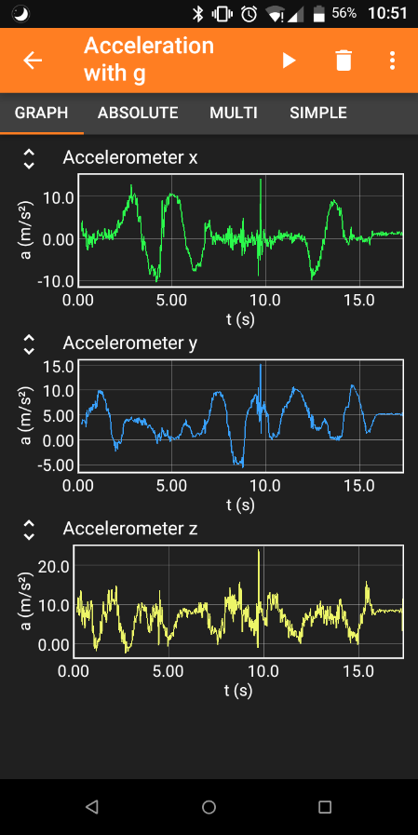Download: in all common app stores

1. **Step: Start your experiment**

**(B)**

**(C)**

* 1. Launch the app on your smartphone.
  2. On the start page, all sensors that you can read out are displayed. Select the desired sensor.

1. **Step: Record your data**
   1. Click the play but ton () to start data collection (A).
   2. In the tabs, the data is displayed graphically and numerically in real time (B).
   3. Click the Pause button () to pause/stop your data collection.
2. **Step: Save your data**
   1. Click the three dots () to open the menu (C). Select **Export data** (D).
   2. Select the desired data format (usually *Excel*) (E). Press **OK** (F).
   3. Save the file to the desired program (local memory or a file management app such as *Total Commander* that receives the file).
   4. Transfer the file via cable, *Bluetooth*, *Airdrop,* or Internet to the evaluation computer.

**(F)**

**(E)**

**(D)**

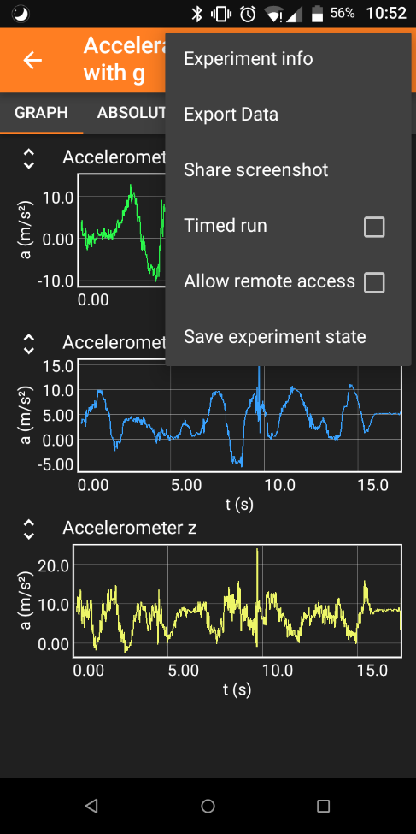Ein Bild, das Text enthält.

## (II) Fit formula from the paper (for copying in *SciDAVis*)

|  |  |  |
| --- | --- | --- |
| Model | Parameters | Fit formula |
| D | w, a | w-a*x |
| S | w, b | w*exp(-b*x) |
| N | w, c | w/(1+c*w*x) |
| DS | w, a, b | (w+a/b)*exp(-b*x)-a/b |
| DN | w, a, c | (w-sqrt(a/c)*tan(sqrt(a*c)*x))/(1+w*sqrt(c/a)*tan(sqrt(a*c)*x)) |
| SN | w, b, c | (-b*w)/(c*w-(w*c+b)*exp(b*x)) |
| DSN | w, a, b, c, | (2*w*c+b-sqrt(4*a*c-b^2)*tan(sqrt(4*a*c-b^2)*x/2))/(2*c* (1+(2*w*c+b)/(sqrt(4*a*c-b^2))*tan(sqrt(4*a*c-b^2)*x/2)))-b/(2*c) |

*Note*: a, b, and c correspond to the parameters in the equation above divided by the moment of inertia of the door, which is why these formulas apply to each door. w is the initial angular velocity. **Use the paper to clarify the conditions under which these fit formulas can be applied.**

### (III) Instructions for SciDAVis

*SciDAVis* is a free data analysis tool similar to the licensed tools *Origin Pro* or *qtiplot*. Below you will find a step-by-step guide on how to use this tool to fit different formulas in a dataset.

Download for Windows: <https://sourceforge.net/projects/scidavis/>

Download for Mac: <https://sourceforge.net/projects/scidavis/files/SciDAVis-beta/>

1. **Step: Import your data**
   1. Extract the data from your data acquisition device. Copy the data to *Excel*.
   2. Select the data you want to analyze. Copy them to the table in *SciDAVis* (A). (Attention: *SciDAVis* can only distinguish columns and not rows or single cells like *Excel*.)
   3. On the right, you can adjust the settings for each column. Make sure that **numeric** is always selected as the **type**. Click **Apply** to save changes (B).
   4. 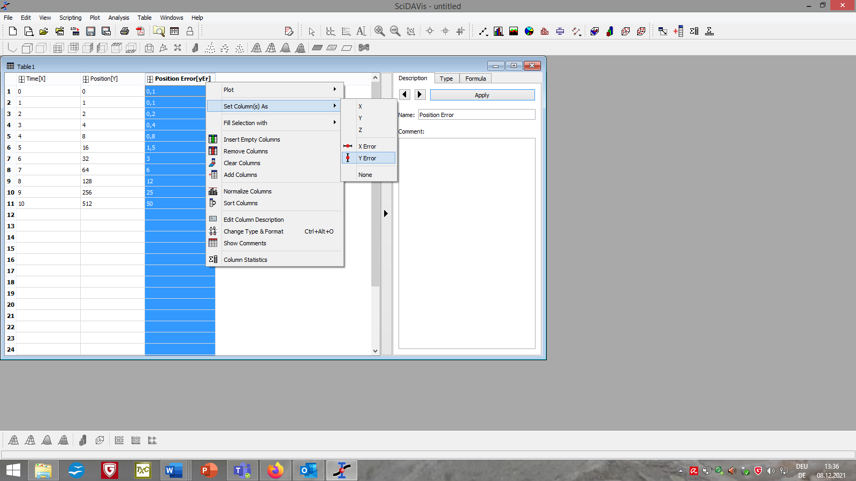Right-click the header and select **Set Column(s) as** you can determine which columns should contain $x$-, $y$-, $x$-error and $y$-error data (C).

**(A)**

**(B)**

**(C)**

1. **Step: Plot your data**
   1. Select the columns you want to plot. On the menu bar, click **Plot** à **Scatter** (D).
   2. 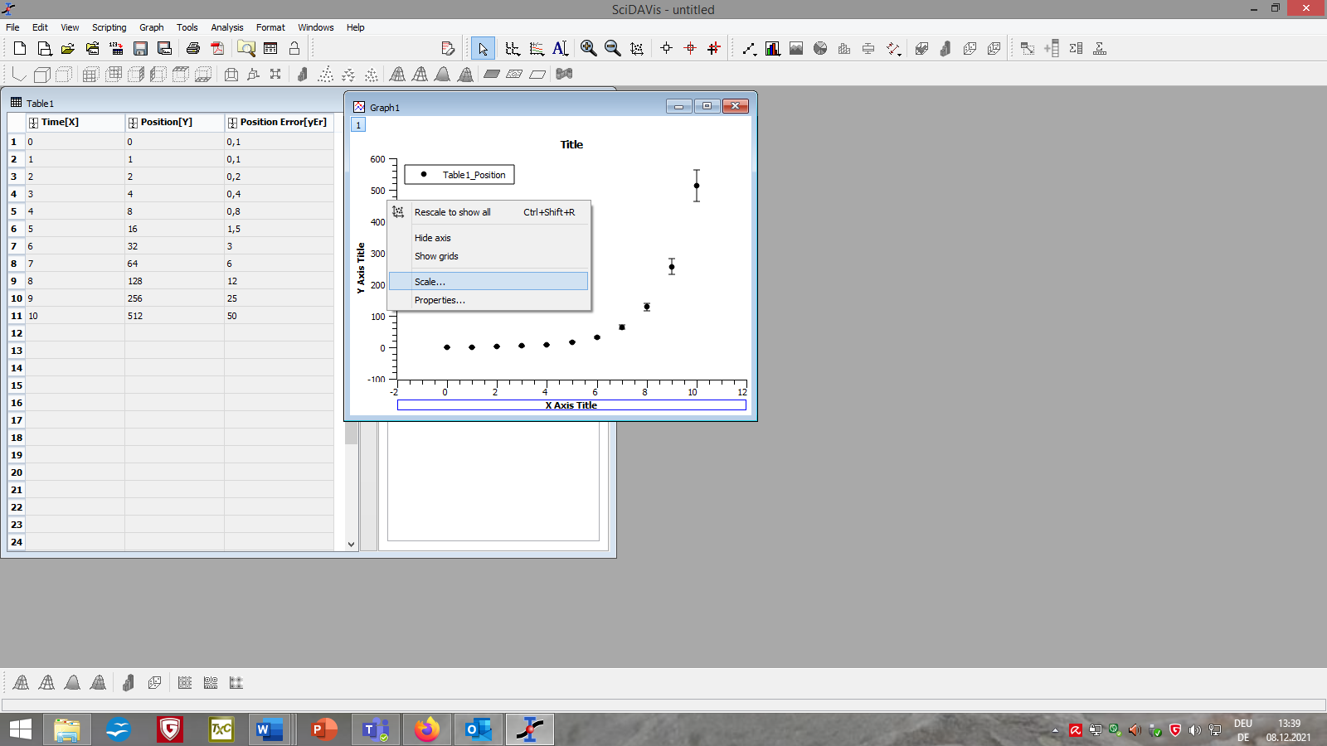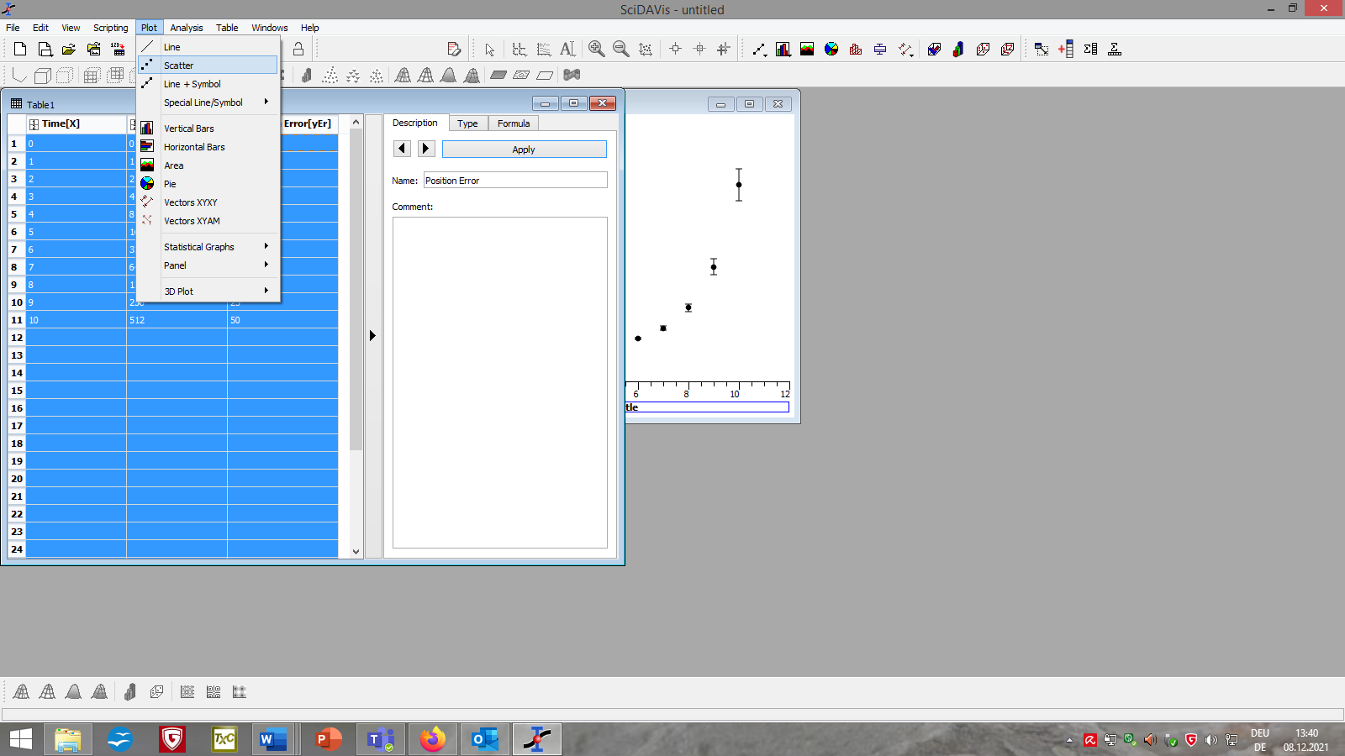By right-clicking the axes or background and select **Scale…** or **Properities…** you can customize the layout of your graph or delete unwanted fits (E).

**(E)**

**(D)**

1. 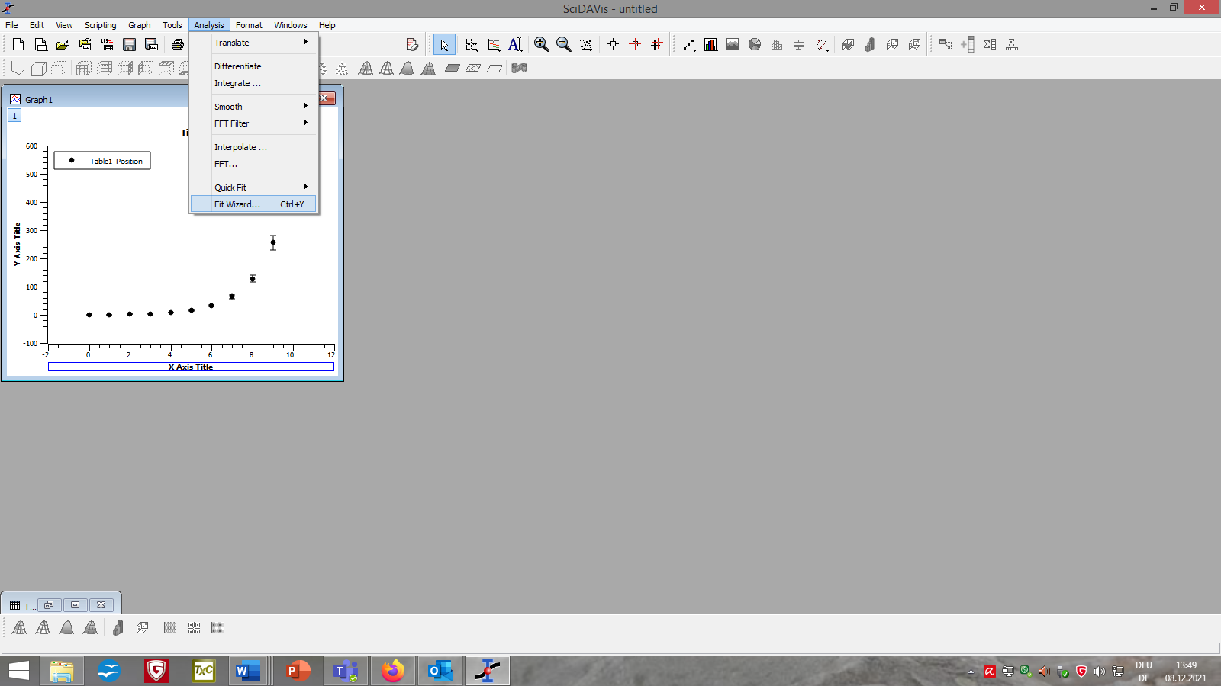**Step: Fit your data**
   1. Click on your graph. From the menu bar, select **Analysis** à **Fit Wizard...** (F)**.**
   2. Select **User defined** in the left column of the newly opened window (G).
   3. Choose a name for your fit function, list the parameters you want separated by a comma and add the formula of your fit function in the large field below (M).

**(F)**

* 1. Click **Save** (I) for later use of the function. Click **Fit >>** (J) to apply the function to your graph.
  2. If necessary, adjust the settings for the fit (e.g. the range of data points considered, the iterations and tolerance of the algorithm, or the source of the $y$-errors) (K).
  3. Use **initial guesses** (L) to tell the algorithm which values you theoretically expect for each parameter. Depending on your input, the fits will be different.
  4. At the bottom, click **Fit** (M). Close the window.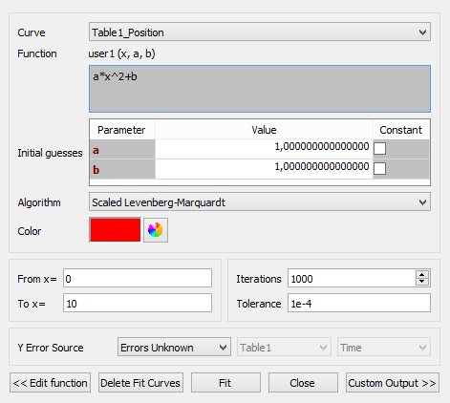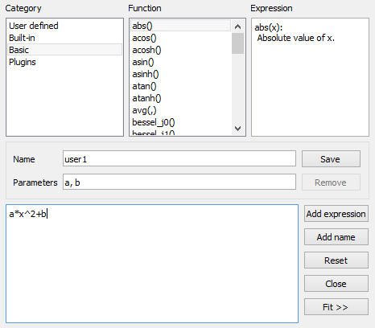

**(S)**

**(K)**

**(M)**

**(J)**

**(I)**

**(M)**

**(G)**

1. **Step: Evaluate your fit**
   1. The window **Results Log** appears automatically and receives various information about the data used and fit functions (N), the algorithm (O) and whether it was successful (P).
   2. You can also find the parameters of your fit with an error range (Q) calculated from the position of the data points and the -error.
   3. An image that contains text.

      Automatically generated description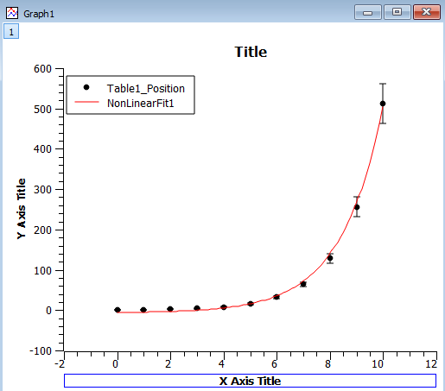You can also find the degree of certainty **R^2** (R) which describes on a scale from 0 (worst case) to 1 (optimal case) how well the data fits the model (used fit formula).

**(R)**

**(Q)**

**(P)**

**(O)**

**(N)**

### (IV) Key questions for the experimental process

To structure your experimentation process, you can orient yourself on the following key questions:

1. What are the advantages and disadvantages of using your smartphone's acceleration or gyroscope sensors? What influence does the choice of sensor have on the experimentation process?
2. What influence does the positioning of the smartphone at the door (height, distance to the door hinges, orientation, ...) have on the experiment and results?
3. What impact does the way you move the door have on your data?
4. Which measurement uncertainties occur during the execution of the experiment? How can these be quantified?
5. Which part of the data set is relevant to answer the research question? Take the paper for help.
6. To what extent do you have to modify your data before you can use the fit formula from Assistance (II)? To do this, be aware of the conditions of application of the fit formula by using the paper and its figure 2 in particular.
7. What criteria can you use to decide whether a fit was "successful"?
8. What significance do the initial guesses have for your fits and the answer to the research question? Use the paper to choose suitable initial guesses.
9. On the basis of which criteria can you give a reasoned answer to your research question? Also compare your results with those from the paper.
10. What information is relevant for the reader of your tabular overview of your experiment?
11. Reflect to which he extent this experiment could also have been carried out with other digital and/or analogue experimental materials or data evaluation methods? What influence would this have on your result and the answer to the research question?
12. Reflect on what you learned in this experiment. What importance does this have for your further studies and your later professional activity?

1. English project website: <https://www.jyu.fi/science/en/physics/studies/digiphyslab>