# Sliding smartphone – pre-lab assignment

1. Sketch a free body diagram of the forces acting on the cell phone as you push it across the table and it moves at constant velocity. For each of these forces write the corresponding formula.

2. How will the cell phone move if you reduce the force with which you push it? Sketch a free body diagram for this case.

Tie one end of the elastic band to the cell phone mask and the other to a solid body, making sure the band is horizontal with the table (A).

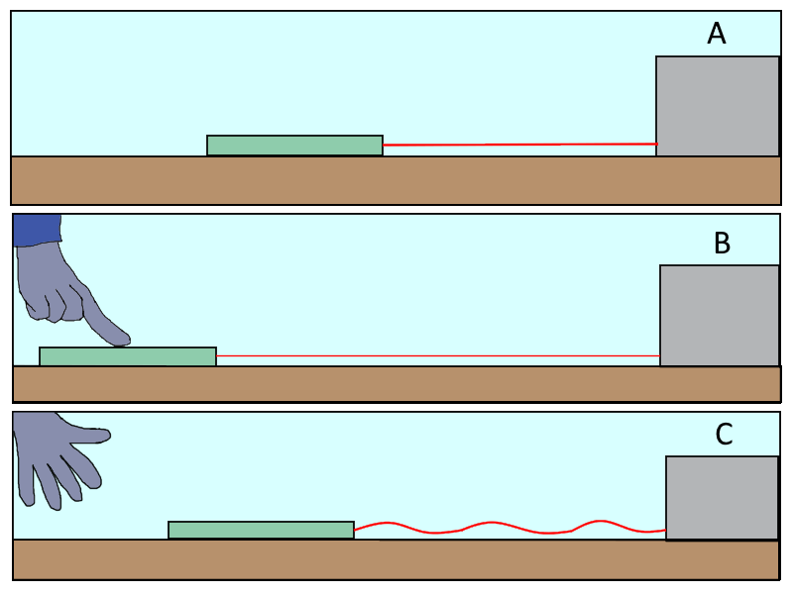Pull the phone out of equilibrium (B) and let it slide across the table (C) and stop on its own (in several attempts, test how far you can pull the phone out of equilibrium without the phone colliding with the body to which it is strapped or falling off the table). Adjust the movement so that the cell phone slides in a straight line and does not become entangled with the elastic band.

3. Sketch how you expect the $a-t$ graph to look for that motion.

When you have perfected the movement of your mobile phone, start the *Acceleration with $g$*  measurement in *PhyPhox* and record the movement.

4. Sketch the resulting graph.

5. Answer the following questions with the help of the graphs from *PhyPhox*:

In which direction does the acceleration of gravity act on your mobile phone?

In which direction are there no significant changes in acceleration?

In which direction do you see the biggest changes in acceleration?

On the image bellow mark $x, y$ and $z$ directions of your mobile phone sensor.

What forces act on the cell phone while it is moving?

Is the elastic force acting on the cell phone constant?

Write an expression for the elastic force. How does it depend on the position? What does "-" mean in the expression for elastic force?

Is the force of friction acting on the cell phone constant?

Does the acceleration of a mobile phone change when only the force of friction acts on it? Why?

Mark questions 6, 7, and 8 in the sketch you drew in question 4.:

6. Mark on the graph the time when the mobile phone was released, when it has the maximum acceleration, when it has the maximum speed and the time when the mobile phone stops moving.

7. Mark on the graph the part of the motion in which both the elastic force and the friction force act simultaneously.

8. Mark on the graph the part of the motion in which only the friction force acts.

9. Sketch a free body diagram for parts of motion where:

Acceleration is maximum

Acceleration is zero

Acceleration is constant

Describe this motion. Which forces act at which moments? What is acceleration in those moments? Why is the acceleration rising / falling / constant?