This document has been created as a part of the Erasmus+ -project “Developing Digital Physics Laboratory Work for Distance Learning” (DigiPhysLab). More info: www.jyu.fi/digiphyslab

Sliding smartphone
Instructor version
6.2.2023



This work is licensed under a Creative Commons Attribution-ShareAlike 4.0 International License.

Sliding smartphone – Instructor version

Overview
- Topic: mechanics, friction, graph interpretation, experimental process.
- Target group: 1st year physics and non-physics students, high school students.
- Timeframe: 90min for the experimental task with pre-lab preparation students do at home.
In this experimental task, students will study the dynamic friction of a smartphone sliding on a flat table surface. Students will learn the process of conducting experiments and draw conclusions based on their observation and experimental data. Using the PhyPhox application, students will measure the acceleration and determine the coefficient of dynamic friction between the smartphone and the desk.

Required equipment
- Smartphone with PhyPhox installed (available for both Android and Apple devices)
- USB connectors
- Computer with a software for data analysis (e.g., Excel)
- Elastic bands or springs
- Weights to put on a smartphone
- Two different flat surfaces to slide the smartphone on
- Blocks with two different surfaces

Pre-lab preparation
Before the experimental task students should do the pre-lab assignment to get a better understanding how the application works, how the experiment is conducted, and of how will they export measurement data. That way less time is needed for students to conduct experiments once they are in the lab.
Discuss problems students had in their pre-lab assignment. Usual areas that need to be discussed with students:
- What are $x, y$, and $z$ directions of the accelerometer sensor?
- What forces act in which direction.
- Interpretation of each segment of $a-t$ graph.
- Newton’s equations of motion.
- How to write the results of the experiment.
Students’ predicted $a-t$ graphs were usually a linear function that decreases over time. Discuss the obtained graph in detail before students start testing the hypothesis.
Additionally, explain to students the steps of an experimental process and the meaning of terms they do not understand.

Orienting questions during the experiment
Recommended questions to ask students during the experimental task:
- Draw a free body diagram.
- What forces are acting on the smartphone when it is stationary?
- What forces act on the smartphone and in which direction while it is sliding?
- How do you interpret the negative sign in the elastic force equation?
- Can you elaborate on your prediction of the hypothesis?
- From what part of the graph do we calculate the coefficient of dynamic friction and why?
- How do you interpret the sign and value of the acceleration on each part of the sliding motion?
- How many variables do we change, from the reference experiment, when testing our hypothesis?
- Is there a hypothesis from which we cannot deduce a meaningful conclusion? Why?
- Can we use two different smartphones to make the experimental process faster?

Testing the equipment
Find elastic bands or springs with a low spring constant. If the spring constant is high, a student’s smartphone might get damaged. Some students might not have a smartphone with an accelerometer sensor so make sure each group has at least a smartphone that can take measurements.
Varying the surface and surface area of the smartphone can be a problem. One solution is to have a cuboid block on which the smartphone can be placed and secured. Blocks can be placed on different sides to vary the surface area, and one side can be that of a wooden block and on the other side rubber (or other material) can be placed to change the surface characteristics.
Have some USB connectors ready for students to use. Transferring experimental data from PhyPhox to a computer can be done via e-mail, chat applications or a USB cable.

PhyPhox and data analysis software
Students exported experimental data from PhyPhox to Excel where they calculated the coefficient of dynamic friction between the table and the smartphone. Before exporting data, it is recommended to save the experimental state in PhyPhox so that students can access the measured data at any point. PhyPhox has an option to export data to Excel and other formats which are suitable for data analysis. Feel free to use any data analysis software (one the students are most comfortable with).

Data collection
Data collection is done by the PhyPhox application (Figure 1.). When meaningful data is collected, students can proceed to data analysis. Make sure students do not damage any equipment during the experiment.
During students’ data collection, ask students questions regarding the experiment and prompt students to think about what experimental skills they are developing.
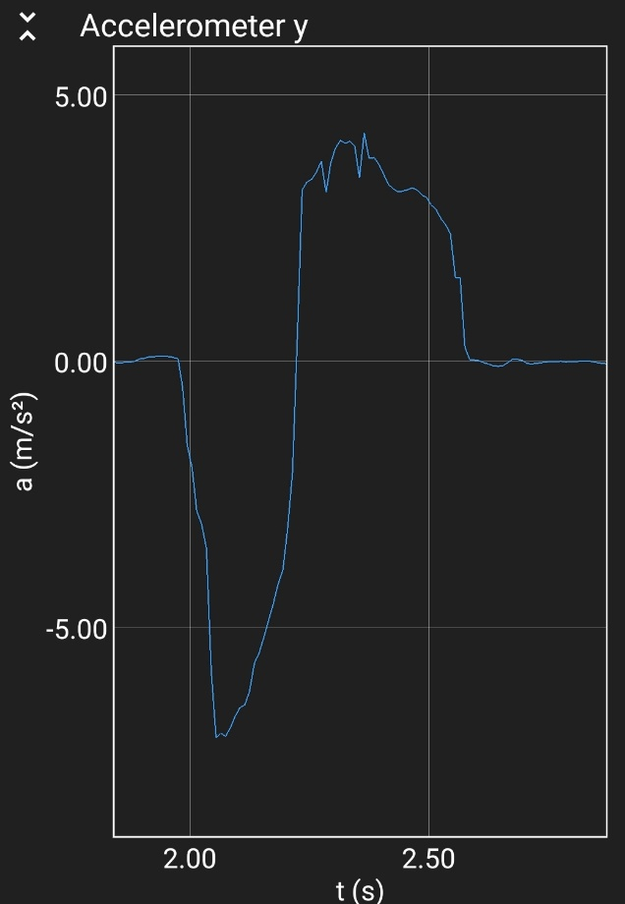
Figure 1: Example of accelerometer data obtained from PhyPhox.

Data analysis and representation
To calculate the coefficient of dynamic friction, students have to select data where the smartphone has a constant acceleration. We used Excel, but feel free to use any program to analyze the data. The students need to determine the average in the selected data set and calculate the coefficient of dynamic friction with the corresponding error.

Reporting
Reporting can be done orally, each group presents their conclusion, how they tested each hypothesis, and how did they analyze the data or students can write a report at home. We recommend oral presentation.
Another option is for students to submit their tested hypothesis with details regarding the experimental process, graphs obtained in each experiment they conducted and a scientific representation of the result.

From our lab
Some first-year students have not used Excel before this lab. Having pre-lab exercise will be helpful for students to learn Excel or to refresh their memory on how to use it. In general, if students come prepared to the lab it will be much easier for them to conduct the experiment and their experience of the lab will be more positive.
When the lab starts, students take some time before they are fully engaged in the experimental task. Discussing pre-lab assignment is a good introduction to the experimental task and discussing problematic areas of the pre-lab assignment motivates them.

Possible modifications
If the experimental task is conducted by high school students, each group can test 2-3 hypotheses. After the experiment, each group can report their findings to other groups. That way each group can draw conclusions based on a report from other groups.
If the experimental task is performed by a group of students, instead of providing the students with hypotheses to test, students can propose their hypotheses and test them. Make sure some groups have hypotheses regarding the influence of different materials for the surface the smartphone is sliding on.
If the timeframe is a problem, we recommend each group does two hypotheses with data analysis in the lab and each group presents their conclusion.

