This document has been created as a part of the Erasmus+ -project “Developing Digital Physics Laboratory Work for Distance Learning” (DigiPhysLab). More info: www.jyu.fi/digiphyslab

Step Counter
Instructor version
9.2.2023



This work is licensed under a Creative Commons Attribution-ShareAlike 4.0 International License.

Step Counter – Instructor version

Overview of the experiment
- Topic: Mechanics, acceleration, calibration
- Target group: Physics and physics teacher training students in the introductory studies.
- Timeframe: 4 hours for the complete task.
- Recommended to work in pairs.
This exercise is perhaps not as close to a physics experiment as to a task in product development. It is more a problem of measurement than a problem of physics. However, being able to read and understand acceleration data is a fundamental aspect of this task. The questions “How does an event of interest look like in my collected data?” and “How can I communicate this information to a computer to assist me in data analysis?” are important when designing any experiment, be it counting steps or subatomic particles.
Note about accessibility: while this experiment is about counting steps, one does not need to be able to walk to conduct this experiment. Everyone defines their own step, which can be any periodic acceleration signal related to moving forward.

Required equipment
- Smartphone with the app phyphox (RWTH Aachen University) or some other app giving access to accelerometer data.
- A computer for running and editing the online python notebook/scripts provided with the instructions.
- Tape measure.
This experiment requires little preparation beforehand besides having the listed equipment available. Students will benefit of downloading and installing the free smartphone app phyphox (or similar) before the session if the lab is done in presence.

About the measuring apps
The app phyphox is intuitive and easy to use. There are two accelerometer tools, “Acceleration with g” and “Acceleration without g”. The difference between these is that in “Acceleration without g” the gravitational component of the acceleration is eliminated from the data. Either of the two tools can be used for this task, but depending on the phone, “Acceleration with g” might have a higher sampling rate by default. In this task a very high sampling rate is not necessary.

Example narrative with comments and suggestions

Define the measurement unit “one step taken by me”.
The step can be defined in several ways. It can be an average comfortable step, the shortest reasonable step (placing the heel directly in front of the other foot’s toes), or the longest possible step. Depending on this choice, the accuracy of the measured walking distance can be increased (constant step length), but this may come at a price in the practicality of the measurement (doesn’t work for regular walking).

Calibrate the measurement device
Here students will determine the average length of their step (as defined in part a)). Some guidance should be provided at this point to consider the advantages and shortcomings of measuring for instance the length of one step once, the length of one step several times, or the length of ten steps a few times. How many measurements are needed to reach a reasonable accuracy?

Design an analysis method
Finding out which coordinate axis on the measuring app points to which direction on the smartphone is the first thing to do. Another decision to make is what data (x, y, z, or absolute acceleration) to use for determining the points in the data where a step was taken.
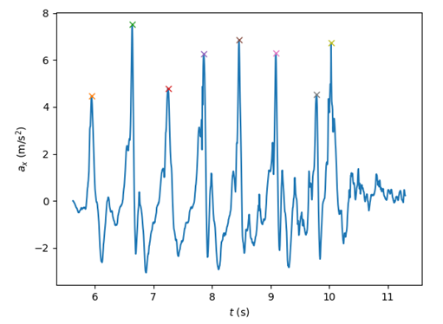
In the accelerometer data from a walking person, one can probably quite quickly see by eye where steps were taken. Using the associated python script or by developing one’s own method, for example, in a spreadsheet, this is the step where one needs to figure out a way to describe what counts as a step to a computer. The essential things to consider are especially a threshold value for acceleration that must be reached for a peak to be counted as a step, and a physical restriction on how much time should pass between peaks for them to be counted as separate steps. In Figure 1 we show accelerometer data of a person walking a short distance. The peaks counted as steps are highlighted with crosses, while there are other peaks present which do not fulfil the criteria for a step.

Figure 1: Accelerometer data of a person taking eight steps. Acceleration in the x direction was used. The peaks counting as steps are highlighted with crosses on the figure.

Test your method
After walking the test distance (ideally more than once) students need to evaluate the result of their measurement. Adjustments need to be made to the method if the results seem unreasonable. To troubleshoot their method, students can be guided to walk a shorter pre-measured distance to see whether the steps counted by the computer match the number of actual steps taken, or whether there are problems in converting the number of steps into a length.
Remind students to experiment bravely and encourage trying new ideas at this point.

Evaluate the uncertainty of your measurements and analysis
Here a typical systematic error is that the method of computing steps is too lenient and too many steps are counted. Another possible uncertainty is the varying length of the step. In this step one can collect measurements done by all students on the course (if they all walk the same test distance), and observe together the spread, outliers, and the average measured length for the distance. A collective best estimate can be reached. In Figure 2 we show an example of what the data could look like for an entire course of 72 students all measuring the same distance. It is noteworthy that outliers in the number of steps are not meaningful, as everyone defined their own step, but measurements are comparable only after everyone uses the same unit.
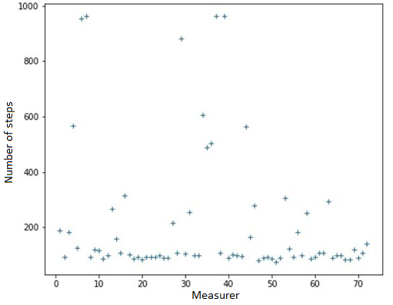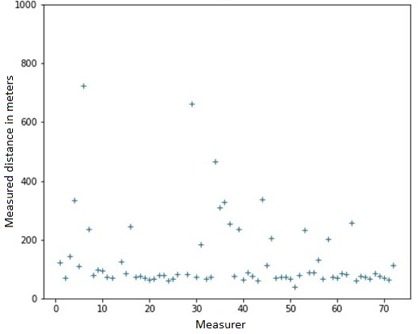
Figure 2: Left panel: The number of steps taken for a given reference length for 72 students on a course. Right panel: The number of steps converted into meters.

Assessment
We have used step-by-step instructions for using a smartphone as a step counter as a form of a report that students create from this experimental task. This way of reporting highlights the design of the experimental procedure. It is important that instructors provide students with their own criteria for what is expected of students in the assessment.

Possible modifications
- This experimental task provides a nice opportunity for an outdoor activity when weather permits. All students participating in the experimental activity could measure, for example, the length of the physics department, the distance between two nearby departments on campus, the length of a bridge or some other structure in the vicinity of the lab.

