This document has been created as a part of the Erasmus+ -project “Developing Digital Physics Laboratory Work for Distance Learning” (DigiPhysLab). More info: www.jyu.fi/digiphyslab

WiFi Analysis
Instructor version
9.2.2023



This work is licensed under a Creative Commons Attribution-ShareAlike 4.0 International License.

WiFi Analysis – Instructor version

Overview of the experiment
- Topic: Electromagnetism, microwaves, hypotheses, outliers.
- Target group: Physics and physics teacher training students at the introductory level (or intermediate to advanced, depending on the scope of the reporting and theoretical description of the phenomena). Quite easily adaptable to the high-school level.
- Timeframe: The task can be assigned in two ways: as an at-home project spanning for example a week, or as an on-campus assignment. If the task is done on campus, two hours is likely enough for the planning, measurements, and analysis. Extra time can be given depending on the scope of the report.
- Done individually, or in pairs.
In this experimental task students make a prediction on which household objects cause a notable attenuation on a WiFi signal when they are placed between the transmitter and the receiver. This prediction is then tested experimentally.
The description of the interaction of electromagnetic waves with matter in a theoretically rigorous way is a rather advanced topic in physics. This task can be conducted with an emphasis mainly on the experimental side of things, focusing solely on conducting a reliable experiment to test a hypothesis. One can add the theoretical details on top of the experiment in form of some background reading and a report assignment, but for this version of the task, we have decided to leave that out.

Required equipment
- Wireless router, mobile hotspot, or some other wireless access point.
- Smartphone, tablet, or computer with a network analyzer app giving a reading of the WiFi signal strength. For Apple devices, the app AirPort allows a continuous measurement giving a list of (time, strength) points. For Android, we have been unable to find a free app that gives such a log of measurements. Network Signal Info Pro has this feature, but it is not free. Still, the free version of the app Network Signal Info or any other app which displays the current value of the signal strength can be used.
- Various items to investigate their properties of attenuation of the WiFi signal, such as books, chairs, oven trays, aluminum foil, etc.
- Graphing and analysis software (Origin, Python, GeoGebra, SciDAVis, anything will do)
- Spreadsheet software can be useful.
If this experimental task is done on-campus, installing the network analyzer app on a mobile device could be given as a pre-lab assignment for students. Making a few test measurements at home just to understand how the app works saves time from the lab session.

The measuring apps
The apps mentioned in the equipment list above are quite easy to use and one just needs to find the reading of the signal strength for the specific network one wants to analyze. The apps might require some permissions to be set from the phone’s app settings to measure the signal strengths.
On one of our pilot runs there was a minor problem or a bug in the Apple app AirPort, which caused the values of the signal strength to change when one closed the data in the app and asked to show it again. This happened only once, but it is recommended to perform multiple measurements for each case to obtain reliable results.
For Android phones we have not found a free app which keeps a log of signal strength values. Therefore, one needs to write values down from the current signal strength shown in the app, or extract points from the graphs of time vs signal strength that these apps sometimes produce.

Example narrative with comments and suggestions

Setting the hypothesis
The important thing is that the hypothesis can be tested with the chosen equipment. For example, let’s consider two hypotheses:
- Thicker objects attenuate the signal more than thin objects, because the signal must travel through more material and has more opportunities to interact with matter.
- Objects made of conducting materials attenuate the signals, because of the interaction of the electromagnetic waves with the free electrons.
To test hypothesis 1, one needs to gather objects made of just a couple of materials, but with a way to vary thickness for each of the materials. To test hypothesis 2, one needs a wider spread of conducting and nonconducting materials, but the thickness of the objects is not that relevant.

Planning
As prompted in the task instructions, students need to plan their experiment so that it is reproducible, and they need to consider how to mitigate the effect of possible reflections and disturbances caused by other objects on the experiment. Some things to consider:
- How to choose the distance between the transmitter and receiver? At long distances reflections from walls and other objects likely play a bigger role as the distance traveled by the waves reflected from a wall might not be relatively that much greater as the distance traveled by a wave going directly to the receiver.
- How to place the examined objects between the transmitter and receiver? It makes sense to place the object close to either the transmitter or receiver so that the transmitted waves going directly to the receiver’s direction pass through the object.
- What is the effect of a human body being between the transmitter and receiver, or moving next to either?
- How long to run the measurement for each of the cases? How many measurement points to take?

Measuring
Figure 1 shows measured data for five different objects taken by a student in our pilot runs. Each point in the graph represents a consecutive measured value from the AirPort app. A mobile hotspot placed on the floor was used as the transmitter, and the examined objects were placed directly on top of the transmitter. The receiver, i.e., the device measuring the signal strength, was placed on a chair above the transmitter. Therefore, in addition to the examined objects there was also the layer of plastic (with many holes in it) from the chair between the transmitter and receiver, but this is a constant in all measurements.
One immediately notices that there are a few likely outliers in the data for the baking tray and the pillow. Chauvenet’s criterion was used for deciding whether or not to remove the outliers, and Figure 2 shows the data with outliers removed. Note that students might not be familiar with Chauvenet’s criterion or criteria for removing outliers in general, and this part might require some additional support from the instructor. Being transparent about what was done to the outliers and handling them in a consistent way is the key.

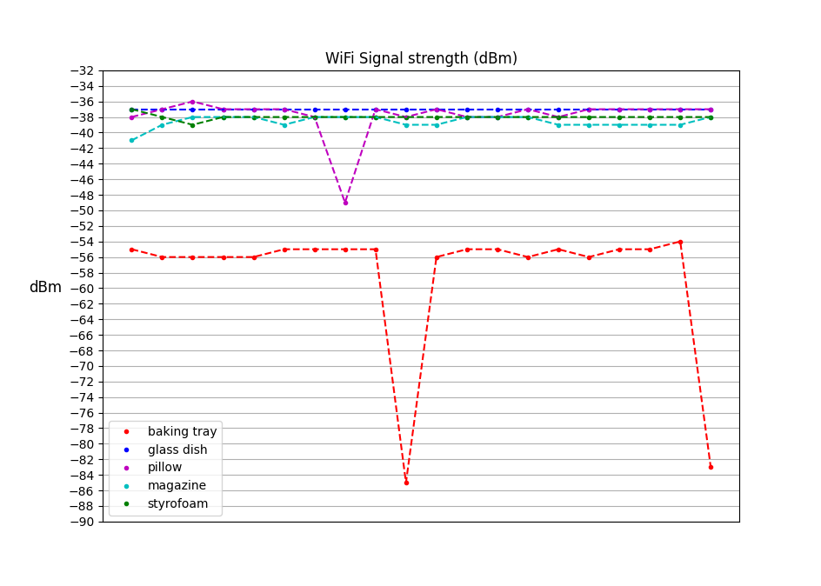
Figure 1: Consecutive measured values of the signal strength for various objects between the transmitter and receiver. A few clear outliers are spotted.

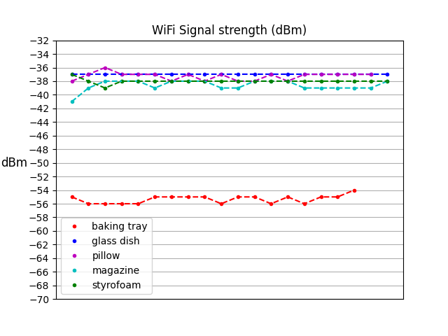
Figure 2: The same as Figure 1 with the outliers removed by using Chauvenet's criterion.

Analyzing
The average signal strength was calculated for each of the five objects, and these are shown in Figure 3. One notices that there is a clear attenuation of the signal in the case of the baking tray. For the other objects the differences are small enough to be within the variability of the WiFi signal in general. Only statistical uncertainties are shown in the figure.

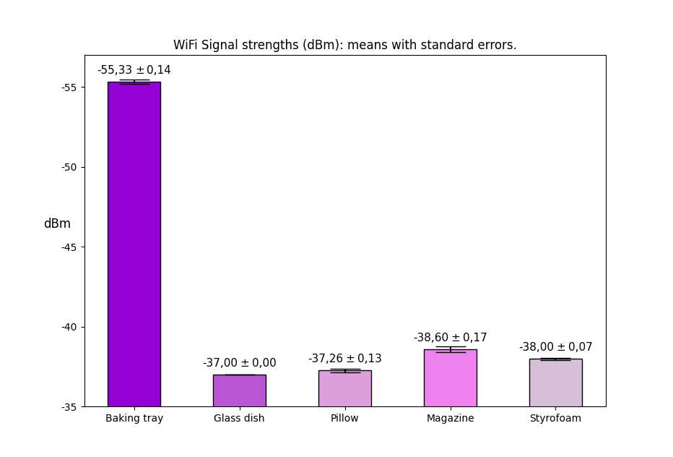
Figure 3: Average signal strengths with standard errors for various objects between the transmitter and receiver. Note that the y-axis is chosen so that the highest bar is the weakest signal.
Based on these measurements it seems that the baking tray made of some metal (likely steel) seems to attenuate the signal significantly. The other materials were nonconducting, so the observation is in line with the hypothesis that conducting materials have a large effect on the signal. More evidence would be required to make stronger conclusions, and some additional measurements could be done using other conducting materials (aluminum foil, human body, etc…) to see if the effect is consistent.

Assessment
As an example of assessment, we have used a short report where the following points are discussed.
- Describe your experimental setup. Especially how you eliminated possible external disturbances that could affect the measurement.
- Discuss outliers in the data and how you dealt with them.
- Make an argument on whether your hypotheses were supported or rejected by the data (or whether it is impossible to say either way).
- Discuss why specific items attenuate the WiFi signal more than others if such items were found.
A discussion between a student and an instructor can also be held within the same themes.

Possible modifications
- If the transmitted signal is stable enough, one could attempt to determine the relationship between the signal strength and the distance from the source.
- The openness of the experimental task can be decreased. For example, the specifics of how to set up the transmitting and receiving devices and how place the items in between them can be given. In this case, it is advisable to discuss with students the reasoning behind the ready-made choices. In a more closed form, the investigation is suitable for the high school level.
- The task can be used as a quick demonstration with, say, one metal plate (baking tray or similar) and some other nonconducting object. One can show in real time the effect that the metal object has on the signal compared to the other.

