FORMATTING OF THESES AND SEMINAR PAPERS  
Writing instructions – Faculty of Sport and Health Sciences

Tuula Tutkija

…. Master`s Thesis

Faculty of Sport and Health Sciences

University of Jyväskylä

Spring 2022

**TIIVISTELMÄ**

Tutkija, T. 2021. Seminaaritöiden muotoilu: liikuntatieteellisen tiedekunnan kirjoitusohjeet. Liikuntatieteellinen tiedekunta, Jyväskylän yliopisto, (opintosuunta) pro gradu -tutkielma, xx s., 3 liitettä.

Pro gradu -tutkielmissa tiivistelmän alkuun tulee tutkimuksen opastavat (bibliografiset) tiedot: kirjoittajan nimi, vuosiluku, työn nimi, tiedekunta, yliopisto ja sivumäärä (numeroitujen sivujen loppuun). Tiivistelmän loppuun merkitään aihetta kuvaavat keskeiset asiasanat (3–6 kpl). Asiasanojen valinnassa tulee mahdollisuuksien mukaan käyttää valmiita asiasanaluetteloita (esim. YSO - Yleinen suomalainen ontologia, englanniksi MeSH - Medical Subject Headings).

Tämä opas on tarkoitettu liikuntatieteellisessä tiedekunnassa kirjoitettavien opinnäyte- ja seminaaritöiden (mm. pro gradu -tutkielmien) muotoilun ohjeeksi. Vaikka opas on laadittu lähinnä opinnäyte- ja seminaaritöiden ulkoasunyhtenäistämiseksi, siihen on sisällytetty joitain keskeisimpiä tieteelliseen kirjoittamiseen liittyviä ohjeita (mm. lähdeviitteiden käyttö). Ohjeet perustuvat pääasiassa teokseen *Tutki ja kirjoita* (Hirsjärvi ym. 2010) ja APA-viittaustyyliin (<https://apastyle.apa.org/>).

Tiivistelmä sijoitetaan otsikkosivun jälkeen seuraavalle sivulle. Tiivistelmässä kerrotaan opinnäytetyön sisältö suppeassa muodossa. Teksti jaetaan korkeintaan neljään kappaleeseen, joiden sisällöt jäsennetään seuraavasti: Ensimmäisessä kappaleessa kuvataan seminaarityön tai tutkimuksen tarkoitus ja kohde sekä tilan niin salliessa aiheenvalinnan keskeinen perustelu. Toisessa kappaleessa esitellään tutkimuksen teoreettis-metodologinen viitekehys tieteenalalle tyypillisellä tavalla. Tässä kohtaa todetaan keskeiset käsitteet ja teoriat ja/tai esitellään seminaarityössä tai tutkimuksessa sovelletut metodit. Kolmanteen kappaleeseen kiteytetään seminaarityön tai tutkimuksen tärkeimmät tulokset ja johtopäätökset.

Tiivistelmän lauseiden tulee olla lyhyitä ja selkeitä. Tiivistelmän on mahduttava yhdelle sivulle. Riviväli on 1 ja fontti 12. Pro gradu -tutkielmiin kirjoitetaan aina sekä suomenkielinen että englanninkielinen tiivistelmä (myös englanninkielisiin pro gradu –tutkielmiin). Kandidaatintutkielmaan ei tarvita englanninkielistä tiivistelmää. Tiivistelmää ei tarvitse kirjoittaa seminaaritöihin.

Asiasanat: tieteellisyys, täsmällisyys, formaatti

*Opinnäyte- ja seminaaritöiden kirjoitusohjeet on laatinut vuonna 2013 Jyväskylän yliopiston Liikuntatieteellisen tiedekunnan nimeämä työryhmä: Pipsa Nieminen, Anna-Liisa Ojala, Teemu Pullinen, Marjaana Häkkinen, Elina Sillanpää ja Katja Waller.*

*Uudistettu painos 21.9.2021, työryhmä: Teemu Pullinen, Mikko Simula, Mirva Rottensteiner, Heli Tyrväinen, Katja Waller ja Liikuntatieteellisen tiedekunnan opiskelijaedustajat.*

**ABSTRACT**

Tutkija, T. 2021. How to write a seminar paper: Writing guidelines of the Faculty of Sport and Health Sciences, University of Jyväskylä, Master’s thesis, __ pp.. __ appendices.

This guide is intended as a guideline for the formatting of theses and seminar papers (e.g. Master`s theses) written at the Faculty of Sport and Health Sciences. This guide is mainly designed to standardise the layout of theses and seminar papers. The guidelines are mainly based on Tutki ja kirjoita (Hirsjärvi et al. 2010) and the APA citation style (https://apastyle.apa.org/).

The abstract is placed on the next page after the title page. The abstract describes the content of the thesis in a concise form. The text shall be divided into a maximum of four paragraphs, the contents of which shall be structured as follows: the first paragraph shall describe the purpose and subject of the seminar paper or study and, where space permits, the main rationale for the choice of topic. The second paragraph presents the theoretical-methodological framework of the study in a manner typical of the discipline. This section identifies the key concepts and theories and/or presents the methods applied in the seminar or study. The third section summarises the main findings and conclusions of the seminar or study.

The sentences in the abstract should be short and clear. The abstract should fit on one page. Line spacing is 1 and font 12. Master´s theses always include an abstract in both Finnish and English (including English-language Master´s theses).

Key words: format, scientific rigour, accuracy

**ABBREVIATIONS**

ATP adenosine triphosphate

BMI body mass index

DOMS delayed onset muscle soreness

DXA dual-energy X-ray absorptiometry

LDL low density lipoprotein

WHO World Health Organization

1 RM one repetition maximum….

If there are many abbreviations used repeatedly in the writing, they are grouped on their own page in alphabetical order. Otherwise, this page is omitted.

**CONTENTS**

TIIVISTELMÄ

ABSTRACT

1 INTRODUCTION 1

2 SECOND MAIN TITLE 2

2.1 Second level subtitle 2

2.2 Second level subtitle 2

2.3 Second level subtitle 2

2.4 Second level subtitle 2

3 THIRD MAIN TITLE 5

3.1 Second level subtitle 5

3.1.1 Third level subtitle 5

3.1.2 Third level subtitle 5

3.2 Second level subtitle 5

3.2.1 Third level subtitle 5

3.2.2 Third level subtitle tason alaotsikko 5

3.2.3 Third level subtitle 5

REFERENCES 7

APPENDICES

Appendix 1: Instructions on how to mark a reference in text (Biology of Physical Activity).

Appendix 2: Instructions on how to mark a reference in text (Health Sciences).

Appendix 3: Instructions on how to mark a reference in text (Sport Pedagogy and Social Sciences of Sport).

# INTRODUCTION

The first main heading is always INTRODUCTION ….

You can save the Tuula Tutkija -docx file in dotm template format (in the templates folder) and thus get the right template to use. Whenever you start a new writing, you can then use the template you have created, so that most of the settings are already automatically correct. Please note, however, that you will have to take care of blank lines between and after paragraphs, etc.

# SECOND MAIN TITLE

Thesis and seminar papers should be written in good language throughout and follow scientific writing conventions. An introductory text is placed under the main heading to introduce the sub-chapters and help the reader to understand the structure and content of the paper.

## Second level subtitle

Text…

## Second level subtitle

Text…

## Second level subtitle

Text…

## Second level subtitle

Tables and figures are placed in the text so that they can be easily found by reference to the text (Figure 1, Figure 2, Table 1). They should be either on the same page or as soon as possible after the reference in the text.

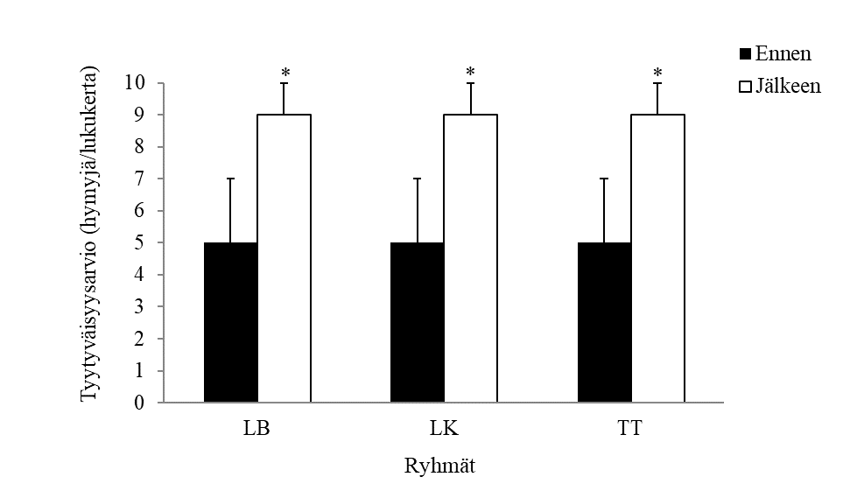

FIGURE 1. Satisfaction with the guidelines for writing theses and seminar papers by discipline before and after the update of the Tuula Tutkija guidelines. LB, exercise biology; LK, behavioral and social sciences of sport; TT, health sciences. Values are means, scatter bars represent standard deviation. * p < 0.05 for statistically significant difference between measurement time points.

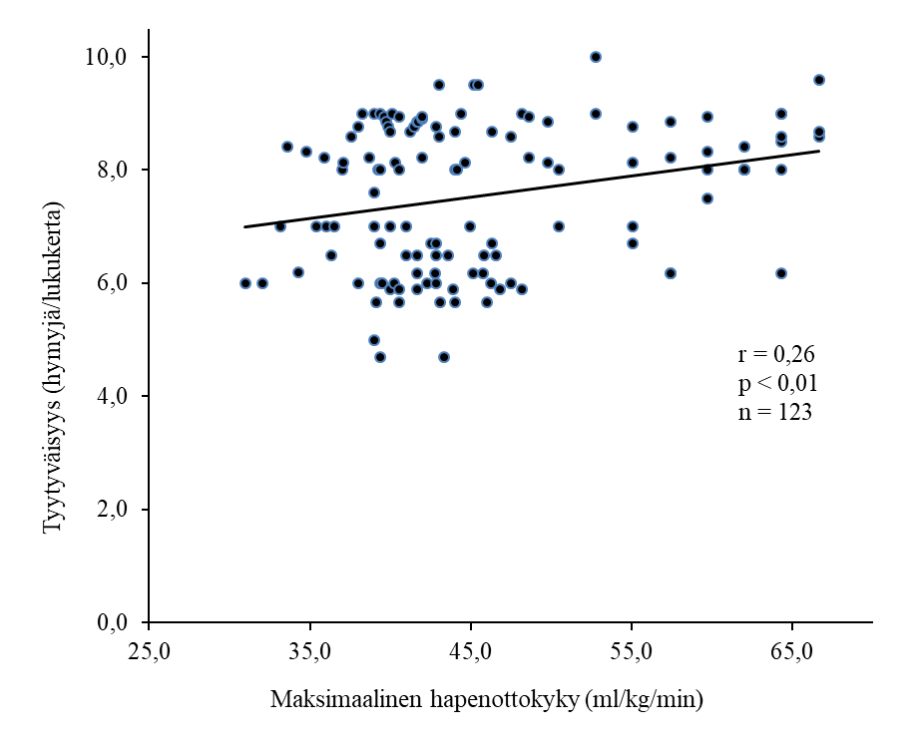

FIGURE 2. Correlation between maximal oxygen uptake and satisfaction with writing instructions for thesis and seminar papers.

TABLE 1: Physical activity among young (26¬45 years) and older (46¬65 years) workers.

|  |  |  |  |  |  |  |
| --- | --- | --- | --- | --- | --- | --- |
|  | 26–45-v. | |  | 46–65-v. | |  |
| Liikuntamuoto | n | % |  | n | % | p-arvoa |
| Kävely | 77 | 52,7 |  | 32 | 53,3 | 0,002 |
| Uinti | 28 | 19,2 |  | 10 | 16,7 | 0,024 |
| Sähly | 5 | 3,4 |  | 1 | 1,7 | 0,095 |
| Miekkailu | 2 | 1,4 |  | 2 | 3,3 | 0,876 |
| Muub | 34 | 23,3 |  | 15 | 25 | 0,110 |
| Yhteensä | 146 | 100 |  | 60 | 100 |  |

a Ikäryhmien väliset erot testattu χ2-testillä, b Tanssi, kuntosaliliikunta, parkour ja ratsastus.

# THIRD MAIN TITLE

Text…

## Second level subtitle

### Third level subtitle

Text….

### Third level subtitle

Text…

## Second level subtitle

Text…

### Third level subtitle

Text…

### Third level subtitle tason alaotsikko

Text…

### Third level subtitle

Text…

# REFERENCES

Aarresola, O. & Konttinen, N. (2012). Vanhemmat moni-ilmeinen vaikuttaja kilpaurheiluun sosiaalistumisessa. Liikunta & Tiede 49 (6), 29–35.

Bangsbo, J., Blackwell, J., Boraxbekk, C. J, Caserotti, P., Dela, F., Evans, A. B., Jespersen, A. P., Gliemann, L., Kramer, A. F., Lundbye-Jensen, J., Mortensen, E. L., Lassen, A. J., Gow, A. J., Harridge, S. D. R., Hellsten, Y., Kjaer, M., Kujala, U. M., Rhodes, R. E., Pike, E. C. J. … Viña, J. Copenhagen Consensus statement 2019: physical activity and ageing. (2019). British Journal of Sports Medicine 53 (14), 856–858. doi: 10.1136/bjsports-2018-100451.

Colberg, S. R., Sigal R. J., Yardley, J. E., Riddell, M. C., Dunstan, D. W., Dempsey, P. C., Horton, E. S., Castorino, K. & Tate, D. F. (2016). Physical Activity/Exercise and Diabetes: A Position Statement of the American Diabetes Association. Diabetes Care 39 (11), 2065–2079. doi:10.2337/dc16-1728.

Heikinaro-Johansson, P. & Hirvensalo, M. (2007). Johdatus liikuntadidaktiikkaan. Teoksessa P. Heikinaro-Johansson & T. Huovinen (toim.) Näkökulmia liikuntapedagogiikkaan. 2. uudistettu painos. Helsinki: WSOY, 94–113.

Iso-Markku, P. (2019). Relationships between physical activity, dementia mortality, and cognition in Finnish twins. University of Helsinki, Faculty of Medicine, Public health Doctoral Program in Population Health. Väitöskirja. Viitattu 6.9.2021. http://urn.fi/URN:ISBN:978-951-51-5503-0.

Jaakkola, T. (2010). Liikuntataitojen oppiminen ja taitoharjoittelu. E-kirja. Jyväskylä: PS-Kustannus. Viitattu 15.6.2017.

Kalaja, S. (2012). Fundamental movement skills, physical activity, and motivation toward Finnish school physical education: A fundamental movement skills intervention. University of Jyväskylä. Studies in Sport, Physical Education and Health 183. Väitöskirja. Viitattu 13.1.2018. <http://urn.fi/URN:ISBN:978-951-39-4817-7>.

Laukaan kunta. (2012). Sosiaali- ja terveyslautakunnan pöytäkirja 12.12.2012. Laukaan kunnan arkisto. Viitattu 29.4.2013. http://laukaa02.hosting.documenta.fi/kokous/

2012184.HTM.

Mangine, G. T., Hoffman, J. R., Gonzalez, A. M., Townsend, J. R., Wells, A. J., Jajtner, A. R., Beyer, K. S., Boone, C.H, Wang, R., Miramonti, A. A., Lamonica, M. B., Fukuda, D. H., Witta E. L., Ratamess, N. A. & Stout, J. R. (2017). Exercise-induced hormone elevations are related to muscle growth. Journal of Strength & Conditioning Research 31 (1), 45–53. doi:10.1519/JSC.0000000000001491.

Namaganda, S. K. (2012). Association between mid-life physical activity and hypertension in older women: a 25 year follow-up. University of Jyväskylä. Department of Health Sciences. Pro gradu -tutkielma.

Perusopetuksen opetussuunnitelman perusteet 2014. (2014). Opetushallitus. Määräykset ja ohjeet 2014:96. Viitattu 30.8.2021. https://www.oph.fi/sites/default/files/documents/

perusopetuksen_opetussuunnitelman_perusteet_2014.pdf.

Rantanen, T. (2005). Sarkopenia. Teoksessa I. Vuori, S. Taimela & U. M. Kujala (toim.) Liikuntalääketiede. 3. painos. Helsinki: Duodecim, 286–296.

Sakari, R. (2013). Mobility and its decline in old age: determinants and associated factors. University of Jyväskylä. Studies in Sport, Physical Education and Health 190. Väitöskirja. Viitattu 20.4.2017. http://urn.fi/URN:ISBN:978-951-39-5063-7.

Task Force. (1996). Heart rate variability: Standards of measurement, physiological interpretation and clinical use. Task Force of the European Society of Cardiology and the North American Society of Pacing and Electrophysiology. Circulation 93 (5), 1043–1065.

Vallerand, R. J. (2001). A hierarchical model of intrinsic and extrinsic motivation in sport and exercise. Teoksessa G. C. Roberts (toim.) Advances in motivation in sport and exercise. Champaign, IL: Human Kinetics, 263–319.

Waller, K., Kaprio, J., Lehtovirta, M., Silventoinen, K., Koskenvuo, M. & Kujala, U. M. (2010). Leisure-time physical activity and type 2 diabetes during a 28 year follow-up in twins. Diabetologia 53 (12), 2531–2537. doi:10.1007/s00125-010-1875-9.

APPENDIX 1. Instructions on how to mark a reference in text (Biology of Physical Activity).

*When referring to a preceding sentence, a) the reference or b) the references are placed in brackets at the end of the sentence, followed by a full stop. For example:*

a) Increased plasma testosterone concentration induced by a resistance exercise has been found to be positively associated with muscle growth (Mangine et al. 2017).

b) On the other hand, it has also been shown that muscle growth can occur as a result of strength training without a significant increase in hormone concentrations (testosterone, growth hormone, IGF-1, cortisol) during exercise loads (West et al. 2009; West et al. 2010).

*The references are listed immediately after the subject when several points of view are presented in the same sentence. For example:*

Previously, one study has found a strong positive correlation (r = 0.76) between acute testosterone response and muscle growth (Ahtiainen et al. 2003), but a few other studies have not found a similar association (r = 0.06 - 0.14; p > 0.05) (McCall et al. 1999; West et al. 2012).

*If a reference refers to several preceding sentences, the reference is placed after the period in the last sentence. For example:*

Acute hormone response, particularly testosterone response, has been shown to be closely linked to muscle growth during an eight-week strength training cycle. About 73 % of the variation in muscle growth could be explained by baseline muscle size and acute hormone responses (testosterone, cortisol, growth hormone, insuline and IGF-1). However, testosterone was by far the most important of the hormonal factors in explaining muscle growth, as without it only 42 % of the variation in muscle growth could be explained. (Mangine et al. 2017) The text continues here ---

APPENDIX 2. Instructions on how to mark a reference in text (Health Sciences).

In Health Sciences, *the reference always comes inside the sentence*. A textual reference is never placed after the period at the end of a sentence. If it is justified to write more than one sentence from the same source, the text should be written in an introductory manner, as in the texts below. Textual references may be placed immediately after the point when several points of view are presented in the same sentence.

The links between physical activity and cognition, i.e. memory and information processing capacity, and between physical activity and dementia have been widely studied. In many previous longitudinal studies, physical activity has been associated with both improved cognition (Chang et al. 2020, Elwood et al. 2013, Singh-Manoux et al. 2005, Virta et al. 2013) and reduced incidence of memory disorders (Andel et al. 2008, Gelber et al. 2012, Rovio et al. 2005). However, previous longitudinal studies have generally failed to account for the influence of genetic factors. In Iso-Marku's (2019) PhD study based on a Finnish twin cohort study, more than 20 000 twins were followed for 29 years and 353 of them died of memory disease. The study found that long-term brisk physical activity in middle age was associated with both reduced memory disease mortality (standardised hazard ratio 0.60, confidence interval [LV] at 95% significance level 0.39-0.93) and improved cognition more than two decades later (standardised regression coefficient 0.91, 95% LV 0.47-1.35). No dose-response relationship was found between the amount of physical activity and cognition or memory mortality.

A study by Ruokolainen et al (2019) found that socioeconomic background factors influence smoking prevalence. At the same time, it was found that smoking is less common among the more highly educated.

Socioeconomic background factors have been found to influence smoking prevalence (Ruokolainen et al. 2019). In the same context, it has been found that smoking is less common among the more highly educated.

APPENDIX 3. Instructions on how to mark a reference in text (Sport Pedagogy and Social Sciences of Sport).

*Reference mark for a single sentence:* the source reference(s) should be enclosed in brackets and placed at the end of the sentence, before the period at the end of the sentence. For example:

As far as winter sports were concerned, women had been competing in the World Championships in downhill, pole vaulting and alpine combined since 1931 (Keskitalo & Siitonen 1977, 65).

*Multi-sentence reference:* the information to be included in the source reference is indicated as above, but placed after the full stop of the last sentence in the reference. For example:

An important factor in the growth of interest in skiing was factory skiing, which attracted masses of factory workers in the early decades of the 20th century. Some skiing competitions for workers organised by businesses and agencies had already taken place in the 19th century. However, it was not until the 1920s that wood-skiing proper began in many factory towns. (Heikkinen 1981, 58, 63; Laine 1992c, 193)