tITLE
FirstName LastName
Master’s Thesis / Bachelor’s Thesis
Degree Programme
Department
University of Jyväskylä
Spring 2020

University of Jyväskylä
Faculty  Humanities and Social Sciences | Department
Author
Title
Degree Programme | Level
Month and year | Number of pages
Abstract
Keywords
Depository University of Jyväskylä
Additional information
Declaration of AI usage
I confirm that this thesis is my own original work. I have properly cited all sources. I understand that submitting AI-generated text as my own writing without thorough editing is considered academic misconduct.

[] I did not use AI tools in the research and writing of this thesis.

[] I used AI tools in the research and/or writing process.

If checked, please specify:

- AI tools used: (e.g., ChatGPT, Grammarly, DeepL,)
- What was the purpose of the AI usage? (e.g., idea generation, proofreading, paraphrasing, translation assistance)
- How did you modify or integrate AI-generated content into the thesis?
- What were the key stages of the writing process where you used AI? (e.g., drafting, feedback and revisions, final version)
- AI assistance reflection: how did the AI tools you used support your independent thinking or help you conduct the research?

Figures
FIGURE 1 An example of the research process. 2
Tables
TABLE 1 How familiar were the students with the thesis template in the beginning of the seminar? 2

Table of contents
1 Chapter heading 1
1.1 Second level heading 1
1.1.1 Third level heading 1
1.1.2 Third level heading 2
1.2 Second level heading 3
2 chapter heading 4
2.1 Second level heading 4
2.2 Another second level heading 4
rEFERENCES 5

APPENDICES (remove this row if there are no appendix in your thesis)

Chapter heading
Using this thesis template is easiest when you know how to use styles in word processing software. In the title above (”Chapter heading”), use the title “Heading 1”. In the first paragraph after each title, use the title “Normal first paragraph”.
This chapter uses the style “Normal”. This, like all paragraphs after the first one, should be indented. This is why we use a different style here than in the first paragraph.
Lorem ipsum dolor sit amet, consectetuer adipiscing elit. Maecenas porttitor congue massa. Fusce posuere, magna sed pulvinar ultricies, purus lectus malesuada libero, sit amet commodo magna eros quis urna. Nunc viverra imperdiet enim. Fusce est.
In porttitor. Donec laoreet nonummy augue. Suspendisse dui purus, scelerisque at, vulputate vitae, pretium mattis, nunc. Mauris eget neque at sem venenatis eleifend. Ut nonummy.

Second level heading
Here is an example of a citation:
Citation has its own style, called “Citation”. Lorem ipsum dolor sit amet, consectetuer adipiscing elit. Maecenas porttitor congue massa. Fusce posuere, magna sed pulvinar ultricies, purus lectus malesuada libero, sit amet commodo magna eros quis urna. Nunc viverra imperdiet enim. Fusce est. Vivamus a tellus.

Third level heading
Below you will find examples of captions for tables and figures. Using the appropriate style (”Caption”) for these, makes it easy to update the list of tables and the list of figures in the beginning of this document.
The placement of the caption differs according to the type of content. For tables, the caption should be above the table. For figures, the caption should be below the figure.
TABLE 1 How familiar were the students with the thesis template in the beginning of the seminar?
Familiarity with the thesis template | Frequency | Percentage (%)
I am familiar with the template and have used it before on other writing assignments. | 2 | 7,4
I have looked at the template before but have never used it. | 6 | 22,2
I knew the template existed, but I was not familiar with it. | 14 | 51,9
I ha never heard of the template before this. | 5 | 18,5
Total | 27

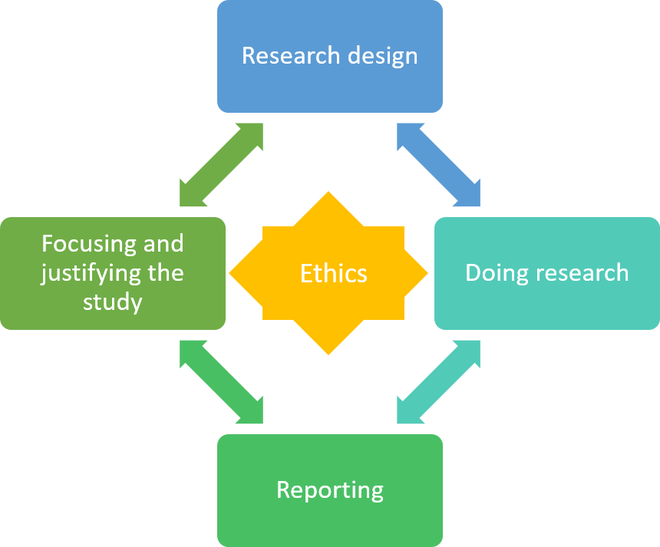
FIGURE 1 An example of the research process.

Third level heading
Lorem ipsum dolor sit amet, consectetuer adipiscing elit. Maecenas porttitor congue massa. Fusce posuere, magna sed pulvinar ultricies, purus lectus malesuada libero, sit amet commodo magna eros quis urna. Nunc viverra imperdiet enim. Fusce est.
In porttitor. Donec laoreet nonummy augue. Suspendisse dui purus, scelerisque at, vulputate vitae, pretium mattis, nunc. Mauris eget neque at sem venenatis eleifend. Ut nonummy.

Second level heading
Lorem ipsum dolor sit amet, consectetuer adipiscing elit. Maecenas porttitor congue massa. Fusce posuere, magna sed pulvinar ultricies, purus lectus malesuada libero, sit amet commodo magna eros quis urna. Nunc viverra imperdiet enim. Fusce est.
In porttitor. Donec laoreet nonummy augue. Suspendisse dui purus, scelerisque at, vulputate vitae, pretium mattis, nunc. Mauris eget neque at sem venenatis eleifend. Ut nonummy.

chapter heading

Second level heading
Lorem ipsum dolor sit amet, consectetuer adipiscing elit. Maecenas porttitor congue massa. Fusce posuere, magna sed pulvinar ultricies, purus lectus malesuada libero, sit amet commodo magna eros quis urna. Nunc viverra imperdiet enim. Fusce est.
In porttitor. Donec laoreet nonummy augue. Suspendisse dui purus, scelerisque at, vulputate vitae, pretium mattis, nunc. Mauris eget neque at sem venenatis eleifend. Ut nonummy.

Another second level heading
Lorem ipsum dolor sit amet, consectetuer adipiscing elit. Maecenas porttitor congue massa. Fusce posuere, magna sed pulvinar ultricies, purus lectus malesuada libero, sit amet commodo magna eros quis urna. Nunc viverra imperdiet enim. Fusce est.
In porttitor. Donec laoreet nonummy augue. Suspendisse dui purus, scelerisque at, vulputate vitae, pretium mattis, nunc. Mauris eget neque at sem venenatis eleifend. Ut nonummy.

rEFERENCES
Anonymous, A., Efficient, E. & Ingenious, I. 2008. How to write references properly. Jyväskylä: Jyväskylä University Press.
Second reference

This reference style JYU Dissertations is used in our university series.
However, use the referencing style required in your department. If you are free to choose youre referencing style (for example APA, Chicago etc.), use it consistently. You can create citations and a reference list in accordance to this style with RefWorks bibliographic management tool by choosing JYU Dissertations as the style. First add the style to your Favourites list > RefWorks > Bibliography > Output Style Manager > select the style. The style is now available in Write-N-Cite as well. The final editing of citations for rarer document types, such as patents, must be done manually.

Appendices
APPENDIX 1

Lorem Ipsum, 2009.

